**Expression of Interest**



**Republic of Guinea Bissau**

**Ministry of Economy, Planning and Regional Integration**

***Guinea-Bissau Public Sector Strengthening Project II***

**Technical Assistance for Reengineering, Analysis and Digitization of Public Administration Human Resources Management Processes.**

**Bid Reference: 45 PRSPII/SQC/2024**



**SUBMITTED BY**



**AH Consulting Limited**

**December 2024**

## Expression of Interest Submission Letter

Kampala, Uganda. 26th December 2024

The Coordinator

Fernanda Ramalho Mendy

UG-PRSP II, Bairro de Penha-Brá, Entrada da Guiné Telecom Bissau, Guinea-Bissau;

Dear Sir/Madam,

**EXPRESSION OF INTEREST FOR TECHNICAL ASSISTANCE FOR REENGINEERING, ANALYSIS AND DIGITIZATION OF PUBLIC ADMINISTRATION HUMAN RESOURCES MANAGEMENT PROCESSES, BID REFERENCE: 45 PRSPII/SQC/2024**

We, **AH Consulting Ltd of Uganda** hereby express interest to provide consultancy services for the above assignment in accordance with your request for Expressions of Interest. **AH Consulting** is an Africa wide value-based consulting firm with 20 years experience in providing consulting services in countries across Sub-Saharan Africa. We are committed to catalyzing transformation across Sub-Saharan Africa through innovative solutions and strategic collaborations in providing information technology, infrastructure development, and digital transformation, we have tackled the complexities of diverse projects and garnered an in-depth understanding of the unique challenges, regulatory landscapes, and technological advancements in the region. Our team of experts, including seasoned IT experts and specialized project managers, is available to leverage our expertise to deliver sustainable, scalable, and cutting-edge solutions that drive progress, efficiency, and prosperity in the region to Government Ministries Departments and Agencies (MDAs), private sector organizations, Development partners and Civil Society organizations/NGOs.

AH Consulting has a proven history of successful collaborations with prestigious donors and institutions, including the World Bank, GIZ, African Development Bank, European Union, Millennium Challenge Corporation, Bill and Melinda Gates Foundation, and governments in Sub-Saharan Africa. Our team's proficiency spans diverse domains, ensuring that our solutions are holistic, innovative, and tailored to the unique challenges of each project. We believe that AH Consulting's expertise, combined with our client-centric ethos, positions us as the best-suited consultant for this assignment. We look forward to the opportunity to contribute to the success of the project and collaborate closely with your esteemed organization to bring about positive change and progress. Moreover, we have executed assignments to date in Western, Southern, Eastern, Southern, Central, North Africa.

We have proposed an assorted list of experts that are highly qualified and experienced that may be considered for this assignment. Our senior executive and managerial team has the right blend of the required skills to provide backstopping and quality assurance for the assignment with a combined total of over 60 years of rich, purposeful experience in the consulting industry all gained across the African Continent.

The top HRMIS systems we have worked on and for which we have been involved in development of specifications are as follows:

1. Ghana HRMIS in 2012 replaced by the one below.
2. Ghana HRMIS in 2018 (now live)
3. Lesotho HRMIS (now live)
4. Electricity Supply Corporation of Malawi (ESCOM) HRMIS (now live)
5. Malawi Electricity Generation Company Ltd (EGENCO) HRMIS (now in specifications development)

We have unparalleled experience and depth of knowledge required for delivering the proposed services using a blend of local, regional and international expertise. Herein, you will find information demonstrating that we are qualified to provide these services: (i) Core Business and Areas of expertise, (ii) Years in Business, (iii) experience in similar assignments, and (iv) Technical and Managerial capabilities including demonstrable skills and competencies of our key experts to successfully and excellently deliver on this assignment.

We look forward to being shortlisted to submit proposals at the next stage. Should you have any enquiries regarding this submission, kindly reach me at our Kampala offices.

Yours faithfully,



**Osbert Atusasiire**

**DIRECTOR OF OPERATIONS**

# TABLE OF CONTENTS

Expression of Interest Submission Letter 2

Power Of Attorney 5

1. AH Consulting Short Profile 7

2. About AH Consulting 9

A. Number of years in offering services/business 9

B. Organizational Profile 9

3. Our Understanding of the Assignment 16

4. Experiences in Digitization of Human Resources Management Processes 17

5. Feasibility Studies/ System Design/ Requirements/ Specifications Development related experiences 24

6. Systems Technical Assessment, Quality Assurance, Project Management related Experience 71

7. Key Experts – Team of Consultants 93

8. CVs of Selected Key Experts 101

Project Director Herbert Rwamibazi 101

Digital Government Specialist – Fredrick Bitta 106

Network & Infrastructure Specialist – Mutuku Muli James 111

Human Resource Specialist Dr Samuel Luzobe Ndibalekera 116

Database Management Expert – John Wachira Kibui 121

Business Analyst Robert Makau Nzenga 125

Change Management Expert – Christine Karimi Njagi 129

9. AH Consulting Legal Documents 133

9.1. Certificate of Incorporation 133

9.2. Trading License 134

10. Copies of completion certificates and contracts 135



**Contact Details:**

**Authorised Representative: Osbert Atusasiire**

Director of Operations

AH Consulting Limited

29 Stretcher Road, Ntinda Nakawa Road.

P.O. Box 8699, Kampala, Uganda

Tel: +256200946459, +256393533080

Email: [info@ahcul.com](mailto:info@ahcul.com)

Email: [aosbert@ahcul.com](mailto:aosbert@ahcul.com)



## Power Of Attorney

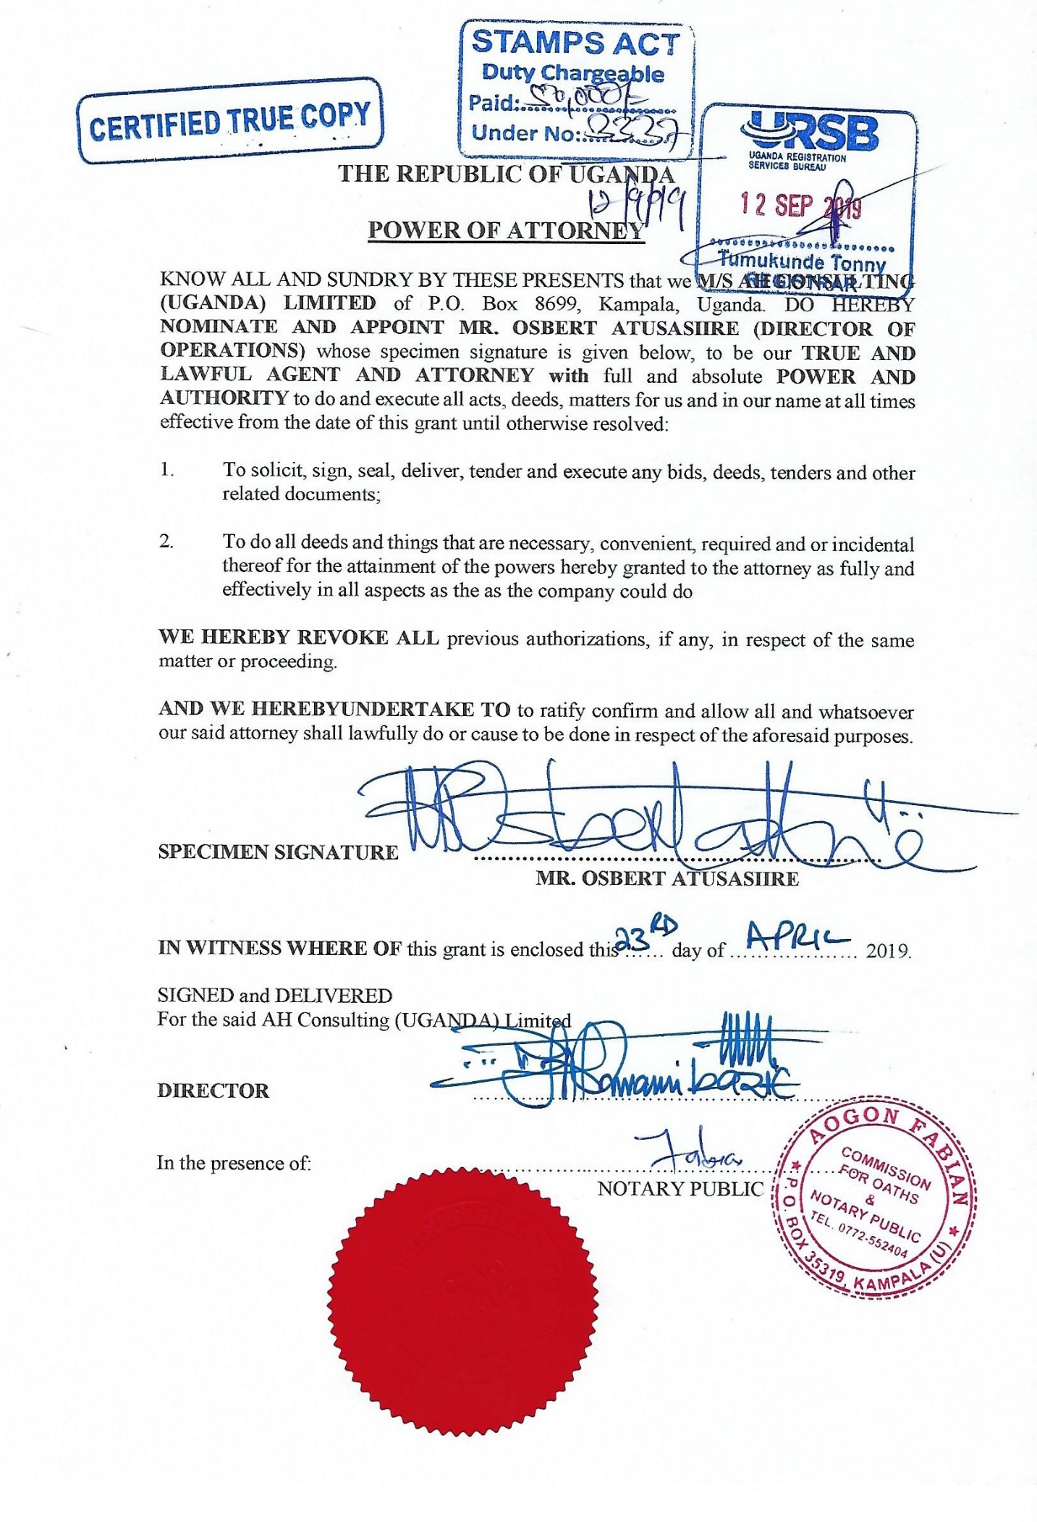

# Our Vision and Mission

**Vision of AH Consulting Limited**

Delivering World Class consulting service and products to our clients.

**Mission of AH Consulting Limited**

Growing profitably and sustainably, offering world class opportunities for our consultants and achieving stakeholder objectives.



# AH Consulting Short Profile

**Introduction:**

AH Consulting Ltd is a prominent consulting firm headquartered in Uganda, recognized for its exemplary track record in executing a wide array of consultancy assignments throughout the dynamic landscape of Sub-Saharan Africa. With an expansive portfolio of over 500 projects, AH Consulting Ltd has solidified its reputation as a reliable and innovative partner, dedicated to delivering comprehensive solutions that address complex challenges faced by governments, organizations, and institutions across the region.

**Our Core Competencies:**

Our firm's exceptional capabilities stem from a team of 50 dedicated professionals who collectively possess a diverse range of expertise. Our roster includes 10 seasoned management personnel and 4 specialized project managers, all of whom demonstrate mastery in several critical areas such as:

* **Financial Software Development:** Crafting tailored financial solutions that optimize efficiency and accuracy.
* **Data Engineering:** Harnessing the power of data for insightful decision-making and strategic planning.
* **Quantitative Finance Application Development:** Designing sophisticated models and frameworks for the evolving financial landscape.
* **IT Architecture Design:** Creating robust and scalable IT infrastructures aligned with organizational goals.
* **Cybersecurity:** Ensuring data and systems are protected against emerging threats.
* **Database Management:** Maximizing data storage and accessibility for informed decision-making.
* **Regulatory Compliance:** Navigating complex regulatory landscapes with precision.
* **Business Process Re-engineering:** Transforming processes for enhanced efficiency and effectiveness.

**Proven Experience and Collaborations:**

AH Consulting Ltd has firmly established itself as a reliable partner for executing assignments funded by a prestigious array of donors and institutions. Our collaborative successes include projects supported by:

* **World Bank:** Delivering transformative solutions across diverse sectors to drive socio-economic growth.
* **GIZ:** Partnering for impactful projects that promote sustainable development.
* **African Development Bank (AfDB):** Advancing economic progress and innovation across the region.
* **European Union (EU):** Catalyzing positive change through comprehensive consultancy.
* **Millennium Challenge Corporation (MCC):** Enhancing efficiency and accountability through strategic interventions.
* **Bill and Melinda Gates Foundation:** Enabling impactful solutions for pressing challenges.
* **Governments Across Sub-Saharan Africa:** Collaborating to achieve national development agendas.

**Select Project Highlights:**

Our illustrious portfolio showcases an assortment of transformative projects, underscoring our adaptability and proficiency across diverse industries. Noteworthy examples include:

* **Cross-Border Electronic Cargo Tracking Systems:** Streamlining trade and logistics for enhanced economic integration.
* **Integrated Agricultural Information Platforms:** Catalyzing data-driven decision-making for sustainable agriculture.
* **Management Information Systems for Financial Sectors:** Empowering institutions with robust tools for strategic financial management.
* **Integrated Financial Management Systems (IFMIS) Rollouts:** Ensuring effective financial management for governments and organizations.
* **E-Procurement Systems:** Enhancing transparency and efficiency in procurement processes.

**Client-Centric Approach:**

AH Consulting Ltd stands as a beacon of client-centricity, dedicating itself to devising customized solutions that align with the unique challenges and aspirations of Sub-Saharan Africa. Our consultants possess an intimate understanding of the region's intricacies, allowing us to seamlessly integrate global best practices with local insights.

Our commitment to empowering Sub-Saharan Africa through strategic consultancy positions AH Consulting Ltd as a trusted partner in catalyzing positive change, fostering sustainable growth, and transforming futures.



The following are our organizational arrangements:

1. **Organizational Structure**

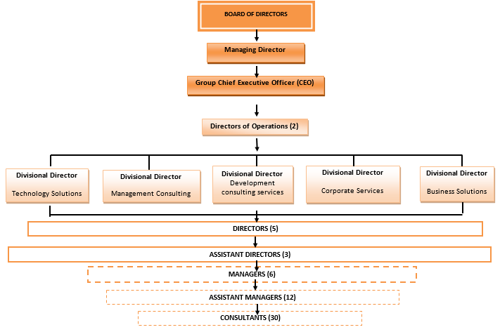

# About AH Consulting

# A. Number of years in offering services/business

AH Consulting has **20 years’ of experience** having commenced operations in June 2004.

# B. Organizational Profile

****AH Consulting (AHC) is an African Consulting Firm providing consulting services to the Public Sector and Development Agencies, and the Private Sector. AHC was formed in June 2004 and has since grown to a substantial staff compliment of over 120 consultants both local and international, with a varied range of skilled expertise to deliver results to clients. Our specific emphasis is on the provision of management and technology consulting services to the public sector and related clients focusing on advisory services in digital transformation.

**Continental Consulting Capabilities**

AHC is an Africa wide value-based Consulting Firm providing information systems and technology consulting and digitalization services from development of system concepts to project commissioning including design, procurement, project management, contracting, supervision, quality assurance and technical audits. We have undertaken projects of similar nature and complexity in Uganda, Kenya, Tanzania, Rwanda, Ethiopia, South Sudan, Burundi, Malawi, Zambia, Angola, Mozambique, Swaziland, Djibouti, Somalia, South Africa, Somaliland, Puntland, Mali, Burkina Faso, Gambia, Sierra Leone, Liberia, Ghana, Nigeria, UK and the USA.

**Key Strengths**

Our key strengths comprise the following:

* **Proven Track Record:** With over two decades of experience since 2004, our firm has demonstrated a consistent ability to deliver successful projects. This extensive track record showcases your reliability and competence in handling complex digitalization initiatives.
* **Public Sector Domain Experience:** More than 75% of our information systems consulting and digitalization projects have been in the public sector. This has given us domain knowledge and intricacies in the implementation of digital oriented projects. Some of the project have been in automation of complex environments with difficult change management initiatives. Others have been time constrained projects that require effective delivery on time and in budget. AHC has delivered on these complex digitalization projects.
* **Extensive Regional Experience:** AHC’s firm experiences across the continent provides valuable insights into regional nuances, regulatory frameworks, and cultural considerations. This ensures that solutions are tailored to the specific needs of the government entity, enhancing effectiveness and minimizing implementation risks. It is this regional knowledge that makes it possible for clients to rely on us for digital advisory services.
* **Comprehensive Service Offering:** From scoping and design to project management, supervision, and quality assurance, AHC offers an end-to-end suite of digital consulting services. This integrated approach streamlines project execution, fosters accountability, and ensures seamless coordination throughout the digitization process.
* **Vendor Neutrality:** AHC is more of a client-side advisor and less of a vendor-side advisor. Due to continued focus in providing digital advisory services to clients seeking to acquire and implement digital solutions, AHC is vendor neutral relying on understanding client needs and requirements to determine the best application and ICT technologies to recommend to clients. This vendor neutrality has made it possible for clients to continue to rely on us for impartial advice on the best technologies that fit their digitalization needs.
* **Technical Expertise:** Our team comprises seasoned professionals with deep expertise in digitization technologies and methodologies. This expertise enables our firm to leverage cutting-edge tools and best practices, driving innovation and efficiency in system modernization efforts. With changes in digital trends, our team now incorporates skilled professionals with expertise in artificial intelligence, machine learning and self-managed complex computing environments.
* **Commitment to Quality:** Quality assurance is a cornerstone of our firm's operations. By implementing rigorous quality control measures and adhering to industry standards, we have consistently delivered high-quality digital projects that meet or exceed client expectations. This commitment to excellence instills confidence in our clients, the reason they continuously turn to us for delivery of time and budget constrained projects that require value-added solutions and high quality results.
* **Client-Centric Approach:** Our firm prioritizes achieving client needs and attaining client satisfaction by fostering open communication, understanding client objectives, and tailoring solutions to address their specific needs and challenges. This client-centric approach ensures alignment with the client and projects goals and fosters long-term partnerships based on trust and mutual success.
* **Innovative Solutions:** AHC firm is renowned for its ability to innovate and adapt to evolving technological landscapes in the digital space. By staying abreast of emerging trends and leveraging innovative approaches, we offer clients transformative solutions that enhance operational efficiency, service delivery, and citizen engagement.

**Our Service Offering in the Digitalisation Space**

The diagram below shows our service offering in the digitalisation space:

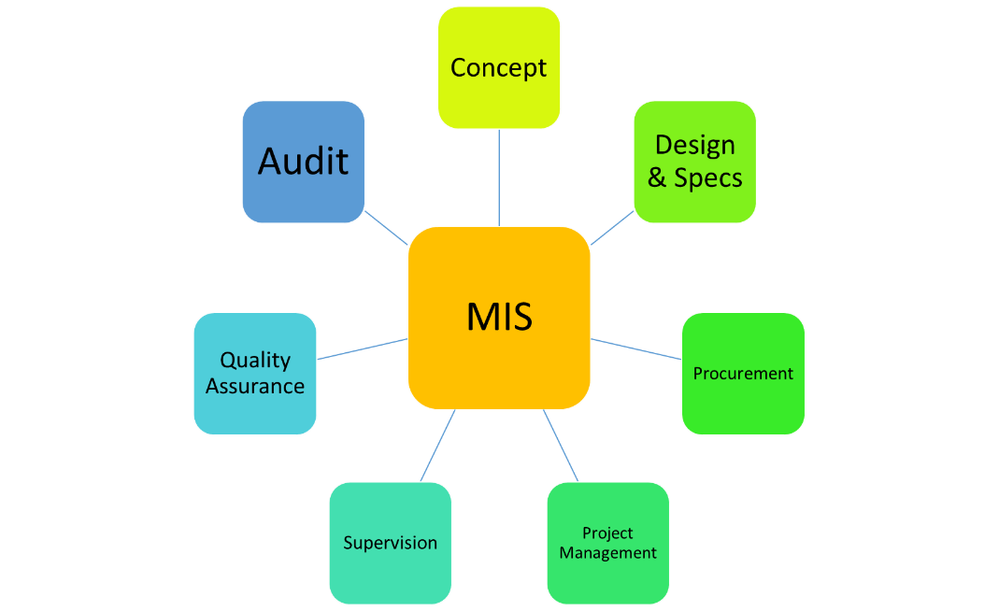

**Selected Digital Transformation Experiences**

| **COUNTRY** | **ASSIGNMENT** |
| --- | --- |
| Liberia | **Digitisation of Liberia County Service Centers (CSC) ICT infrastructure:**   * Consultancy Service for a Firm to Develop Requirements, Specifications and Bidding Document for improving the County Service Centers (CSC) ICT infrastructure |
| Sierra Leone | **Digitisation of Sierra Leone e-Cabinet system:**   * Technical Assistance to support the development of e-Cabinet blueprint with technical specifications and design for implementation of e-Cabinet system in Sierra Leone * Procurement technical advisory services for the selection of a vendor for the turnkey implementation of the planned systems. |
| Malawi | **Digitisation of Electricity Generation Company of Malawi Ltd (EGENCO):**   * Design and development of specifications for the procurement of an Integrated Management Information System including ERP, HR, logistics, Maintenance, GIS, Customer Services, and integrations with Generation Control and SCADA systems. * Procurement technical advisory services for the selection of a vendor for the turnkey implementation of the planned systems. * Supervision and quality assurance of EGENCO and vendor implementation services. |
| Uganda | **Petroleum Authority of Uganda (PAU):**   * Design of Business Continuity Systems and Development of Specifications for a Tier 3 Data Centre for Real Time Monitoring Centre for Oil and Gas production operations. |
| Kenya | **Digitisation of NEMA Kenya under the Kenya Petroleum Technical Assistance Project:**   * Design of an Integrated Environment Management Systems and ERP for the Petroleum Industry and NEMA. * Development of specifications for the procurement of the vendor for supply, installation, implementation, commissioning and support of the IEMIS. |
| Malawi | **Digitisation of Electricity Supply Corporation of Malawi (ESCOM) funded by Millennium Challenge Account (MCA) Malawi:**   * Development of Specifications for The Electricity Supply Corporation of Malawi (ESCOM) Management Information System (MIS). * Consultancy Services for the Project Management Supervision and Quality Assurance of the Electricity Management Information Systems (EMIS – including SCADA, Financial, HR, Billing). |
| Uganda | **Digitisation of China National Offshore Oil Company (CNOOC) Uganda Ltd Human Capital Management Systems:**   * Supply, Training, Implementation and Support of the Competency Management System Rollout – Phase 1 in association with IHRDC. |
| Sierra Leone | **Digital Upgrade of the Local Government IFMIS in Sierra Leone:**   * Independent Assessment of the Central government Integrated Financial Management Information System (IFMIS). * Development of the 5-year IFMIS strategy for the enhancement of the IFMIS functions. * Cost Benefit Analysis report of hosting options for e-procurement system in Sierra Leone. * Business Process Review, design and development of specifications for the procurement of a Local Government IFMIS for the Government of Sierra Leone (upgrade to PFM Smart Applications). * Supervision and quality assurance of the Local Government IFMIS for Sierra Leone. |
| Malawi, Rwanda, Uganda, Liberia, Sierra Leone, Ghana | **Vulnerability Assessment and Penetration Testing (VAPT)**   * Vulnerability Assessment and Penetration testing of the SAP IFMIS Application and ICT Environment in the AGD under GIZ Malawi. * Vulnerability Assessment and Penetration testing of the National Bankf Rwanda as a pre-condition for the implementation of the payment systems (ACH, RTGS, and CSD). * Security Audit of Uganda Revenue Authority systems. * VAPT for IFMIS for Liberia, Sierra Leone and Ghana. |
| Lesotho | **Private Sector Competitiveness Modernization Project (PSCP):**   * Digital assessment of the Construction Permit Systems for Lesotho under Maseru City Council. |
| Kenya, Somaliland and Ethiopia | **Digitisation of the Somaliland Electronic cargo Tracking Systems under Trademark East Africa (TMEA):**   * Feasibility Study for the design and Implementation of the Cross Border Electronic Cargo Tracking System (eCTS) and Covid-19 Digital Surveillance Tracker for the Berbera Corridor and development of specifications for the supply, implementation and commissioning of the eCTS. |
| Kenya, Djibouti and Ethiopia | **Digitisation of the Djibouti Electronic cargo Tracking Systems under Trademark East Africa (TMEA):**   * Requirements Gathering, Analysis, Design, Baseline Collection and Quality Management Electronic Cargo Tracking System for the proposed Ethiopia – Djibouti Corridor. |
| Ethiopia | **Digital Enhancement of Data Centre Infrastructure for Ethiopian Roads Authority (ERA):**   * Supervision of Ethiopian Roads Authority (ERA) and Ministry of Transport (MoT) Data Center infrastructure and Unified Communication and Collaboration Solutions Project funded by World Bank. |
| Lesotho | **Digitisation of the Human Resource Management Systems and Payroll for the Ministry of Public Service/Ministry of Finance:**   * Audit of Human Resources Information System for the Kingdom of Lesotho. * Development of the HRM/Payroll digitisation strategy and roadmap. * Development of specifications for vendor procurement for the supply, installation, implementation and commissioning of the HRMIS/Payroll. * Supervision and project management of the Oracle HRMIS and Payroll implementation activities. |
| Liberia | **Technical Audit of Liberia IFMIS under Ministry of Finance and Development Planning:**   * Technical audit of the Liberia Integrated Financial Management Information System and review of the rollout strategies for the rest of the Government MDAs. |
| Ethiopia | **Digitisation of the Urban Lands filling systems for the Ministry of Urban Development and Construction, Urban Revenue Enhancement, Fund Mobilization and Finance Bureau:**   * Design of the ULGDP II and UIIDP Management Information System (MIS) that supports the program’s operations at the federal, regional and ULGs levels (44 cities). * Development of the digital land filing systems for the ULGDPII and UIIDP. |
| Ghana | **Digitisation of the Government of Ghana IFMIS infrastructure ecosystem:**   * Development of Human Resource Requirement Analysis and tender documents to procure the services of an implementation partner for oracle-based Human Resources Management Information System. * Technical Assessment of Integrated Financial Management Information Systems (Financials, Budget Payroll and HRMIS). * Supervision and quality assurance of GIFMIS implementation activities. * Consultancy services to develop the terms of reference (TORS) /specifications for implementation of the GIFMIS technical assessment recommendations. * Preparation of a 5-Year GIFMIS Strategy. * Consultancy services for GIFMIS 3-month transitional support. |
| Ethiopia | **Ministry of Finance and Economic Cooperation (MoFEC):**   * Supervision and Quality Assurance for the Oracle EBS Rollout Implementation of the service for Integrated Financial Management System (IFMIS) to 100 MDAs and 12,000 users. |
| Malawi | **Reserve Bank of Malawi (RBM):**   * Needs Assessment and requirement specification development for the Integrated Management Information System (IMIS) using Business Intelligence Systems and Data Warehousing for Executive Reporting Systems. * Design a Transaction Processing Hub for the Microfinance and Financial Cooperatives Industry in Malawi and development of associated functional and technical spefications. |
| Malawi | **Digitisation of Export Development Fund of Malawi (EDF):**   * Business Process Review, ICT Needs Assessment and requirement specifications development for the procurement of the EDF management information systems comprising of ERP and core banking solutions. |
| Rwanda | **Digtisation of the Institute of Certified Public Accountants of Rwanda (ICPAR) under the Ministry of Finance and Economic Planning, Rwanda**:   * Development of a digital ICT blueprint and policy framework for Institute of Public Accountants in Rwanda ICPAR. |
| Kenya | **ICT Authority Kenya:**   * Quality Assurance for the Implementation of the Government of Kenya Integrated Financial Management Information System (IFMIS) |
| Uganda | **Office of the Auditor General, OAG:**   * Development of IT Audit Manual, Delivery of IT Audit Training, and joint performance of 2 IT Audits. |
| Rwanda | **Ministry of Finance and Economic Planning:**   * Quality Assurance of for SMARTFMS of the IFMIS Solution of the Government of Rwanda. |
| Ethiopia | **Digital Transformation of the African Union Commission under the Institutional Transformation Project**   * Design of the IFMIS comprising the financial, human resource, medical, procurement and internal audit systems. * Project management of the IFMIS implementation for the IFMIS. |
| Ivory Coast | **Post-Covid Digital Operating Model for the African Development Bank (AfDB):**   * Diagnostic Analysis and Design of a new Post Covid-19 Operating Model of the African Development Bank. |
| Rwanda | **Digitisation of the Rwanda e-Government systems:**   * Technical Support and procurement activities of the e-government project. |
| Malawi | **Ministry of Finance/FIMTAP Project:**   * Peer Review and Impact Assessment of the Integrated Financial Management System Implementation. |
| Malawi | **IMF/EASTAFRITAC:**   * Design and implementation of fiscal reporting systems based on defined IMF in-year fiscal reports. |
| Uganda | **Ministry of Finance, Planning and Economic Development:**   * Rationalization of the Medium-Term Expenditure Framework (MTEF) Segment (in the Chart of Accounts) on the Integrated Financial Management System (IFMS). |
| Uganda | **Housing Finance Company Ltd:**   * Design of the Bidding documents and Procurement management for a Banking Management Information System (BMIS) comprising of preparation of bidding documents for Procurement Management, Development of Negotiation Protocol and Contract preparation and effectiveness. |
| Uganda | **Directorate of Economic Affairs and Research, Office of the President (DEAR):**  Consultancy Services to conduct a functional review, develop a strategic plan organizational structure review, job descriptions and conduct of a HR needs assessment. |
| Rwanda | **Rwandair:**  Development of the functional requirement specifications for intranet and extranet specifications. |
| Uganda | **Uganda Development Bank Ltd:**  Develop an Information, Communication & Business Technology Manual for Uganda Development Bank Ltd. |

# Our Understanding of the Assignment

AH Consulting understands this assignment as a transformative project aimed at optimizing public administration human resources management through a structured approach that involves reengineering, comprehensive analysis, and digitization. Our objective is to modernize HR processes, making them more efficient, transparent, and responsive to the needs of public sector stakeholders. This initiative is pivotal for enhancing service delivery, promoting sustainable practices, and facilitating improved decision-making through data-driven strategies.

**Proposed Approach and Methodology**

Our approach begins with an in-depth analysis of current HR management processes to identify strengths, weaknesses, and areas for enhancement. This initial diagnostic phase involves stakeholder consultations, process mapping, and gap analyses to ensure a clear understanding of existing structures and workflows. The findings from this phase will inform the design of tailored reengineering strategies that align with best practices and sector-specific requirements.

Once the current state is assessed, we will employ a structured reengineering approach to streamline processes, eliminate inefficiencies, and ensure alignment with strategic objectives. This phase will include process redesign workshops, collaboration with key stakeholders, and scenario modeling to propose the most effective process changes.

**Strategies for Achieving Project Objectives**

1. **Stakeholder Engagement and Collaboration**: We prioritize close collaboration with public administration leaders, HR professionals, and other relevant stakeholders to capture insights and gain buy-in. Regular workshops and feedback loops will ensure continuous input throughout the reengineering and digitization phases.
2. **Adoption of Best Practices and Benchmarking**: Our methodology integrates global best practices and relevant benchmarks, drawing from successful case studies in public sector transformation. This allows us to tailor our strategies to fit the local context while aligning with international standards.
3. **Technology Integration**: A significant part of our approach involves identifying and integrating state-of-the-art digital tools and platforms that support automation, data analytics, and streamlined HR operations. This will include the design and implementation of user-friendly digital systems and interfaces that facilitate real-time access to HR data and improved management capabilities.
4. **Capacity Building and Training**: We recognize that the sustainability of process improvements depends on the competence of the people who operate them. Thus, our strategy includes targeted training sessions, knowledge transfer, and capacity-building initiatives designed to empower HR staff with the skills needed to manage and utilize new systems effectively.
5. **Change Management Framework**: To ensure seamless adoption, we will incorporate a robust change management plan that includes communication strategies, leadership engagement, and support systems to ease the transition and promote a culture of continuous improvement.

AH Consulting’s approach is designed to deliver a transformative impact by reengineering public administration HR processes, integrating advanced digitization strategies, and building a foundation for long-term operational excellence. Our methodology is evidence-based and adaptable, focused on achieving sustainable change that enhances productivity and service quality. By combining our in-depth knowledge, extensive experience, and strategic methodologies, we are well-positioned to achieve the project's objectives and drive meaningful change in public administration HR management.

# Experiences in Digitization of Human Resources Management Processes

AH Consulting Ltd has been at the forefront of delivering consultancy services across Africa. We have partnered with government public sector institutions and various development partners (donors) to successfully implement significant consulting projects throughout the continent. Our expertise includes providing technical assistance for reengineering, analysis, and digitization of public administration human resources management processes, as well as other digital transformation initiatives. Our team possesses extensive experience in assignments of a similar nature and complexity. Below is a summary of relevant assignments and experiences with private and public sector clients, demonstrating our qualifications to execute the tasks outlined in this assignment.

**Experiences in Digitization of Payroll, HR, and Pensions Processes**

The assignments in the table below demonstrate our rich experience in the Digitization of Payroll, HR, and Pensions Processes for Private and Public sector Institutions across Africa. Specifically, in this area the assignments we have undertaken entail the following among others:

| **Period** | **Assignment** | **Client** | **Contract Value** | **Role** |
| --- | --- | --- | --- | --- |
| 1ST Nov 2012 To 1st March 2013 | **Developing HR Requirement Analysis And Tender Documents To Procure The Services Of An Implementation Partner For Oracle-Based Human Resources Management Information System**  AH Consulting Was Contracted By The Controller And Accountant General’s Department Of The Ministry Of Finance And Economic Planning For This Assignment In Ghana.  **Objective of the assignment**  The objective of this consultancy assignment is to help the government make an informed decision on the type of human resource database system which is appropriate for evidence-based decision making.  **The Scope of the assignment was to produce the following deliverables:**   1. **White paper and a presentation on Position Management:**   The consultants will partner with the government’s proposed working group to:   * Collect data and review current state (process, systems and data); * Conduct 8-10 in-person or group sessions with key stakeholders to understand objectives and key challenges; these sessions will also involve; * Share best practice knowledge from collective experience regarding Organization Design, and use of Position Management in governments; * Partner with the PSC and key stakeholders to develop a **white paper** based on information gathered above and outline findings and provide alternatives; * Recommend solutions for ensuring establishment controls that meet the objectives, not over-complicated and feasible to maintain over the long run; and * Make a presentation to the Steering Committee on the key points of the white paper to facilitate policy decision.  1. **Requirements analysis for HRMIS:**   The consultants will develop requirements analysis document for the HRMIS system. This document will reflect the current requirements of the users, consistent with standard Oracle HRMIS Release 12 functionalities to the extent possible. Requirements which are inconsistent with the standard processes will only be supported if they pertain to a legislative policy decision or there is a compelling reason as determined by a group specifically nominated by PSC and key stakeholders to determine if deviations from standards is needed. This control procedure is an important step that will be instituted by the PSC to ensure standard and consistency of process and data management. **Key aspects of the document, amongst others, will be:**   * Master list of HR processes for HR Core Modules; * Functional requirements for each of these processes; * Security, roles and authorizations; * Workflow for data initiation, update, approval and processing in payroll, based on Standard Operating Procedures for HR Master Data Maintenance to be developed by the consultants as part of this document. The SOP will be updated during the implementation; * Reporting requirements for various stakeholders like PSC, MDAs, CAGD etc; * Integration with Financials/General Ledger; and * Volumetrics of HRMIS like number of employees, cost centres, organizations, bank accounts, positions, number of users, organizations where system will be rolled out for direct access to central staff of MDAs and MMDAs, etc, to help the bidders realistically assess the level of effort required to complete the work.  1. **Procurement documents and evaluation support:**  * The consultants will prepare bidding documents for competitive procurement of implementation services partner for Oracle-based HRMIS. Bidding documents will be based on templates provided under the World Bank procurement guidelines. The key input of the consultants, amongst others, will be the evaluation criteria and scoring methodology to evaluate the proposals. * The consultants will also prepare the evaluation matrix based on bid responses and support the procurement team and the evaluation committee in activities like pre-bid conference (if it is designed in the procurement process), reference checks, final evaluation report, clarifications, award negotiations for the final contract. | Controller And Accountant General’s Department Of The Ministry Of Finance And Economic Planning.  Accra  Ghana | US$ 199,600 | Sole Consultant |
| October 2019 – December 2019 | **Assignment Name:** Consulting Services for technical assistance on auditing of HRMIS system  **Narrative Description of project:** AH Consulting was contracted by Public Finance Management Reform Secretariat Ministry of Finance to enhance the integrity and performance of civil and teaching services through massive overhaul of establishment management machinery and revamping of human resources business processes.  **Description of Actual Services Provided by our Staff:**  The assignment involved the following:   * Improving the management of Establishment Registry (ER), as well as the quality and * Review contractual agreements relating to the HRMIS; * Schedule and conduct detailed interviews with stakeholders; * Analyze system impact on the business processes; * Establish system support strategy; * Assess of system functional and interface capabilities; * Undertake database analyses; * Assess the logical design and ICT system architecture; * Hardware assessment and utilization; * Review the Architectural framework; * Assess internal controls effectiveness; * Review the adequacy of capacity building and training for internal technical teams; * Recommend Systems roll-out plan; * Reviewing the cost benefit analysis of the investment made; and * Preparation of bi-weekly progress reports among others. | Public Finance Management Reform Secretariat, Ministry of Finance.  Lesotho  **Client’s contact person for the assignment:**  Procurement and disposal unit Public Finance Management Reform Secretariat,  Ministry of Finance. [lsopfm@gmail.com](mailto:lsopfm@gmail.com) | USD 159,273 | Sole Consultant. |
| March 2020 to November 2021 | **Assignment Name: Consultancy services to undertake Development of HRMIS Strategy, HRMIS Procurement Requirements, Data Cleaning, Project Management, Supervision and Quality Assurance.**  Narrative Description of project: AH Consulting was contracted by the Ministry to supervise and conduct quality assurance to ensure that the selected HRMIS vendor provides a solution that adheres to the set user and system requirements.  **Description of Actual Services Provided by our Staff:**  The assignment involved the following:  **Task 1: Preparation of the HRMIS Strategy**   * Development of HRMIS vision, mission, and goals for the GoL, taking into account the existing and planned activities. The vision will be developed from the strategic intentions for the HRMIS reform and its realisation across MDAs and all parties that require and/or provide information to the HRMIS through interface/integration. * Development of the HRMIS application strategy comprising of both vertical and horizontal deepening of HR business processes across all government entities, with a view to ensuring that GoL’s human resource management accounting processes are automated for use in all MDAs. * Development of the HRMIS integration and interface strategy that will enable HRMIS access to systems that are vital for operation of associated processes, and for HRMIS to provide information to other systems that are dependent on the HRMIS for transaction processing and reporting. * Development of the HRMIS ICT strategy, comprising of definitions with respect to hardware, outsourcing, wide area networks (WANs), Local Area Networks (LANs), location decisions, infrastructure, especially with key stakeholder institutions such as MoCST, Ministry of Finance, MDAs etc. * Development of a capacity building and training strategy, comprising of application, technical and soft skills strategies to ensure the effective transfer of knowledge from the vendors of systems and infrastructure components to enable GoL to effectively manage and monitor the HRMIS installations. The capacity building and training strategy will take into account the current and future absorptive capacity of GoL and will cover skills enhancements required for oversight agencies that are expected to provide assurance over the HRMIS implementation activities. * Inputs to HRMIS change management and communication strategy, working closely with the Ministry of Public Service Change Management Consultant. * Development of a HRMIS support and maintenance strategy that comprises objectives in preventive and reactive maintenance of HRMIS applications and ICT infrastructure, and the provision of support to application and technical users that directly interact with the GHRMIS. * Design of HRMIS governance structures that are consistent with the vision of the HRMIS and commensurate with international best practice with respect to development, implementation, and coordination of HRMIS activities. * Preparation of a high-level HRMIS roadmap with appropriate phases, and detailed plan with activities derived from the above HRMIS strategy. The roadmap and detailed plan shall to form the basis for coordination, tracking and monitoring of implementation progress. * Preparation of an annual results monitoring matrix that shall be used by PSMP and all stakeholders to monitor the progress of the HRMIS strategy implementation over the 5-year period.   **Task 2: HRMIS Procurement Technical Support**   * Preparation of a procurement strategy and plan for vendor selection taking into consideration the World Bank procurement requirements. * Preparation of the HRMIS Request for Proposal document based on the World Bank single stage bidding document for information systems. The RFP will include the Technical Requirements based on the HRMIS specifications and all the necessary bidding forms. * Assistance to GoL in the provision of bid clarifications and any addenda that may arise in the course of the procurement process. * Preparation of the Evaluation Criteria to be incorporated in the RFP for evaluation of bid responses. * Participate in the bid evaluation process and provide technical guidance in ensuring the adherence to the procurement requirements and specifications for the selection of the best evaluated bidder. * Preparation of a bid evaluation report together with the Project Office in accordance with World Bank standards and responding to any required clarifications on the report to obtain the required no objections. * Preparation of the negotiation protocol, supporting GoL in the negotiation processes and preparation of the minutes of negotiations ahead of contracting with the best evaluated bidder. * Supporting GoL to draft and finalise the contract for the HRMIS implementation and to obtain the required clearances ahead of contracting. * Ensuring completion of the necessary contract effectiveness conditions to enable the timely commencement of vendor implementation activities.   **Task 3: Data Cleaning Readiness Support**   * Working with the MoPS data cleaning team, preparation of a data cleaning strategy for the HR and payroll records ahead of migration into the new HRMIS, indicating the data quality standards. * Develop a project plan for data cleaning all HRMIS data record-by-record to indicating resource scheduling and activity scheduling, with assignment of GoL resources. * Review data requirements, existing data available compared to the requirements, and resources available for this exercise to ensure planned data cleaning activities are scheduled to coincide with the data migration activities of the HRMIS vendor. * Provide technical support to the MoPS team to develop data storage formats for all cleaned data in readiness for migration. * Provide data analysis capabilities to enable analysis of all cleaned data for any anomalies or errors ahead of migration. * Provide technical support to GoL internal audit department to undertake audit of the cleaned data ahead of data migration.   Prepare a data cleaning completion report. | Public Finance Management Reform Secretariat, Ministry of Finance,  Corner Kingsway and High Court Road  Government Complex, Finance House,  Third Floor, Room 3044 Maseru Lesotho | US$ 332,777.80 | Sole Consultant |
| Nov 2018 -Dec 2019 | **Consulting Services to Provide Technical Assistance for Establishment Management Control and Human Resources Management**  AH Consulting was contracted by Public Finance Management Reform Secretariat Ministry of Finance to enhance the integrity and performance of civil and teaching services through massive overhaul of establishment management machinery and revamping of human resources business processes.  **The assignment involved the following:**   * Improving the management of Establishment Registry (ER), as well as the quality and reliability of data * Align the ER with the registry (or directory) of all budget institutions defined as one of the key reference tables in IFMIS. * Ensure the interface requirements with other systems (IFMIS, National ID, and Banking Systems) works efficient. * Enhancement of human resources management to improve establishment management controls, processes and practices * Enhancement of human resources business processes in public service and teaching service * Enrichment of controls in personnel emoluments budgeting and expenditure * Development of Staffing Strategy * Human Resources Audit Assessment * Human Resource Information strategy, action plan * Developed HR continuity strategy * Designed and monitoring systems implemented   Developed new Human Resource Policies & protocols | Public Finance Management Reform Secretariat  Ministry of Finance.  Finance House, Government Complex, Maseru, Lesotho ; Phone. +266 2231 7978 | USD 375, 000 | Sole Consultant |
| Sept 2016-April 2018 | **Consultancy services to Support the Development of Human Resource Strategy, Performance Management System, Develop Training Needs Analysis and Training Plan.**  The main activities include;   * Hold Preliminary consultation meetings with relevant stakeholders * Development of HR Policy * Development of HR Strategy * Review and Update the Organisational Structure * Review and Update the Scheme of Service * Development of a Remuneration and Benefits Policy * Development of HR Management Operations Manual * Review and Update the Performance Management system in place. * Development of a wellness Policy * Conduct Training Needs Analysis. * Compile a consolidated final report with recommendations on the development and review of HR documents and on the TNA for close consideration and adoption by the OAG.   Delivery of documents and the report. | Office of the Auditor General Public Finance Management Secretariat,  Ministry of Finance, Finance House, Corner Kingsway and High Court Road  Office of the Auditor General Lesotho  4th Floor, Finance House,High Court Road,  PO Box 205 City, Maseru.  Lesotho  Phone, +266 22 314247. [www.auditgen-ls.org](http://www.auditgen-ls.org) | US$ 120,000 | Sole Consultant |



# Feasibility Studies/ System Design/ Requirements/ Specifications Development related experiences

The assignments in the table below demonstrate our rich experience in the Development of Information Systems Specifications for Private and Public sector Institutions across Africa. Specifically, in this area the assignments we have undertaken entail the following among others:

* *Gap Analysis*
* *Development of Functional and non- functional/ Technical Specifications;*
* *Business Process Reviews, Mapping, Analysis and Reengineering;*
* *Requirements analysis;*
* *Developing System Conceptual, Preliminary and Detailed Designs;*
* *Preparation of System acquisition Implementation plans;*
* *Preparation of Disaster recovery/Business Continuity plans;*
* *Preparation of Bidding Documents for Management Information Systems; and*
* *Development of MIS strategies.*
* *Feasibility Study & Detailed Design of Information Management Systems.*
* *Gap Analysis;*
* *Development of Functional and non- functional/ Technical Specifications;*
* *Requirements Gathering, Analysis, Design, Baseline Collection;*

| **#** | **Duration** | **Assignment name/& brief description of main deliverables/outputs** | **Name of Client & Country** | **Contract value/ Amount paid** | **Role** |
| --- | --- | --- | --- | --- | --- |
|  | 20 May 2021 – 31 August 2021 | **Feasibility Study on the Design and Implementation of the Cross Border Electronic Cargo Tracking System (eCTS) and Covid-19 Digital Surveillance Tracker for the Berbera Corridor**  AH Consulting was contracted by TradeMark East Africa to offer consultancy services to conduct a Feasibility Study on the Design and Implementation of the Cross Border Electronic Cargo Tracking System (eCTS) and Covid-19 Digital Surveillance Tracker for the Berbera Corridor. The main objective of the assignment was to assist the TMEA to determine the technicalities to establish and operationalize a cross-border electronic Cargo Tracking System (eCTS) and a Digital Surveillance Tracker (DTS) for managing truck driver compliance to COVID-19 heath measures.  **The assignment involved the following:**   * Carry out a situational analysis of the current situation as regards tracking of cargo along the Berbera corridor. This situational analysis will aim to identify and document the actors, their roles and points of intervention (for both public and private sector actors) along the corridor in the current context in the way cargo is handled today by the various actors with and will address technical issues (including the tracking methodology used of existing systems, if any, administrative and operational issues, costs, efficiency and efficacy issues; * Working with TMEA staff, the Customs Authority of the Ethiopian Ministry of Revenues and the relevant authorities in Somaliland, document the process of handling of transit cargo between the two territories from the perspective of how customs manages (and other participating agencies/actors) the risk of losing customs revenue associated with cargo dumping or loss; * Identify and document the current opportunities of improving the management of transit cargo by the various actors (both private and public) along the transit corridor; * Exhaustively document the technologies used today by the various actors (both private and public) in handling of Transit Cargo across border along the corridor, how these technologies support people and processes to execute their mandates and the existing and emerging gaps (and opportunities) of such technologies; * Assess and document the state of affairs in terms of accessibility, availability and cost of technological requirements such as internet, GPS coverage, GSM coverage (3G, 4G coverage) , power among other prerequisites needed to establish and operate a cross-border cargo tracking system, for customs and related purposes; * Identify and contextualize possible operationalization models and technology approaches for implementing a cross-border cargo tracking system from a role and responsibility perspective either as established in other places (e.g., the RECTS in the EAC) or unique to the Barbera corridor for customs and related purposes; * Propose feasible recommendations for the implementation and piloting of the eCTS along the Berbera Corridor; and   Working with the Ministries of Health in Somaliland and Ethiopia, document the current procedures used in facilitating cargo and driver movement along the corridor. Provide recommendations and opportunities of implementing technological solutions to ease the movement of cargo and drivers. | TradeMark East Africa,  Fidelity Insurance Centre,  P O Box 313 00606,  Nairobi, Kenya. | US$ 140,000 | Leader of Consortium (90%) |
|  | June 2021 – 31 December 2021 | **Consultancy Services for Requirements Gathering, Analysis, Design, Baseline Collection and Quality Management of the Electronic Cargo Tracking System for the Proposed Ethiopia – Djibouti Corridor.**  AH Consulting was contracted by TradeMark East Africa to offer Consultancy Services for Requirements Gathering, Analysis, Design, Baseline Collection and Quality Management of the Electronic Cargo Tracking System for the Proposed Ethiopia – Djibouti Corridor.  **The main objective of the assignment were:**   * Objective 1: Requirements Gathering and needs analysis. * Objective 2: System solution and operations design * Objective 3: Baseline Collection. * Objective 4: Quality Management of the System design, development and operationalization of ECTS.   **The assignment involved the following:**  **Objective 1: Requirements Gathering and needs analysis**   * To gather requirements and conduct needs analysis for the proposed Electronic Cargo Tracking System (ECTS) to ensure the system operates optimally to deliver the best services for all primary and secondary stakeholders. * This ensures that all aspects of how the ECTS will be designed and operate are documented in details. The detailed documentation will then be used in the solution development and operationalization.   **Objective 2: System solution and operations design**   * To propose the high level system and operations design of the system solution in relation to the expectations of all primary and secondary stakeholders and realities on the ground. * This ensures that all expectations of all primary (first line of users and beneficiaries of the proposed ECTS) and secondary (any other indirect party of interest of the ECTS)stakeholders and realities on the ground are not only considered but the solution is designed based on fit-for-purpose principle among others such as scalability etc.   **Objective 3: Baseline Collection**   * To collect baseline data and informant for the proposed ECTS based on specific measures (indicators) against the actual current Customs operations that will be impacted by the introduction of ECTS directly or indirectly. * Baseline data and informant collection is an essential exercise for establishing the start-point before the implementation of the ECTS initiative. The baseline data and information will be revisited the implantation of the ECTS to determine the impact of the intervention.   **Objective 4: Quality Management of the System design, development and operationalization of ECTS**  To subject the ECTS to Quality Control and Quality Management through the entire life cycle of system design, development and operationalization. This ensures that the ECTS is designed, developed and operationalized based on the best practices in Quality Management for systems solutions interventions. This will not only ensure that the solution deployed meets all the documented requirements/expectations but also takes into account important considerations for the operating environment, the future, etc. | TradeMark East Africa,  Fidelity Insurance Centre,  P O Box 313 00606,  Nairobi, Kenya. | US$ 100,000 | Sole Consultant |
|  | 3 months  March 2020 to March 2021 | **Requirements Gathering, Analysis and Design of an Integrated Agricultural Information Platform (AIP) / Agricultural Management Information System (AMIS) for the Sector**  ***Actual services provided by our staff;***  *Stakeholder Consultations & Validations:*   * Conducted extensive stakeholder interviews and workshops with key representatives from the Ministry of Agriculture Animal Industries and Fisheries, agricultural institutions, farmers' associations, and other relevant stakeholders to gather their insights, requirements, and feedback on the existing agricultural information management processes and the desired features of the Integrated Agricultural Information Platform (AIP). * Organized validation sessions and presentations to share the proposed design and functionalities of the AIP with stakeholders, seeking their input, suggestions, and validation to ensure alignment with their needs and expectations. * Engaged with agricultural experts, industry leaders, and technology providers to validate the best practices and emerging trends in agricultural information management and ensure that the design of the AIP incorporates relevant benchmarks and international standards.   ***Benchmarking & Best Practices:***   * Conducted a thorough benchmarking analysis of existing Agricultural Management Information Systems (AMIS) and similar integrated agricultural platforms globally to identify best practices, innovative features, and lessons learned that could be applied in the design of the AIP for the Ministry of Agriculture Animal Industries and Fisheries. * Researched and compared the business processes and data management practices of leading agricultural organizations and institutions in other countries to identify areas of improvement and potential models for effective data collection, analysis, and decision-making within the AIP. * Analyzed industry-specific standards and frameworks for agricultural information management, such as data interoperability, data security, and data sharing, to ensure that the AIP design aligns with these standards and promotes seamless integration with existing systems and data sources.   ***Gap Analysis:***   * Conducted a comprehensive analysis of the current agricultural information management processes within the Ministry of Agriculture Animal Industries and Fisheries, identifying gaps, redundancies, and inefficiencies in data collection, storage, analysis, and dissemination. * Evaluated the existing technology infrastructure and information systems utilized by the Ministry, identifying gaps and limitations that hinder the effective management and utilization of agricultural data. * Assessed the capacity and skill sets of the ministry's staff members involved in agricultural information management, identifying gaps in knowledge, training needs, and organizational structure that may impede the successful implementation and adoption of the Integrated Agricultural Information Platform (AIP).   ***Other tasks completed***   * Review, document and provide an analysis on all existing literature, data and information processing and delivery methods, systems and procedures within MAAIF. * Study the existing and planned sector intervention and establish a relationship between them and the planned installation. * Develop an analysis of the infrastructural and technical skills requirements that need to be achieved in MAAIF, to increase internal individual organisational efficiency in support of the development informational requirements for the farmers while allowing interoperability between the existing and planned information systems. * Identify appropriate ICT solutions that will strengthen research, extension/advisory and farmer relationships through efficient information sharing and knowledge management. * Develop detailed technical requirements for the appropriate ICT infrastructure systems that will support implementation of identified ICT solutions in support of information sharing and knowledge management within MAAIF.   Study the objectives of the Regional Communications Infrastructure Programme being implemented under the National Information Technology Authority (NITA-U) to establish common infrastructure and systems which can be integrated for efficiency. | Ministry of Agriculture Animal Industries and Fisheries, Uganda | **US$ 155,250** | Sole Consultant |
|  | February 2023 – September 2023 | **Consulting Firm To Conduct Business Process Review (BPR) For Implementation Of PFM Smart Application For The Accountable Governance For Basic Service Delivery Project**  The objective of this assignment is to conduct a comprehensive business process review and assist the MoF in validation process. The main deliverable will be a validated BPR report that will be used as a basis to develop and formulate technical and functional requirements along with systems specifications as warranted for the implementation of PFM Smart, the upgraded version of the existing Petra Financials in all local councils.  We will review the existing business processes (as-is) and information flow relating to the processing of financial transactions of local councils. The end-to-end transaction cycle within the existing Petra Financials can start from reviewing and documenting the laid down or existing (as-is) business processes for the local councils revenue collection, budget preparation functional areas, initiation of procurement activities by the local council/devolved sector - to the inspection of the related procured goods or services through to the expenditure payments processed accordingly for the delivery of the goods or services as per contractual agreement.  We will conduct a detailed and end-to-end review of the government’s information flows, functional processes along the related requirements for these functions. It is expected that all issues identified during this exercise are documented. Where needful, a redesign of the “as-is” or existing business processes around GFM shall be considered for the new PFM Smart implementation. It must be noted that the consultant may not be able to gain access to any documentation of the current business processes being supported by the deployed PFM Smart and so the Consultant equally, should be prepared to firstly conduct interviews of the business process owners and users in order to determine and then document the “as-is”. The documented “ás-is” should then form the baseline for the process review and any process reengineering effort as dictated and agreed by the government for this engagement. Specifically, the Consultant will be required to perform the following services:   * Examine the existing processes in order to document the business processes and information flows for PFM Smart transaction processing and identify any bottlenecks in the processes and information flows. * Conduct a review of the existing procedures and guidelines as stipulated statutorily in the PFM Law and Regulations for processing transactions in the course of executing the national budget. * Determine the average time for PFM Smart transaction processing by the local councils (online and offline). * Determine overall needs for systems documentation around design, implementation, and support of PFM Smart; examine the Configuration Blueprint along with the SRS – System Requirement Study for the existing Petra Financials deployment. * Prepare a BPR - Business Process Review document along with defining detailed functional requirements capturing functional areas and processes, information and data flows, related documents and forms, PFM Smart transaction types, and operational methods and procedures for PFM Smart operations across government.   The consultant is expected to engage in discussions with key stakeholders, local councils, Public Financial Management Reform Division, Fiscal Decentralization Division, Directorate of Financial Management Systems and Technology, Budget Bureau, Procurement Directorate, (Ministry of Finance), Accountant General’ Department, Ministry of Local Government and National Public Procurement Authority among others. | Project Fiduciary Management Unit-Ministry of Finance  Freetown  Sierra Leone  Attention: Alpha I. Sesay  E-mail: agbsdproject2022@gmail.com | USD57,460 | Sole Consultant |
|  | 5 months  November 2017 to April 2018 | **Consultancy Services for a Business Process Review of the Export Development Fund of Malawi**  *The assignment involved:*  *Stakeholder Consultations & Validations:*   * Conducted interviews and focus group discussions with key stakeholders from the Export Development Fund of Malawi, including staff members, management, and external partners, to gather their perspectives on current business processes, challenges, and opportunities for improvement. * Organized validation workshops and presentations to share the findings of the business process review with stakeholders and seek their input, feedback, and validation on proposed recommendations. * Engaged with representatives from relevant government agencies, trade associations, and industry experts to gather insights and validate the alignment of proposed business process improvements with industry standards and best practices.   *Benchmarking & Best Practices:*   * Conducted an in-depth analysis of business process frameworks, methodologies, and best practices in the export development industry globally to identify areas of improvement and potential benchmarks for the Export Development Fund of Malawi. * Researched and compared the business processes of similar organizations and export development funds in other countries to gather insights and identify best practices that could be applied to enhance the efficiency, effectiveness, and competitiveness of the Export Development Fund of Malawi. * Conducted a benchmarking analysis of performance indicators and key metrics related to export development and trade promotion, comparing the Fund's performance against industry benchmarks to identify gaps and areas for improvement.   *Gap Analysis:*   * Analyzed the existing business processes and workflows of the Export Development Fund of Malawi, identifying inefficiencies, bottlenecks, duplication of efforts, and areas of improvement in areas such as client onboarding, project evaluation, funding disbursement, and monitoring and evaluation. * Conducted a comprehensive review of the Fund's organizational structure, roles and responsibilities, and communication channels to identify gaps in coordination, decision-making, and information flow that may hinder the smooth operation of business processes. * Assessed the Fund's technology infrastructure, including its information systems, data management, and automation capabilities, identifying gaps and opportunities for leveraging technology to streamline processes, enhance data accuracy, and improve overall operational efficiency.   ***Other Tasks Involved***   * Analysing the existing workflows and processes within and among the divisions of EDF. * Re-designing existing processes to achieve breakthrough improvements in performance measures with specific recommendations of an appropriate banking solutions including enterprise resource planning (ERP), hardware, robust network, web and related organizational IT requirement. * Introducing end-to-end processes through system mediation eliminating the operational gaps. * Preparing requirement specifications, high level system architectural directions, work-flow processes, diagrams, configuration and implementation plans for integration existing systems together to form the seamless enterprise system infrastructure. This should include a detailed system requirement/software requirement study and comprehensive technical proposal for the recommended IT solution. * Preparing system architecture specification at enterprise level for required new components and modules with appropriate connectors, which will be identified during the system study. * Identifying skills gaps within and among the divisions of EDF and recommending appropriate required capacity building programme. * Preparing a comprehensive and structured business case for appropriate banking application software project detailing all benefits including return on investment (ROI). * Reviewing and preparing software acquisition and installation project implementation plan and charter. * Preparing a comprehensive disaster recovery and contingency plan. * Providing technological support if necessary, subsequent to the BRP including tender documentation, selecting vendors for an appropriate IT system, procuring recommended hardware and software. | Export Development Fund  Malawi | US$ 94,000 | Sole Consultant |
|  | 7 months  April 2019 - October 2019 | **Design & Development of an Environmental Information System for the Petroleum Sector (Including Business Process Re-Engineering) for National Environmental Management Authority, Kenya**  The purpose of this assignment was to study the current NEMA operations within its functions and licensing regime for the petroleum sector and design an Integrated Environmental and Social Information Management System which can process, store, disseminate and archive all relevant information emanating from NEMA operations in reference to its mandate in the petroleum sector.  **Actual services provided by our firm;**  **Phase i: Preparatory**   * Study the processes of submission of reports, receipt and dissemination of information in NEMA; * Facilitate workshops involving stakeholders and users to identify existing challenges, areas of improvement, and potential gaps. * Review NEMA's corporate strategic plan, policies, processes, and performance to gain insights into their short, medium, and long-term objectives. * Study the nature of information and records generated by NEMA and received from external sources, how the information is processed, stored and disseminated to intermediate and end users; * Study the current NEMA licensing and information management system with a view of identifying which processes will integrate with the current existing EMIS; * Undertake focused interviews with relevant target Officers in NEMA and other relevant Lead Agencies to analyze the information needs for internal users; * Study other ENVIS managed by other relevant Lead Agencies and evaluate options to synergize with the ESIMS applicable for NEMA based on information needs assessment; * Study the existing infrastructure to determine its adequacy to support the envisaged EMIS and make appropriate recommendations; * Develop an interim report containing findings from the tasks above. * Conduct an extensive benchmarking study of organizations operating in comparable environments. * Perform a comprehensive evaluation of NEMA's business processes and implement necessary reengineering aligned with corporate strategy and industry best practices.   **Phase ii: Design**   * Design an effective, efficient and simple to use mobile incident reporting system including required action and follow – up alert system. * Develop a comprehensive Enterprise Architecture for NEMA to support the achievement of its short, medium, and long-term objectives. * Draft a System Design Document and Functional Requirements document for proposed ESMIS * Make recommendations for required equipment and hardware. * Conduct a skills gap analysis and provide recommendations for an effective capacity building program for NEMA staff. * Document the existing IT, OT, and Telecommunication domains within NEMA. * Propose an implementation roadmap and estimate costs for the solutions identified throughout the assignment to address NEMA's requirements. * Compilation and forwarding of the final ESIMS design document for NEMA management approval. | National Environmental Management Authority, Kenya  Popo Road,South C, off Mombasa Road  P.O.BOX 67839  Nairobi  Kenya | US$ 345,600 | Sole Consultant |
|  | June 2023 todate | **Developing Technical Specifications of an Integrated Management Information System for Electricity generation Company (Malawi) Limited (EGENCO)**  AH, Consulting has been contracted to support Electricity generation Company (Malawi) Limited (EGENCO) with the development and acquisition of an MIS that will improve the efficiency and effectiveness of business processes in most of its operational areas, and address many of the current challenges. **The assignment involves:**   * Identify, confirm and document all existing operational procedures for all computerised and manual systems. * Facilitate workshops involving stakeholders and users to identify and analyze existing challenges, gaps, and potential areas for improvement. * Review existing operational procedures and recommend system improvement processes in line with best practices. * Conduct an benchmarking study of a of two successful power utility companies in Sub-Saharan Africa, operating in comparable environments. * Develop and recommend detailed specifications to lead to implementation of computerised systems for all identified manual systems. * Develop and recommend detailed specifications to lead to implementation of software systems of a robust IMIS. * Develop and recommend specifications for Database Management Systems to be deployed. * Develop and recommend detailed specifications for attendant hardware systems to be implemented. * Conduct an in-depth basic ICT training needs assessment for all employees and recommend a training regime that will address all identified gaps. * Identify and document capacity-building interventions to enable EGENCO employees acquire requisite skills and knowledge to be able to effectively and efficiently use the IMIS to be implemented. * Develop quality assurance methodology for system installation and testing during implementation of the IMIS. * Develop a comprehensive implementation roadmap outlining the necessary steps and timelines for executing the solutions identified in the assignment, along with providing cost estimates for the entire implementation process.   **EXPECTED DELIVERABLES**   * Detailed report on the Requirements Analysis undertaken. * Detailed Technical Specifications to be used as input for the procurement of both the software and hardware for the IMIS. * Report on Basic Computer Skills Training Needs Assessment and Capacity Building requirements. * Indicative Budgets for the successful implementation of an Integrated Management Information System for EGENCO. | The Chairperson  Internal Procurement & Disposal Committee  Electricity Generation Company (Malawi) Limited  No. 7 Victoria Avenue  Chayamba Building  PO Box 1567,  Blantyre,  Malawi | USD 181,500 | Sole Consultant |
|  | February 2023 todate | **Consultancy Services To Undertake A Business Impact Analysis (BIA) and Design Of A Business Continuity And Disaster Recovery Site (BCP/DRS).**  The design of the Business Continuity Plan and Disaster Recovery Site has several components and highly specialized petroleum data management systems and applications. The overall objective of the Consultancy is to: -   * Conduct a comprehensive analysis of the risks to Business Continuity of the PAU that could arise from failure of the Data Centre, and/or other ICT systems related to the work of the PAU. * Identify existing, and any additional options, for Business Continuity of the PAU, at the different levels of failure of the Data Centre and other ICT systems such as the data backups of the Real Time Monitoring Centre (RTMC). in the PAU. * Undertake a review of the current Primary Data Centre and design a turnkey ICT Disaster Recovery Site for Business Continuity and make any recommendations for the enhancement with the view to achieve International best practice and appropriate levels of High availability, Redundancy and Reliability for Authority’s Mission Critical Business Systems and functions and Compatibility with the Primary Data Centre. * Rank and cost the options identified, design and propose terms of reference for implementation of the most highly ranked option. The terms of reference proposed should enable putting in place, operating and maintaining of ICT Disaster Recovery and resulting business continuity of the PAU in line with international best practice. * Design and develop the Terms of Reference (ToRs), with estimated costs, for each option for the implementation and Set-up of a turnkey Disaster Recovery Site, with appropriate levels of High availability, redundancy and reliability for Authority’s Mission Critical Business Systems based on a cost-effective solution between the primary Data Centre and the remote DRS. The ToRs should also cost post implementation support of 2 years. * Conduct a comprehensive analysis, of the risks to business continuity of the PAU that could arise from failure of the Data Centre, and/or other ICT systems related to the work of the PAU and Identify existing or other options, for the Authority’s business continuity at the different levels of failure of the Data Centre and other ICT systems. In addition, conduct a Business Impact Analysis to establish the Recovery Time Objective (RTO) and Recovery Point Objective (RPO) for various business functions and systems. Rank the options identified above and recommend an option implementation. * Develop and document BCP and DRP policies and procedures that meet international industry best practices including High Availability, Redundancy, Resilience, Scalability and Compatibility with the Primary Data Centre with a BCP/DRP plan that is understandable, in digital format and easy to use, maintain, and update. * Prepare a design for the option selected by the PAU and prepare terms of reference for its development. The terms of reference proposed should enable the putting in place, operation and maintenance of an ICT Disaster Recovery site and system for the PAU together with the resulting Business Continuity in line with international best practice and appropriate levels of availability, Redundancy and Reliability for the Authority’s Mission Critical Business Systems and functions and Compatibility with the Primary Data Centre. * Review the country's legislation related to the development and implementation of an ICT Disaster Recovery which will result in Business Continuity, and make any recommendations for their enhancement, with a view to achieve international best practice in this regard. | Petroleum Authority of Uganda  Petroleum House, Plot 21-29, Johnston Road, Entebbe  P.O. Box 833 Entebbe, Uganda  +256 313 231 600| +256 417 896 600 | USD 270,000 | Sole Consultant |
|  | 8 months  November 2017 - July 2018 | **Integrated Management Information System (IMIS) Requirements Specification Consultancy**  AH Consulting was contracted by Reserve Bank of Malawi to offer consultancy services for Integrated Management Information System (IMIS) Requirements Specification. The main objective of the assignment was to carry out an analysis of the RBM’s technology landscape, compile requirements specification report and design documents for the solution.  *The assignment involved the following:*  **Stakeholder Consultations & Validations tasks:**   * Conducted stakeholder consultations with key personnel from the Reserve Bank of Malawi and other relevant stakeholders to gather input and insights on the requirements and expectations for the Integrated Management Information System (IMIS) project. * Facilitated validation sessions with stakeholders to ensure alignment and agreement on the identified requirements for the IMIS, addressing any concerns or discrepancies. * Collaborated with stakeholders to validate the proposed design and functionalities of the IMIS, seeking their input and feedback to ensure the system meets their specific needs and requirements.   **Benchmarking & Best Practices tasks:**   * Conducted a comprehensive benchmarking analysis of similar central banks or financial institutions to identify best practices in implementing and operating an effective and efficient integrated management information system. * Evaluated international standards and guidelines for integrated management information systems, comparing them with the requirements and goals of the Reserve Bank of Malawi to determine areas of alignment and areas for improvement. * Researched emerging technologies and trends in the field of integrated management information systems, providing insights and recommendations on innovative approaches and solutions that could be implemented by the Reserve Bank of Malawi to enhance their IMIS.   **Gap analysis tasks on the assignment**   * Conducted a thorough analysis of the existing payment systems and identified gaps and weaknesses in their business models, interoperability standards, and protocols. * Examined the current policy and governance framework related to the national switch and MFI transaction hub, assessing its effectiveness and making recommendations for improvements in areas such as scheme operating rules, interoperability regulations, and dispute management framework. * Assessed the security measures and infrastructure of the payment systems, analyzing potential risks, internal controls, and compliance frameworks to ensure the robustness and resilience of the systems against operational and cybersecurity threats.   **Preparation of Requirements Specification Report**   * A review report of the business processes that are relevant to the assignment in the RBM which including a list of identified areas for possible automation or streamlining for successful implementation of the IMIS; * An analysis of RBM’s current ICT systems taking into account the data and processing requirements of users and Management across various departments and the reporting approaches that have been adopted. The analysis included a list of identified gaps in areas of design and system architecture, configuration, security, technical integrity, operational reliability with respect to the IMIS. * An analysis of the key reports with a list of identified gaps in the reporting structure in order to add value to the decision-making processes. * A compilation of key management reports to be consolidated in a dashboard and isolate areas which are amenable to deployment of triggers to alert Management for immediate action. * An outline of priority areas (e.g. monetary policy, corporate governance) and related reports, critical for decision-making within the Bank. * An enhanced business case detailing the benefits RBM will attain from the project with respect to the proposed solution design. * A Project Viability Report detailing all aspects of project feasibility and implications according to PESTLE areas and their interrelations.   **Formulating Business and Technical Model of the IMIS**   * A Requirements Specification Report detailing all functional and non-functional requirements of the proposed system. * Proposed design of the system that takes into account all the data and processing requirements of all the stakeholders. * A profile of the proposed reporting format that will ensure seamless access by Management using modern technology tools and mobile devices such as tablets. * A recommended management structure and a comprehensive security architecture for the proposed IMIS. * Standards and requirements for integrating with existing internal systems. * A detail of infrastructure requirements and their feasibility for deployment within the RBM environment and any possible external sources. * A report on the current RBM operational environment and how it will need to adapt to the new IMIS. * A presentation of the IMIS design report to the Bank.   **Implementation Plan for the proposed design**   * Business and technical requirements that must be covered by the proposed solution. * A Deployment Plan for the proposed design that shall, amongst other things, include User Acceptance Testing and training of users. * A Risk Management Report indicating critical success factors for the implementation phase of the project, potential risk factors and proposed means/options to mitigate the risks. * Change management plan detailing all change management processes that will be required for the successful implementation of the proposed design. * A Human Resources Plan defining the technical qualifications, experience and skill-set of personnel required to implement the IMIS project, including their roles. * Provide a detailed Business Continuity Management and Disaster Recovery Plan for the proposed design. * Provide a data governance approach to be adopted so as to ensure adequate controls on the quality of the data. The approach is to ensure that the IMIS presents consistent and trusted data which the business users can rely upon to make critical decisions. * Provide a report on an ideal Information Architecture (IA) approach to be adopted by RBM to ease information access from the IMIS environment.   **Preparation of Bid Documents** | Reserve Bank of Malawi, Lilongwe, Malawi | US$ 248,550 | Sole Consultant |
|  | 26 months  January 2014 to March 2016 | **Consultancy Services for the Development of Specifications for The Electricity Supply Corporation of Malawi (ESCOM) Management Information System (MIS)**  AH, Consulting was contracted to support ESCOM with the development and acquisition of an MIS that will improve the efficiency and effectiveness of business processes in most of its operational areas, and address many of the current challenges.  *The assignment involved:*  **Stakeholder Consultations & Validations:**   * Engaged with key stakeholders including ESCOM management, employees, and relevant government agencies to gather their input, feedback, and requirements for the development of the MIS. * Conducted validation sessions with ESCOM stakeholders to ensure that the proposed specifications align with their needs and expectations. * Facilitated workshops and focus groups to gather insights from external stakeholders such as customers, suppliers, and industry experts to incorporate their perspectives into the MIS development process.   **Benchmarking & Best Practices:**   * Researched and analyzed industry-leading MIS systems and best practices in the energy sector to identify benchmarking standards and potential improvements for ESCOM's MIS. * Conducted comparative analysis of MIS implementations in similar organizations to understand their functionalities, performance, and efficiency, providing insights for the design and development of ESCOM's MIS. * Reviewed and assessed international standards and frameworks related to MIS development and implementation, ensuring that ESCOM's MIS aligns with global best practices and meets industry standards.   **Gap Analysis tasks undertaken:**   * Conducted an in-depth analysis of ESCOM's existing information systems and identified gaps in terms of functionality, data integration, reporting capabilities, and user experience. * Assessed the alignment of ESCOM's current MIS with its business objectives and strategic goals, identifying areas where the system fell short in supporting the organization's needs. * Evaluated the scalability, security, and performance of the current information systems, identifying potential weaknesses and recommending improvements to enhance the efficiency and effectiveness of ESCOM's MIS.   **Other Tasks**   * Analysing ESCOM’s current business processes and perform a User Needs Assessment that will provide a framework of principals for the consolidation effort and align ESCOM’s operations with industry best practices; * Performing a complete Software Requirements Analysis for an MIS which will address ESCOM’s current challenges as outlined above; * Developing a Software Requirements Specification (SRS) for the MIS; * Developing documentation to support the procurement of a follow-on consulting firm to develop and implement the MIS; * Participating in the procurement and selection process of the follow-on consulting firm; * Conducting a Training Needs Assessment (TNA) of all ESCOM staff (both permanent and on contract) with respect to basic computer skills including web usage; * Developing a training strategy and plan based on the TNA, profiling the different required training activities; * Preparing a data cleaning strategy, targeting all the key master data files currently in use; * Using an advanced data analysis tool, identifying the gaps, duplicates and missing records; * Developing a plan to address all the identified data gaps for ESCOM internal teams to correct the gaps; * Identifying the state of the Wide Area Network (WAN) and Local Area Networks (LAN’s) and the interconnectivity for each branch/site expected to use the E-MIS; * Identifying the associated needs for the WAN and LAN; * Preparing an overall WAN and LAN architecture integrating the Primary Data Centre (PDC) and the Disaster Recovery Site (DRS); and * Developing specifications to be included in the E-MIS Request for Proposals (RFP); * Carrying out a volumetric assessment to determine the transaction load volumes across the ESCOM systems; * Developing a system software and hardware component architecture appropriate for the application software to be specified; * Developing hardware specifications for the identified components; * Based on the application needs, developing the Primary Data Centre (PDC) and Disaster Recovery Site (DRS) architecture; * Determining the civil works that need to be undertaken to prepare the identified sites which include development of Bills of Quantities (BOQ’s) for the required civil works if any; and * Developing final specifications for the infrastructure implementation, indicating what will be implemented by ESCOM and what will be covered under the E-MIS implementation. | Millennium Challenge Account (MCA)-Malawi/ Millennium Challenge Corporation  Malawi | US$ 731,556 | Sole Consultant |
|  | March 2020 to November 2021 | **Assignment Name: Consultancy services to undertake Development of HRMIS Strategy, HRMIS Procurement Requirements, Data Cleaning, Project Management, Supervision and Quality Assurance.**  Narrative Description of project: AH Consulting was contracted by the Ministry to supervise and conduct quality assurance to ensure that the selected HRMIS vendor provides a solution that adheres to the set user and system requirements.  **Description of Actual Services Provided by our Staff:**  The assignment involved the following:  **Task 1: Preparation of the HRMIS Strategy**   * Development of HRMIS vision, mission, and goals for the GoL, taking into account the existing and planned activities. The vision will be developed from the strategic intentions for the HRMIS reform and its realisation across MDAs and all parties that require and/or provide information to the HRMIS through interface/integration. * Development of the HRMIS application strategy comprising of both vertical and horizontal deepening of HR business processes across all government entities, with a view to ensuring that GoL’s human resource management accounting processes are automated for use in all MDAs. * Development of the HRMIS integration and interface strategy that will enable HRMIS access to systems that are vital for operation of associated processes, and for HRMIS to provide information to other systems that are dependent on the HRMIS for transaction processing and reporting. * Development of the HRMIS ICT strategy, comprising of definitions with respect to hardware, outsourcing, wide area networks (WANs), Local Area Networks (LANs), location decisions, infrastructure, especially with key stakeholder institutions such as MoCST, Ministry of Finance, MDAs etc. * Development of a capacity building and training strategy, comprising of application, technical and soft skills strategies to ensure the effective transfer of knowledge from the vendors of systems and infrastructure components to enable GoL to effectively manage and monitor the HRMIS installations. The capacity building and training strategy will take into account the current and future absorptive capacity of GoL and will cover skills enhancements required for oversight agencies that are expected to provide assurance over the HRMIS implementation activities. * Inputs to HRMIS change management and communication strategy, working closely with the Ministry of Public Service Change Management Consultant. * Development of a HRMIS support and maintenance strategy that comprises objectives in preventive and reactive maintenance of HRMIS applications and ICT infrastructure, and the provision of support to application and technical users that directly interact with the GHRMIS. * Design of HRMIS governance structures that are consistent with the vision of the HRMIS and commensurate with international best practice with respect to development, implementation, and coordination of HRMIS activities. * Preparation of a high-level HRMIS roadmap with appropriate phases, and detailed plan with activities derived from the above HRMIS strategy. The roadmap and detailed plan shall to form the basis for coordination, tracking and monitoring of implementation progress. * Preparation of an annual results monitoring matrix that shall be used by PSMP and all stakeholders to monitor the progress of the HRMIS strategy implementation over the 5-year period.   **Task 2: HRMIS Procurement Technical Support**   * Preparation of a procurement strategy and plan for vendor selection taking into consideration the World Bank procurement requirements. * Preparation of the HRMIS Request for Proposal document based on the World Bank single stage bidding document for information systems. The RFP will include the Technical Requirements based on the HRMIS specifications and all the necessary bidding forms. * Assistance to GoL in the provision of bid clarifications and any addenda that may arise in the course of the procurement process. * Preparation of the Evaluation Criteria to be incorporated in the RFP for evaluation of bid responses. * Participate in the bid evaluation process and provide technical guidance in ensuring the adherence to the procurement requirements and specifications for the selection of the best evaluated bidder. * Preparation of a bid evaluation report together with the Project Office in accordance with World Bank standards and responding to any required clarifications on the report to obtain the required no objections. * Preparation of the negotiation protocol, supporting GoL in the negotiation processes and preparation of the minutes of negotiations ahead of contracting with the best evaluated bidder. * Supporting GoL to draft and finalise the contract for the HRMIS implementation and to obtain the required clearances ahead of contracting. * Ensuring completion of the necessary contract effectiveness conditions to enable the timely commencement of vendor implementation activities.   **Task 3: Data Cleaning Readiness Support**   * Working with the MoPS data cleaning team, preparation of a data cleaning strategy for the HR and payroll records ahead of migration into the new HRMIS, indicating the data quality standards. * Develop a project plan for data cleaning all HRMIS data record-by-record to indicating resource scheduling and activity scheduling, with assignment of GoL resources. * Review data requirements, existing data available compared to the requirements, and resources available for this exercise to ensure planned data cleaning activities are scheduled to coincide with the data migration activities of the HRMIS vendor. * Provide technical support to the MoPS team to develop data storage formats for all cleaned data in readiness for migration. * Provide data analysis capabilities to enable analysis of all cleaned data for any anomalies or errors ahead of migration. * Provide technical support to GoL internal audit department to undertake audit of the cleaned data ahead of data migration. * Prepare a data cleaning completion report. | Public Finance Management Reform Secretariat, Ministry of Finance,  Corner Kingsway and High Court Road  Government Complex, Finance House,  Third Floor, Room 3044 Maseru Lesotho | US$ 332,777.80 | Sole Consultant |
|  | 18 Months  December 2020 - Ongoing | **Consultancy Services for Upgrading and Reviewing of Comprehensive Computer Assisted Urban Land Holding and Basic Municipal Revenue Filing Management System and Data Base Formation in 18 cities in Oromia (4 Cities), and SNNPRS (4 Cities), Tigray (4 cities), Amhara (4 cites), Harari (1 city) and Dire Dawa city**  Activities Performed:   * Assess existing situations (existing IT and file management system, property data and revenue management practices, etc.)And know the existing system gap type and magnitude. * Upgrade ULHBRFMS and update the database by incorporating other regular municipal revenue items. * Scale up updated version of the system and updated database model to the rest of 18 ULGs. * Structure, organize, and integrate land holding and other municipal revenues (regularly collected revenue) files manually then scan basic documents as listed in the scope of this assignment, create electronic version of the files, from the scanned documents capture basic date and from a database. And make the files suitable for regularization, adjudication, and data migration into the CRPRS and CPTAS. * By in placing the above mentioned system and data base help:-   + - cities in their land holding and other file reorganization and pre-adjudication finalization effort;     - Land Administration/Management offices in handling the pre- adjudication required tasks on time with the required quality so that it will facilitate and expedite the adjudication and property right registration process;     - Land Administration/Management offices in rendering services related with land and buildings. Land titling, land transfer, building construction permit etc.     - Revalue administering offices in assessing and collecting revenues related with land and buildings. Land titling fee, Land permit annual fee, land lease revenue, land transfer fee and tax, building construction license fee, technical fee, construction materials license fee, etc.     - And serves as a history tracking subsystem for the Land Administration/Management offices and municipal revenue administering offices. | Ministry of urban development and Construction, Ethiopia | US$ 1,600,000 | Sole Consultant |
|  | 3 months  September 2015 to January 2016 | **Consulting Services to Design a Transaction Processing Hub for the Microfinance and Financial Cooperatives Industry in Malawi.**  AHC was contracted by the Reserve Bank of Malawi to design a Transaction Processing Hub for Microfinance Institutions and Financial Cooperatives that would improve, among other things, the processing efficiency of small-value transactions, microfinance core banking and mobile phone-based applications while allowing for down streaming of services such as credit referencing services and interconnection to national switch.  **The assignment involved the following tasks:**  **Stakeholder Consultations & Validations:**   * Conducted interviews and workshops with key stakeholders from the microfinance and financial cooperatives industry, Reserve Bank of Malawi, and relevant government agencies to understand their requirements and gather insights for the design of the transaction processing hub. * Organized validation sessions to present the proposed design of the transaction processing hub to stakeholders and incorporated their feedback and suggestions into the final design. * Engaged with representatives of microfinance institutions and financial cooperatives to gather their perspectives and ensure that the design of the transaction processing hub meets their specific needs and enhances their operational efficiency.   **Benchmarking & Best Practices:**   * Researched and analyzed transaction processing hubs and best practices in the microfinance industry, both domestically and internationally, to identify benchmarking standards and gather insights for the design of a robust and efficient system. * Conducted comparative analysis of existing transaction processing hubs in similar industries and countries to understand their functionalities, scalability, and technological advancements, providing valuable inputs for the design of the hub for the microfinance and financial cooperatives industry in Malawi. * Reviewed industry standards, regulations, and frameworks related to transaction processing systems to ensure compliance and incorporate best practices in areas such as data security, transaction efficiency, and interoperability.   **Gap Analysis:**   * Assessed the current transaction processing systems used by microfinance institutions and financial cooperatives in Malawi to identify gaps and limitations in terms of speed, reliability, data integrity, and overall performance. * Conducted a comprehensive analysis of the existing infrastructure, technologies, and processes related to transaction processing, identifying areas for improvement and optimization in order to enhance the overall efficiency and effectiveness of the system. * Evaluated the alignment of the current transaction processing systems with the regulatory requirements and industry standards, identifying any gaps and proposing necessary enhancements to ensure compliance and mitigate risks.   **Other Tasks**   * Conducting background research of the sector which includes MFIs and SACCOs to understand its landscape; * Understanding the sector expectations and advising on the overall implementation of the Hub project; * Gaining an appreciation of technical and business requirements of the processing hub; * Surveying the management information systems currently in use in the sector, MIS requirements, HR support, connectivity issues, etc.; * Conducting an analysis of the sector’s management Information capacity needs and the role of a multi-user transaction processing hub in meeting such needs; * Identifying options available to meet current and future needs of the sector; * Assessing the operational environments and how these will need to adapt to the new Hub arrangements; * Supporting efforts already underway to establish and formalize project management structures for the initiative that includes the involvement of executive-level officials at both RBM and beneficiary institutions in order to strengthen outcomes, address expected implementation obstacles, speeding-up and securing authority and approvals needed to progress the initiative at each successive phase; * Developing specifications regarding the architecture and design of the hub; * Creating a detailed operational model of the hub including management structure, security details of the platform needed which include: a Technological Definition of the appropriate hub; an analysis of the technological environment available and required for the hub; a definition of the skills and knowledge sets required for the successful implementation of the hub; essential technical conditions and options for the project; an outline of Project Metrics, performance, benchmarks to be used; and Technological Standards to be followed; * Designing and developing a business model that takes into consideration the rapid and continuing technological evolution and convergence in the communications sector and the microfinance sector as well as its impact on the costs, pricing, and development of services; * Developing minimum standards to connect with existing/running MIS of other institutions as well as ability to facilitate reporting to Registrar, Credit Reference Bureau; and linkage to National Switch, Automated Transfer System (ATS) and Telecommunication Service Providers; * Preparing a presentation on the needs identified and the model design recommended for the appreciation of the Steering Committee and Stakeholders; * Developing precise estimates of hub design, equipment needs and capacity, resulting capital expenditure and operating costs needed for the infrastructure to meet the identified present and future needs of the sector; * Preparing estimates of rates of return for the hub’s initial investment costs, including the embedded data handling, transmission, control, storage and services housing as well as conducting scenario analysis of trends, project risks and total cost; * Analysing the budgetary and financial impacts of the Project and estimating investment requirements (including import content) of the project over the first five years of operations; * Quantifying the amount of counterpart funds needed to be contributed by the project as well as by players (users) of the hub; * Assessing all aspects of project feasibility (technical, economic, financial, political, legal and organizational) and their interrelations; * Preparing economic scenarios, risk analysis, rate return analysis, analysis of total cost of operation for the first five years of operations; * Quantifying the economic development benefits to the sector and the country that would arise from the project; and * Identifying and assessing the developmental outcomes that would be expected if the Project is implemented in accordance with the recommendations of the Study; * Designing and proposing the organizational structure and requirements that would meet the needs of the project as an entity; * Identifying and prioritizing corporate governance issues that are necessary and critical to support the business plan of the hub; * Defining the qualifications of the personnel needed to carry out the project; * Defining the respective roles and relationships of the staff, user institutions, RBM, etc.; * Outlining key success factors and foreseeable, barriers to success, both external and internal; * Assessing and determining the critical success factors for the implementation of the hub; * Defining successful change management process(es) for the sector; * Preparing bidding documents that cover all of the goods and services needed for project implementation; and * Developing a timetable for project implementation including a timeline for publicizing the bids and for awarding the contract(s) for the goods and services required in line with World Bank procedures. | Reserve Bank of Malawi under the Financial Sector and Technical Assistance Project (World Bank)  Malawi | US$ 164,320 | Sole Consultant |
|  | 7 months  March 2019 - October 2019 | **Development of TORs/Specifications for Implementation of the GIFMIS Technical Assessment Recommendations.**  **The assignment involved the following:**  *Stakeholder Consultations & Validations:*   * Conducted extensive consultations with key stakeholders from the Ministry of Finance, including officials from different departments and units, to gather their input and insights on the technical assessment recommendations and their requirements for the development of TORs/Specifications. * Organized validation workshops and meetings with stakeholders to present the proposed TORs/Specifications, gather feedback, and ensure alignment with the ministry's goals and objectives. * Facilitated individual interviews and focus group discussions with end-users and system administrators to validate the technical assessment recommendations and understand their perspectives on the implementation process.   *Benchmarking & Best Practices:*   * Conducted a comprehensive benchmarking analysis of similar government financial management systems implemented in other countries, considering best practices, lessons learned, and technological advancements relevant to the GIFMIS project. * Researched and analyzed industry standards, guidelines, and frameworks related to financial management systems in the public sector to ensure compliance and adoption of best practices in the development of TORs/Specifications. * Studied case studies of successful GIFMIS implementations in other countries, examining the key factors that contributed to their success, such as system architecture, data integration, reporting capabilities, and change management strategies.   *Gap Analysis:*   * Conducted a detailed analysis of the existing financial management systems and processes in the Ministry of Finance, identifying gaps, weaknesses, and areas of improvement based on the technical assessment recommendations. * Assessed the compatibility and integration requirements between the existing systems and the proposed GIFMIS solution, identifying gaps in data exchange, interoperability, and system interfaces. * Analyzed the ministry's functional requirements and identified gaps between the current systems and the desired state, highlighting areas where the proposed TORs/Specifications need to address customization, configuration, and additional functionalities required for effective implementation.   *Other Tasks*   * Development of TORs and related Specifications for a vendor to implement OBIEE with a Data Warehouse and ensure all interfaces to the GIFMIS modules can prepare and produce the required reports. * Develop TORs for recruitment of Project Managers for all GIFMIS components (Financials, HRMIS, Hyperion and Payroll). * Development of TORs for a vendor to implement Oracle Middleware and to ensure all interfaces to the GIFMIS modules can connect through the middleware from all other systems. * Development of TORs for supply and implementation of a GIFMIS Helpdesk System that can be used by all components. * Develop TORs for recruitment of a Change Management Specialist. * Development of TORs for Preparation of a PFM Strategy. * Develop TORs for a PFM reforms coordinator at MOF. * Development of TORs for supply and implementation of an Electronic Document Management System (EDMS) for CAGD and PFMRP. * Development of TORs for a consultant to conduct a detailed study to develop a comprehensive NTR inventory and to design an NTR automation strategy. * Development of TORs for GIFMIS Support Staff for CAGD, PSC and MOF. * Development of TORs for health check of the GRA systems. * Development of TORs for Training for Technical Staff for the GIFMIS i.e. system and database administrators * Development of TORs for Training for functional staff for Financials, Hyperion, Payroll and HRMIS. * Development of TORs for upgrade of SWIFT platform to SWIFT Alliance Access and integration with the Oracle E-Business Suite (EBS). * Development of TORs for a consultant to conduct a functional review of CAGD. * Development of TORs for a GIFMIS Chief Information Officer Resident in CAGD. * Development of TORs for operationalisation of the data transfer from Payroll to Financials. * Development of TORs for Business Process Review of CAGD processes. * Development of TORs for the GIFMIS support team at CAGD * Development of TORs/Specifications for implementation and commissioning of the HRMIS Phase 1 and implementation of Phase 2 and phase 3. * Development of TORs for HR audits for MDAs and MMDAs intending to use the HRMIS. * Development of TORs for recruitment of HRM Specialists to support the HRMIS implementation. * Development of TORs for functional and technical support consultants for the HRMIS. * Development of TORs for preparation of a GIFMIS ICT Policy to be operationalised at CAGD. * Development of TORs for preparation of a GIFMIS Disaster Recovery and Business Continuity Policy. * Development of TORs for designing a new GIFMIS ICT Architecture that allows redundancy, scalability, resilience and high performance for all key ICT components, and for implementation of the Oracle Sun Super Cluster (SSC). This should include migration from IBM environment to Oracle SSC in the NITA environment. * Development of TORs for implementation of security on the dedicated network link between GIFMIS PDC and BoG. * Development of TORs for implementation of a disaster recovery environment for Hyperion. * Develop TORs for implementation of a centralized network (WAN) monitoring and management center in CAGD for the GIFMIS. * Development of Scope for Renewal or retirement of all Non-Oracle licenses. * Development of TORs for creation of an instance on Hyperion for MMDAs, and for rollout implementation services to MMDAs. * Development of TORs for preparation of an ICT Security Policy. * Development of TORs for an ICT Security Administrator. * Development of specifications for procurement of encryption technology for the GIFMIS. | Ministry of Finance, Ghana | US$ 299,992 | Sole Consultant |
|  | 9 months  April 2019 – March 2020 | **Technical Assistance (Consultancy Service) For Design of The ULGDP II and UIIDP Management Information System that supports the Program’s Operations at the Federal, Regional and ULG Levels (44 Cities)**  Stakeholder Consultations & Validations:   * Conducted extensive stakeholder consultations with representatives from the Ministry of Urban Development and Housing, federal and regional government officials, and urban local governments (ULGs) to understand their information needs and gather input on the design and functionality requirements of the ULGDP II and UIIDP Management Information System. * Facilitated validation workshops and focus group discussions with key stakeholders to present the proposed system design, gather feedback, and ensure that the system aligns with the operational needs and priorities of the ULGs and the urban development programs. * Collaborated closely with ULG staff and other stakeholders to conduct user acceptance testing of the system, obtaining feedback on its usability, performance, and effectiveness in supporting the program's operations, and incorporating their suggestions and recommendations into the final design.   **Benchmarking & Best Practices Tasks:**   * Conducted a comprehensive benchmarking analysis of management information systems implemented in similar urban development programs globally, identifying best practices, innovative features, and technological solutions that could be adapted and implemented for the ULGDP II and UIIDP Management Information System. * Researched and analyzed international standards, guidelines, and frameworks related to urban development and management information systems to ensure that the design of the system aligns with industry best practices and enables efficient data collection, analysis, reporting, and decision-making processes. * Studied case studies and success stories of similar management information systems implemented in urban development programs, extracting lessons learned, key challenges, and effective strategies for data integration, performance monitoring, and reporting to inform the design and implementation of the ULGDP II and UIIDP Management Information System.   **Gap Analysis Tasks:**   * Conducted a comprehensive analysis of the current data management processes and information systems used at the federal, regional, and ULG levels to identify gaps, redundancies, and inefficiencies in data collection, storage, analysis, and reporting. * Assessed the existing technological infrastructure and capacity of the ULGs and regional government offices, identifying gaps and limitations that may hinder the successful implementation and operation of the Management Information System. * Conducted a review of the program's objectives, strategies, and reporting requirements, identifying gaps in the current data management practices and systems that need to be addressed to improve the program's effectiveness, efficiency, and decision-making processes.   Other services provided by our staff;   * Undertaking a comprehensive situation analysis study of the Ministry’s business and ICT Environment * Developing a Concept Design for ULGDP II & UIIDP Systems * Developing a Preliminary Design for ULGDP II & UIIDP Systems. * Developing a Detailed Design for ULGDP II & UIIDP Systems * Preparation of TOR for Software Development and Preparation of Specification for Hardware Requirements of ULGDP II & UIIDP Systems. * Supervision of the Software Development, Installation and Commissioning of ULGDP II & UIIDP Systems. | Ministry of urban development and housing, Ethiopia | US$ 398,000 | Sole Consultant |
|  | 3 months  July 2014 | **Consultancy Services to carry out Business process mapping and review of the current management information systems at Uganda Communications Commission**  AH Consulting was contracted to carry out a Business Process Mapping and review and provide an expert opinion on the current management information systems, determine bottlenecks and current/future requirements and support the development of system specifications to aid the procurements and implementation of an integrated Management Information Systems (MIS) Solution like an Enterprise Resource Planning (ERP) System.  **Tasks Performed**  Stakeholder Consultations & Validations:   * Engaged in extensive consultations with key stakeholders at Uganda Communications Commission (UCC), including management, department heads, and staff, to gather their input and understand their requirements for the business process mapping and review of management information systems. * Conducted validation workshops and meetings with stakeholders to present the findings of the business process mapping exercise and gather feedback to ensure that the proposed changes align with the operational needs and priorities of UCC. * Facilitated focus group discussions and individual interviews with UCC staff to validate the identified gaps and challenges in the current management information systems and gather their insights on potential improvements and enhancements.   **Benchmarking & Best Practices:**   * Conducted a comprehensive benchmarking analysis of management information systems used in similar regulatory bodies and telecommunications organizations, both locally and internationally, to identify best practices, industry standards, and innovative approaches that could be adopted by UCC. * Researched and analyzed relevant industry guidelines, regulations, and frameworks related to management information systems in the telecommunications sector to ensure compliance with regulatory requirements and industry best practices. * Studied case studies and success stories of organizations that have implemented effective management information systems in the telecommunications sector, extracting lessons learned, key features, and strategies for data integration, reporting, and decision-making.   **Gap Analysis:**   * Conducted a thorough analysis of UCC's existing business processes and management information systems to identify gaps, redundancies, and inefficiencies in data collection, storage, analysis, and reporting. * Assessed the current technological infrastructure and capabilities of UCC's management information systems, identifying gaps and limitations that may hinder efficient data management and system performance. * Reviewed UCC's strategic objectives and performance indicators to identify gaps in the current management information systems that need to be addressed to enhance data accuracy, timeliness, and availability for effective decision-making.   Other tasks   * Conduct a Business Process review and assessment of current management information systems; * Determine current and future user/system requirements; * Develop system setup and implementation options, and carry out a high-level cost-benefit analysis for each of the options; * Make recommendations of the potential integrated MIS solutions options, carry out a cost benefit analysis for each of the proposed solutions and highlight the most preferred option; * Conduct detailed user, functional and system requirements for the proposed new solution and system specifications to aid either the system enhancements of the current systems or the procurement of such a system will be developed after management decides on which of the above options to take. | Uganda Communications Commission (UCC), Uganda | US$ 29,988 | Sole Consultant |
|  | 10 months  August 2011 - June 2012 | **Core banking system requirements analysis for Housing Finance Bank Ltd.**  AH Consulting was contracted to carry out a detailed analysis of the bank’s business process and technology with a view of implementing a robust core banking system that offers functionality and scalability which meets the business technology and strategic objectives of the bank  **Stakeholder Consultations & Validations:**   * Conducted interviews and workshops with key stakeholders from Housing Finance Bank Ltd, including management, IT staff, and end-users, to gather their requirements and expectations for the core banking system. * Facilitated validation sessions with stakeholders to review and refine the identified requirements, ensuring alignment with the bank's strategic objectives and regulatory compliance. * Engaged with external stakeholders, such as regulators and industry experts, to validate the identified requirements and gather insights on best practices and industry standards.   **Benchmarking & Best Practices:**   * Conducted an extensive benchmarking analysis of core banking systems used by similar financial institutions, comparing features, functionalities, and performance metrics to identify best practices and assess industry trends. * Analyzed industry guidelines and regulatory requirements related to core banking systems to ensure compliance and adherence to security, risk management, and data privacy standards. * Studied case studies and success stories of core banking system implementations to identify lessons learned, challenges faced, and innovative approaches used by other financial institutions.   **Gap Analysis:**   * Conducted a comprehensive analysis of the existing systems and processes at Housing Finance Bank Ltd to identify gaps and limitations in meeting the bank's current and future requirements. * Assessed the gaps between the bank's desired state and the capabilities of existing core banking systems, identifying areas that require customization, integration, or the adoption of new technologies. * Evaluated the scalability, reliability, and performance of the existing systems, identifying gaps that need to be addressed to ensure the core banking system can support the bank's growth and operational needs.   **Other Tasks Performed**   * Analyzing in detail the process automation and reporting requirements of the various business units as per organizational strategy and departmental plans * Carrying out a detailed process mapping for all the business units * Analyzing and documenting in detail all the business process and functional requirements. * Carrying out information technology and application systems gap analysis and integration requirements analysis * Developing bidding documents * Identifying potential core banking system suppliers available in the market * Developing a bid evaluation criterion for a core banking system. * Participating in evaluating the bid together with the bank’s technical team in accordance with the banks procurement guidelines. * Developing an evaluation report and submitting it to management for decision making. | Housing Finance Bank  Kampala  Uganda | US$ 23,875 | Sole Consultant |
|  | 2 months  April 2012 to June 2012 | **Elaboration of Functional Requirements Specifications for Intranet and Extranet**  AH Consulting was engaged to carry out an elaboration of functional requirements specifications for intranet and extranet of RwandAir. This intranet and extranet will address organizational needs pertaining to sharing documents and information, scheduling meetings and sharing calendars, conducting opinion polls among staff, posting announcements and managing and delegating action items and project tasks.  **The tasks undertaken included the following:**  **Stakeholder Consultations & Validations:**   * Conducted interviews and workshops with key stakeholders from RwandAir Limited, including employees from different departments and management, to gather their requirements and expectations for the intranet and extranet systems. * Organized validation sessions with stakeholders to review and refine the identified functional requirements, ensuring they align with the airline's strategic goals and meet the needs of various user groups. * Engaged with external stakeholders, such as partners, suppliers, and customers, to gather their input and validate the functionality and usability of the proposed intranet and extranet systems.   **Benchmarking & Best Practices:**   * Conducted a thorough benchmarking analysis of intranet and extranet systems used by other airlines and organizations in the aviation industry, comparing features, user experience, security measures, and performance metrics to identify best practices. * Researched industry standards and guidelines for intranet and extranet systems, ensuring compliance with data protection, privacy regulations, and cybersecurity requirements. * Studied case studies and success stories of intranet and extranet implementations in similar organizations, analyzing lessons learned and innovative approaches to inform the design and functionality of RwandAir's systems.   **Gap Analysis:**   * Assessed the current state of RwandAir's intranet and extranet systems, identifying gaps and limitations in terms of functionality, user experience, integration with other systems, and scalability. * Evaluated the alignment between the existing systems and the airline's business requirements, identifying areas where improvements or enhancements are needed to optimize internal communication, collaboration, and external partner interactions. * Analyzed the gap between the desired state of the intranet and extranet systems and the capabilities of the current infrastructure, identifying technical and operational gaps that need to be addressed to ensure a seamless and secure user experience.   **Other tasks performed:**   * Interviewing all the RwandAir departments to identify different activities that are performed by the departments and then come up with a list of functional requirement specifications for each department that will be included on the intranet and extranet. * Interpret business requirements to system specifications and model requirements in conjunction with the High-Level Design and User Interface Design documents to deliver a presentation that meets business requirements * Recommend the hardware specifications for the new system * Draw terms of references for a firm or consultant who is going to design the intranet / extranet system for Rwandair. * Undertake systems costing for proposed work. | RwandAir Limited  Kigali  Rwanda | US$ 25,000/  US$ 25,000 | Sole Consultant |
|  | 3 months  2013 | **Consultancy services to develop HR requirement analysis and tender documents to procure the services of an Implementation partner for Oracle based Human Resources Management Information System.**  AH Consulting was contracted to develop HR requirement analysis and Tender documents to procure the services of an implementation partner for oracle based Human Resources Management Information system. **The assignment involved:**  **Stakeholder Consultations & Validations:**   * Conducted extensive consultations with key stakeholders from the Ministry of Finance and Economic Planning, including HR department representatives and end-users, to gather their requirements and expectations for the Oracle-based Human Resources Management Information System (HRMIS). * Facilitated workshops and focus group discussions to validate the gathered requirements, ensuring they align with the ministry's strategic objectives, meet the needs of various user groups, and comply with relevant policies and regulations. * Engaged with external stakeholders, such as implementation partners and HR technology experts, to seek their input and validation on the proposed HRMIS requirements and tender documents.   **Benchmarking & Best Practices:**   * Conducted a comprehensive benchmarking analysis of HRMIS implementations in similar government institutions and organizations, evaluating their functionalities, scalability, integration capabilities, and user experience to identify best practices. * Researched industry standards and guidelines for HRMIS systems, ensuring compliance with data privacy, security, and information management regulations. * Reviewed case studies and success stories of Oracle-based HRMIS implementations, analyzing lessons learned, customization options, and integration possibilities to inform the development of HR requirement analysis and tender documents.   **Gap Analysis:**   * Assessed the existing HR management processes and systems within the Ministry of Finance and Economic Planning, identifying gaps and inefficiencies in terms of data management, reporting capabilities, employee self-service functionalities, and overall HR service delivery. * Evaluated the alignment between the current HR systems and the ministry's requirements and goals, identifying areas where the HRMIS implementation can bridge gaps and enhance efficiency, transparency, and accountability. * Analyzed the gap between the desired state of the HRMIS and the capabilities of the current infrastructure, identifying technical requirements, resource gaps, and implementation challenges that need to be addressed during the procurement process and implementation phase.   **Other tasks**   * Developing a white paper and presentation on Position management * Carrying out a requirements analysis for HRMIS * Business Process Analysis * Process mapping * Preparation of procurement documents and evaluation support in line with World Bank procurement procedures | Ministry of Finance and Economic Planning under the Public Financial Management Project (World Bank)  Ghana | USD$ 135,000 | Sole Consultant |
|  | 7 months  March 2019 – October 2019 | **Preparation of a 5-year Government Integrated Financial Management Information System (GIFMIS) Strategy**  AH Consulting was contracted by Ministry of Finance of Ghana to prepare a 5-year GIFMIS Implementation Strategy that Government of Ghana could adopt for the realization of set IFMIS implementation vision over a 5-year period. **Tasks performed included:**  **Stakeholder Consultations & Validations:**   * Conducted extensive stakeholder consultations with key representatives from the Ministry of Finance, including finance officers, IT personnel, and department heads, to gather their inputs, requirements, and expectations for the 5-year Government Integrated Financial Management Information System (GIFMIS) Strategy. * Facilitated workshops and interactive sessions with stakeholders to validate the proposed strategy, ensuring alignment with the ministry's overall goals, objectives, and budgetary considerations. * Engaged with external stakeholders, such as financial management experts and technology consultants, to seek their expertise and validation on the proposed GIFMIS Strategy and its potential impact on financial management processes.   **Benchmarking & Best Practices:**   * Conducted a thorough benchmarking analysis of similar government agencies and organizations that have implemented successful GIFMIS strategies, assessing their strategies, implementation methodologies, governance frameworks, and outcomes to identify best practices. * Researched industry standards and global best practices in financial management information systems, ensuring compliance with international financial reporting standards, data security protocols, and efficiency benchmarks. * Reviewed case studies and success stories of GIFMIS implementations in other countries, analyzing lessons learned, challenges faced, and innovative approaches to inform the development of the GIFMIS Strategy for the Ministry of Finance.   **Gap Analysis:**   * Assessed the current state of the Ministry of Finance's financial management processes, systems, and information flow, identifying gaps, inefficiencies, and areas for improvement in terms of data integration, reporting capabilities, budgetary control, and transparency. * Evaluated the alignment between the existing financial management systems and the ministry's strategic objectives, identifying gaps and areas where the GIFMIS Strategy can enhance efficiency, effectiveness, and accountability. * Analyzed the technological infrastructure, human resources, and capacity gaps that may hinder the successful implementation of the GIFMIS Strategy, identifying requirements for system upgrades, training programs, and change management initiatives to bridge the gaps and ensure successful adoption and implementation.   **The assignment also involved the following:**   * Development of GIFMIS vision, mission, and goals for the GoG, taking into account the existing and planned activities. The vision will be developed from the strategic intentions in driving the GIFMIS reform and its realisation across MDAs and MMDAs, and all parties that require and/or provide information to the GIFMIS through interface/integration. The vision to be developed will be guided by the PFMRS, PAD and Public Financial Management (PFM) Act 2016 (Act 921). The GIFMIS Technical Assessment and PEFA reports * Development of the GIFMIS application strategy comprising of both vertical and horizontal deepening of PFM processes across all government entities, with a view to ensuring that key financial management and accounting processes are automated. * Development of a GIFMIS integration and interface strategy that will enable GIFMIS access to systems that are vital for operation of associated processes. * Development of the GIFMIS ICT strategy, comprising of definitions with respect to hardware, outsourcing, wide area networks (WANs), Local Area Networks (LANs), location decisions, infrastructure, especially with key stakeholder institutions such as NITA, Bank of Ghana (BoG), Internal Audit (IA), Ghana Audit Services (GAS), MDAs and MMDAs. * Development of a capacity building and training strategy, comprising of application, technical and soft skills strategies to ensure the effective transfer of knowledge from the vendors of systems and infrastructure components to enable GoG to effectively manage and monitor the GIFMIS installations. The capacity building and training strategy will take into account the current and future absorptive capacity of GoG, and will also cover skills enhancements required for oversight agencies that are expected to provide assurance over the GIFMIS implementation activities. * Development of a GIFMIS change management and communication strategy with different components, targeting work and process changes synchronised with the planned application strategies. The change management and communication strategy will be public sector oriented, taking into consideration the rigid nature of government processes and procedures, but taking advantage of the PFM Act 2016 provisions. * Development of a GIFMIS support and maintenance strategy that comprises objectives in preventive and reactive maintenance of GIFMIS applications and ICT infrastructure, and the provision of support to application and technical users that directly interact with the GIFMIS. * Design of GIFMIS governance structures that are consistent with the vision of the GIFMIS and commensurate with international best practice with respect to development, implementation, and coordination of GIFMIS activities. * Preparation of a high level GIFMIS roadmap with appropriate phases, and detailed plan, using Microsoft Project with activities derived from the above GIFMIS strategy. The roadmap and detailed plan is to form the basis for coordination, tracking and monitoring of implementation progress. * Development of the implementation approach for the strategy in light of the ongoing implementation activities and how to take on board institutional, political and technical challenges hitherto faced and outlined in the GIFMIS TA. * Preparation of an annual results monitoring matrix that shall be used by PFMRP and all stakeholders to monitor the progress of the GIFMIS strategy implementation over the 5 year period. | Ministry of Finance,  Ghana | USD 298,540 | Sole Consultant |
|  | 4 months  April 2018 – July 2018 | **Consultancy services for development of an ICT blue print and policy framework for the institute of public accountants in Rwanda (ICPAR)**  AH Consulting was contracted by ICPAR to offer consultancy services for developing an ICT blue print and policy framework. The main objective of the assignment is to develop an ICT blue print and policy framework for the Institute of Public Accountants in Rwanda.  **The assignment involved the following:**  Stakeholder Consultations & Validations:   * + Conducted stakeholder interviews and workshops with key representatives from the Institute of Public Accountants in Rwanda (ICPAR), including management, staff, and members, to gather their insights, needs, and expectations for the development of the ICT blue print and policy framework.   + Facilitated focus group discussions and feedback sessions with various stakeholders, such as government entities, industry experts, and other professional organizations, to validate the proposed ICT strategies and policies, ensuring alignment with industry standards and best practices.   + Organized stakeholder validation meetings where the draft ICT blue print and policy framework were presented and discussed, gathering feedback and incorporating suggestions to enhance the final deliverables.   Benchmarking & Best Practices:   * + Conducted a comprehensive benchmarking analysis of similar professional accounting bodies and organizations globally, assessing their ICT strategies, policies, infrastructure, and digital transformation initiatives to identify best practices.   + Researched industry standards, guidelines, and frameworks related to ICT governance, cybersecurity, data management, and digitalization in the context of professional accounting organizations, ensuring compliance and alignment with international standards and regulations.   + Reviewed case studies and success stories of ICT blueprints and policy frameworks implemented by other professional accounting bodies, analyzing lessons learned, challenges faced, and innovative approaches to inform the development of the ICT blue print and policy framework for ICPAR.   Gap Analysis:   * + Assessed the existing ICT infrastructure, systems, and processes at ICPAR, identifying gaps, weaknesses, and areas for improvement in terms of technology capabilities, data management, connectivity, and information security.   + Evaluated the alignment between the current ICT practices and the strategic objectives of ICPAR, identifying gaps and areas where the ICT blue print and policy framework can enhance operational efficiency, member services, and organizational growth.   + Analyzed the skills and capacity gaps within the organization's ICT team, identifying training and development needs to bridge the gaps and ensure effective implementation of the ICT blue print and policy framework.   **The assignment also involved:**   * + Review of all applicable and relevant documents Such as * The ICPAR Strategic plan * National ICT Strategy and Plan * Public Financial Management Reform Strategy   + Risk assessment   + Needs analysis   + Review of gaps between the strategic goals and current operations | Institute of Public Accountants in Rwanda (ICPAR)  Rwanda | US$ 64,000 | Sole Consultant |
|  | 5 Months  December 2006 to April 2007 | **Design and Implementation Supervision of Integrated Payroll and Personnel System (IPPS) Advisory Services**  Description of Actual Services Provided by our Staff:  **Stakeholder Consultations & Validations:**   * + Conducted extensive stakeholder consultations with key government officials, human resource departments, and end-users to gather requirements, understand their needs and expectations, and ensure their active participation in the design and implementation of the Integrated Payroll and Personnel System (IPPS).   + Organized workshops and training sessions to educate stakeholders on the benefits of the IPPS, address their concerns, and gain their validation and support for the proposed system.   + Facilitated feedback sessions and validation meetings with stakeholders to review system prototypes, test functionalities, and incorporate their inputs and suggestions into the final design of the IPPS.   **Benchmarking & Best Practices:**   * + Conducted benchmarking studies to assess the best practices in payroll and personnel management systems, both within the public sector and in relevant industries, to identify innovative solutions, features, and approaches that can be incorporated into the design of the IPPS.   + Researched and analyzed industry standards, regulations, and guidelines related to payroll and personnel management, ensuring compliance and adherence to legal requirements and best practices in data privacy, security, and reporting.   + Reviewed case studies and success stories of organizations that have implemented similar integrated payroll and personnel systems, studying their implementation methodologies, lessons learned, and outcomes to inform the design and implementation strategy for the IPPS.   **Gap Analysis:**   * + Conducted a comprehensive analysis of the existing payroll and personnel management processes, systems, and infrastructure within the client organization, identifying gaps, inefficiencies, and areas for improvement.   + Evaluated the alignment between the current payroll and personnel practices and the desired objectives and outcomes of the IPPS, identifying gaps and areas where the system can streamline processes, enhance data accuracy, and improve overall efficiency.   + Assessed the technical and human resource capabilities within the organization, identifying skills gaps, training needs, and resource requirements to successfully implement and manage the IPPS, bridging the identified gaps through training programs and capacity building initiatives.   **Other Tasks Assigned**   * Support to the IPPS project team to review the IPPS implementation arrangements as indicated in the IPPS Study (2003) and prepare a time bound and realistic IPPS Implementation Plan for the Realization of the IPPS across Central Government. * Preparation of a Project Charter and the Governance Structures indicating the Structures and Institutional Requirements for the successful implementation of the IPPS. * Review and re-computation of the IPPS implementation funding requirements for the supply and installation costs; | Ministry of Public Service, Uganda | US$ 190,000 | Sole Consultant |
|  | 6 months  July 2013- Jan 2014 | **Consultancy Services to carry out Needs Analysis for the Development of Management Information System (MIS) for Uganda Coffee Development Authority (UCDA).**  The assignment involved;  **Stakeholder Consultations & Validations:**   * Engaged with key stakeholders including UCDA management, staff, and coffee industry representatives to gather their requirements, understand their needs, and ensure their involvement and buy-in for the development of the Management Information System (MIS). * Conducted workshops, focus group discussions, and interviews with stakeholders to validate and refine the identified needs and requirements, ensuring that the proposed MIS solution aligns with their expectations and addresses their specific challenges and goals. * Facilitated feedback sessions and presentations to stakeholders, presenting the proposed MIS design and functionality, gathering their feedback and suggestions, and incorporating their inputs to enhance the system's effectiveness and usability.   **Benchmarking & Best Practices:**   * Conducted an extensive benchmarking study of existing MIS solutions within the coffee industry and similar agricultural sectors, analyzing their functionalities, features, and performance to identify best practices and industry standards. * Researched and assessed leading MIS frameworks and technologies, exploring their suitability and applicability to the specific requirements of UCDA, to ensure that the proposed MIS incorporates the latest advancements and aligns with industry best practices. * Examined case studies and success stories of organizations that have implemented effective MIS solutions in the agricultural sector, studying their implementation approaches, outcomes, and lessons learned, to inform the design and implementation strategy of the MIS for UCDA.   **Gap Analysis:**   * Conducted a comprehensive analysis of the existing information management processes and systems at UCDA, identifying gaps, inefficiencies, and limitations that hinder effective decision-making and performance monitoring. * Assessed the alignment between the current information management practices and the desired objectives and outcomes of the proposed MIS, identifying gaps and areas where the system can enhance data collection, analysis, and reporting to support UCDA's strategic goals. * Evaluated the data infrastructure, human resources, and technical capabilities of UCDA, identifying gaps in terms of data availability, skills, and technology, and providing recommendations for capacity building and resource allocation to bridge the identified gaps and ensure successful implementation of the MIS.   **Other Tasks**   * Carrying out a needs Analysis for the Development of Management Information System (MIS) with a view of implementing a management information System that offers functionality and scalability which meets the business Technology and strategic objectives. | Uganda Coffee Development Authority (UCDA)  Uganda | US$ 11,000 | Sole Consultant |
|  | 2 months  November 2005 to December 2005 | **Design of the Integrated Financial Management System of the Government of Lesotho.**  Development of specifications (Bid documents) for the design of the IFMIS: AH Consulting was part of a consortium led by Helm Corporation that was contracted to undertake the design of the Integrated Financial Management Information System for the Government of Lesotho. The design was translated into a bid document to enable the commencement of the procurement activities.  The following areas were covered in the design: Planning and budgeting   * Accounting and financial management * Payroll, Procurement * Fixed assets accounting * Sector Wide Programs * Audit and oversight assurance   **Tasks completed Stakeholder Consultations & Validations:**   * Conducted extensive consultations with key stakeholders including government officials, department heads, and finance personnel to gather their requirements and understand their needs for the design of the Integrated Financial Management System (IFMS) in Lesotho. * Facilitated workshops and focus group discussions to validate the proposed system design and functionalities, ensuring that it aligns with the stakeholders' expectations and addresses their specific financial management challenges. * Presented the proposed IFMS design to stakeholders, gathering their feedback and suggestions, and incorporating their inputs to enhance the system's effectiveness, usability, and alignment with the government's financial management objectives.   **Benchmarking & Best Practices:**   * Conducted a benchmarking study of similar financial management systems implemented in other countries, analyzing their features, functionalities, and implementation approaches to identify best practices and lessons learned. * Researched and assessed leading financial management software and technologies, exploring their suitability and applicability to the specific requirements of the Government of Lesotho, to ensure that the proposed IFMS incorporates modern practices and industry standards. * Reviewed case studies of successful IFMS implementations in similar government settings, examining their outcomes, challenges, and benefits to inform the design and implementation strategy of the IFMS in Lesotho.   **Gap Analysis:**   * Conducted a comprehensive analysis of the existing financial management processes and systems in the Government of Lesotho, identifying gaps, inefficiencies, and areas for improvement. * Assessed the alignment between the current financial management practices and the desired objectives and outcomes of the IFMS, identifying gaps and areas where the system can enhance financial reporting, budgeting, expenditure management, and accountability. * Evaluated the data infrastructure, human resources, and technical capabilities within the government, identifying gaps in terms of data quality, skills, and technology, and providing recommendations for capacity building, process improvements, and system integration to bridge the identified gaps and ensure successful implementation of the IFMS. | Government of Lesotho  Ministry of Finance  Maseru  Lesotho | US$ 40,000 | Joint Venture |

# Systems Technical Assessment, Quality Assurance, Project Management related Experience

The assignments in the table below demonstrate our strong and unparalleled systems experience in the following technical areas among others:

* *Provision of Independent MIS Technical Assessments;*
* *Provision of Quality Assurance services during Systems Implementations;*
* *Preparation of systems Quality Management, Change Management and Implementation Plans;*
* *Supporting African Governments in implementing recommendations made to improve the quality of MIS implementations;*
* *Training and Capacity Building; and*
* *Project Management of MIS Implementations*.

| **#** | **Duration** | **Assignment name/& brief description of main deliverables/outputs** | **Client & Country** | **Contract value (in US$** | **Role** |
| --- | --- | --- | --- | --- | --- |
|  | 3 Months  March 2020 – August 2020 | **Provision of Quality Assurance on the Implementation of Somaliland Financial Management Information System (SLFMIS)**  AH Consulting was contracted by the Ministry to undertake a structured quality assurance review of the existing SLFMIS modules to confirm that, implementation progress is in line with the conceptual design and Statement of User Requirements; identify any implementation gaps; the system has appropriate systems security controls in place; identify existing and potential gaps and risks; and make practical recommendations and prepare a structured road-map to mitigate the identified risks, and ensure system sustainability.  **Description of Actual Services Provided by our Staff:**  The assignment involved the following:   * On the business side, review the existence and appropriateness of the required business processes, tools, processes and how they are mapped into the SLFMIS. * Structured end to end review of the deployed system functionality against the conceptual design and user requirements. * Assess the current functional modules and for each module evaluate business processes and systems test controls, compile an implementation status summary (including roll out to MDAs) detailing business processes designed and deployed, modules under development, potential gaps, implementation risks and challenges. * Assess integration capability of SLFMIS with other potential Government information systems and recommend mechanism for sharing information with other systems including interoperability with systems – such as Somaliland State Bank Core Banking System and Human Resource Management Information System. * Review of the IT specifications and business requirements for new system(s)/modules and support the full use of all existing modules. * Quality assurance on the supporting ICT infrastructure (e.g. application software, databases, servers, data storage, interfaces for harvesting data, user management, data center operations, etc.), network connectivity (including information security, internet connectivity, etc.), technical capacity (to manage existing/future systems), systems security arrangement and security measures, server room environment (power backup and air conditioning among others). * Quality review interface technical platforms and data exchange platforms – banking interfaces, tax administration applications etc. * Review database/ modules inter-dependencies, integrations interfaces including integration of business processes of MDAs and public entities. * Undertake detailed review of the system source code (and escrow arrangement, if any), input/ output controls to evaluate the integrity of the system coding structure, and existing software quality assurance mechanism. * Evaluate the processes and procedures in place in initiating and instituting business requirements change management requests. * Review the data management practices and controls including recording achieving, storage and system access controls- including local and remote penetration testing. * Test and evaluate the robustness of business continuity and disaster recovery practices * Review the effectiveness and robustness of the system implementation Governance framework. * Benchmark the extent to which the envisaged and scoped system deployment standards and security standards are complied with * Evaluate the effectiveness of on the job trainings provided by the developers and system managers – including the knowledge transfer and system sustainability arrangements * Evaluate the practices and management of the developers and SLFMIS Manager Service Level Agreements (SLAs) and propose an appropriate institutional quality assurance implementation framework. * Conduct competency/skills assessment of the SLFMIS team with the goal of developing a training and capacity development plan critical to sustainability of the system. * Evaluate the capacity of the Government SFMIS team effectively manage the system (business processes, system security, technical and operational support). * Review the effectiveness in deployment of the Standard Chart of Accounts in the SLFMIS- the robustness of the system in supporting budgeting, budget execution and reporting. | Ministry of Finance Development  Somaliland | US$ 201,000 | Sole Consultant |
|  | 5 Months  July 2020 – Ongoing | **Provision of Quality Assurance on the Implementation of Somalia Financial Management Information System (SFMIS)**  AH Consulting was contracted by the Ministry to provide Quality assurance on both the already implemented SFMIS modules and the modules under deployment and those yet to be implemented with gradual modular roll-out to line ministries, identify gaps, advise and propose improvements to the present systems setup in order to provide the government with the most appropriate and independent views on the overall SFMIS implementation and deployment.  **Description of Actual Services Provided by our Staff:**  The assignment involved the following:   * Review the existence and appropriateness of the required business processes, tools and processes, and how these are mapped into the SFMIS; * Structured end to end review of the deployed system functionality against the conceptual design and user requirements; * Assess the current functional modules and for each module, evaluate business processes and systems test controls, compile an implementation status summary (including roll out to MDAs) detailing business processes designed and deployed, modules under development, potential gaps, implementation risks and challenges; * Assess integration capability of SFMIS with other potential Government information systems and recommend mechanism for sharing information with other systems including interoperability with systems such as such as Central Bank of Somalia (CBS) core banking and payment systems, security sector and teacher’s databases. * Review of the IT technical specifications and business requirements for new system(s)/modules and support the full use of all existing modules; * Quality assurance on the supporting ICT infrastructure; * Quality review of interface technical platforms and data exchange platforms including but not limited to banking interfaces, tax administration applications; * Review database and modules inter-dependencies, integrations interfaces including integration of business processes of MDAs and public entities; * Undertake detailed review of the system source code and agreements (and escrow arrangement, if any), input/ output controls to evaluate the integrity of the system coding structure, and existing software quality assurance mechanism * Evaluate the processes and procedures in place in initiating and instituting business requirements change management requests; * Review the data management practices and controls including recording achieving, storage and system access controls- including local and remote penetration testing; * Test and evaluate the robustness of business continuity and disaster recovery practices; * Review the effectiveness and robustness of the system implementation Governance framework; * Benchmark the extent to which the envisaged and scoped system deployment standards and security standards are complied with; * Evaluate the effectiveness of on the job trainings provided by the developers and system managers – including the knowledge transfer and system sustainability arrangements; * Evaluate the practices and management of the developers and SFMIS Manager Service Level Agreements (SLAs) and propose an appropriate institutional quality assurance implementation framework; * Conduct competency/skills assessment of the SFMIS team with the goal of developing a training and capacity development plan critical to sustainability of the system; * Evaluate the capacity of the Government SFMIS team effectively manage the system -business processes, system security, technical and operational support; * Evaluate the effectiveness of support mechanism (1st level and 2nd level) and existing channels of end user support (helpdesk); * Evaluate the maintenance and support processes and tools and;   Review of IT Security Policy | Ministry of Finance Development  Villa Somalia, Mogadishu | US$ 395,147 | Sole Consultant |
|  | March 2020 – December 2020 | **Consultancy services to undertake Development of HRMIS Strategy, HRMIS Procurement Requirements, Data Cleaning, Supervision and Quality Assurance**  The assignment involved the following:  **Task 1: Preparation of the HRMIS Strategy**   * Development of HRMIS vision, mission, and goals for the GoL, taking into account the existing and planned activities. The vision will be developed from the strategic intentions for the HRMIS reform and its realization across MDAs and all parties that require and/or provide information to the HRMIS through interface/integration. * Development of the HRMIS application strategy comprising of both vertical and horizontal deepening of HR business processes across all government entities, with a view to ensuring that GoL’s human resource management accounting processes are automated for use in all MDAs. * Development of the HRMIS integration and interface strategy that will enable HRMIS access to systems that are vital for operation of associated processes, and for HRMIS to provide information to other systems that are dependent on the HRMIS for transaction processing and reporting. * Development of the HRMIS ICT strategy, comprising of definitions with respect to hardware, outsourcing, wide area networks (WANs), Local Area Networks (LANs), location decisions, infrastructure, especially with key stakeholder institutions such as MoCST, Ministry of Finance, MDAs etc. * Development of a capacity building and training strategy, comprising of application, technical and soft skills strategies to ensure the effective transfer of knowledge from the vendors of systems and infrastructure components to enable GoL to effectively manage and monitor the HRMIS installations. The capacity building and training strategy will take into account the current and future absorptive capacity of GoL and will cover skills enhancements required for oversight agencies that are expected to provide assurance over the HRMIS implementation activities. * Inputs to HRMIS change management and communication strategy, working closely with the Ministry of Public Service Change Management Consultant. * Development of a HRMIS support and maintenance strategy that comprises objectives in preventive and reactive maintenance of HRMIS applications and ICT infrastructure, and the provision of support to application and technical users that directly interact with the GHRMIS. * Design of HRMIS governance structures that are consistent with the vision of the HRMIS and commensurate with international best practice with respect to development, implementation, and coordination of HRMIS activities. * Preparation of a high-level HRMIS roadmap with appropriate phases, and detailed plan with activities derived from the above HRMIS strategy. The roadmap and detailed plan shall to form the basis for coordination, tracking and monitoring of implementation progress. * Preparation of an annual results monitoring matrix that shall be used by PSMP and all stakeholders to monitor the progress of the HRMIS strategy implementation over the 5-year period.   **Task 2: HRMIS Procurement Technical Support**   * Preparation of a procurement strategy and plan for vendor selection taking into consideration the World Bank procurement requirements. * Preparation of the HRMIS Request for Proposal document based on the World Bank single stage bidding document for information systems. The RFP will include the Technical Requirements based on the HRMIS specifications and all the necessary bidding forms. * Assistance to GoL in the provision of bid clarifications and any addenda that may arise in the course of the procurement process. * Preparation of the Evaluation Criteria to be incorporated in the RFP for evaluation of bid responses. * Participate in the bid evaluation process and provide technical guidance in ensuring the adherence to the procurement requirements and specifications for the selection of the best evaluated bidder. * Preparation of a bid evaluation report together with the Project Office in accordance with World Bank standards and responding to any required clarifications on the report to obtain the required no objections. * Preparation of the negotiation protocol, supporting GoL in the negotiation processes and preparation of the minutes of negotiations ahead of contracting with the best evaluated bidder. * Supporting GoL to draft and finalise the contract for the HRMIS implementation and to obtain the required clearances ahead of contracting. * Ensuring completion of the necessary contract effectiveness conditions to enable the timely commencement of vendor implementation activities.   **Task 3: Data Cleaning Readiness Support**   * Working with the MoPS data cleaning team, preparation of a data cleaning strategy for the HR and payroll records ahead of migration into the new HRMIS, indicating the data quality standards. * Develop a project plan for data cleaning all HRMIS data record-by-record to indicating resource scheduling and activity scheduling, with assignment of GoL resources. * Review data requirements, existing data available compared to the requirements, and resources available for this exercise to ensure planned data cleaning activities are scheduled to coincide with the data migration activities of the HRMIS vendor. * Provide technical support to the MoPS team to develop data storage formats for all cleaned data in readiness for migration. * Provide data analysis capabilities to enable analysis of all cleaned data for any anomalies or errors ahead of migration. * Provide technical support to GoL internal audit department to undertake audit of the cleaned data ahead of data migration. * Prepare a data cleaning completion report. | Public Finance Management Reform Secretariat, Ministry of Finance,  Lesotho | US$ 332,777.80 | Sole Consultant |
|  | 3 Months  October 2019 – December 2019 | **Consulting Services for Technical Assistance on Auditing of HRMIS system**  **Objectives of the assignment**  This consultancy is expected to enhance the integrity and performance of civil and teaching services through massive overhaul of establishment management machinery and revamping of human resources business processes. This will be done through:   * Improving the management of Establishment Registry (ER), as well as the quality and reliability of data * Align the ER with the registry (or directory) of all budget institutions defined as one of the key reference tables in IFMIS. * Ensure the interface requirements with other systems (IFMIS, National ID, and Banking Systems) works efficient. * Enhancement of human resources management to improve establishment management controls, processes and practices * Enhancement of human resources business processes in public service and teaching service * Enrichment of controls in personnel emoluments budgeting and expenditure | Public Finance Management Reform Secretariat, Ministry of Finance  Lesotho | US$ 159,273 | Sole Consultant |
|  | 4 months  June 2018 to September 2018 | **Technical Assessment of IFMIS Financials, Budget, Payroll and HRMIS**  AH Consulting was contracted by the Ministry of Finance Ghana to conduct a technical assessment of the Ghana IFMIS Financials, Budget, Payroll and HRMIS.  The assignment involved the following:   * Identify any gaps and shortcomings with the four inter-related systems (Budget, Financials, HRMIS and Payroll) and provide recommendations to improve systems’ functionality; * Recommend improvements to present IT infrastructure for improving efficiency; * Assess the adequacy, relevance and timeliness of training delivered; * Review the implementation and benefits alignment for the systems; * Review the software setup and operations; * Evaluation of systems outputs; * Review systems security procedures; * Conduct user satisfaction survey; * Review support and maintenance arrangements; * Review change management and communication arrangements; * Review oversight arrangements | Ministry of Finance, Ghana | US$ 291,720 | Sole Consultant |
|  | 24 Months  April 2016 to October 2018 | **Project Management, Supervision and Quality Assurance of the Implementation of Management Information Systems (SCAD, GIS, ERP, HR, Billing, Network development and maintenance,) for the Electricity Supply Corporation of Malawi (ESCOM).**  AH Consulting was contracted by the Millennium Challenge Corporation (MCC) to support ESCOM in preparing for the implementation of the ESCOM Management Information System (EMIS), and to supervise the implementation of the EMIS by the Supplier in accordance with the specified objectives, time frame and budget. AH Consulting is undertaking project management, supervision and as well as quality assurance to MCA-Malawi/ESCOM that the Supplier has a sufficient quality assurance process in place. The assignment involved:  **Preparation**   * Planning the implementation requirements of ESCOM including undertaking the strategy for the site preparation and verification process for ESCOM headquarters, regional offices and district offices; * Ensuring that the Chart of Accounts and the codification tables for transition into the new system are properly developed and signed off jointly with ESCOM before commencement of data conversion and migration; * Supporting ESCOM with data migration and conversion process; * Ensuring that ESCOM has undertaken all the internal planned training ahead of the EMIS implementation; * Supporting key stakeholders’ decision making through provision of documentation and communication of agreed specifications, goals, objectives, scope, outputs, resources required, budget, schedule, project structure, roles and responsibilities; * Identifying risks and implementing strategies to manage them; * Establishing priorities for critical project tasks and ensure that the responsible ESCOM team members are coordinated to execute the tasks and to ensure the successful completion of the project milestones; * Assisting ESCOM to ensure that all preparatory work required before the implementation of the EMIS has been completed.   **Supervision**  During the implementation phase of the EMIS project, AH Consulting undertook the following tasks:   * Review of the project plan and implementation schedule developed and presented to ESCOM and MCA-Malawi by the Supplier for approval and adoption; * Technical advice and input to ESCOM to maximize the likelihood of the EMIS project achieving its planned objectives; * Escalation and resolution of issues arising in the course of implementation; * Verifying the solution design as per specifications and solution build processes for the EMIS applications; * Business continuity of operations; * Supervising all tests required during the testing phase including unit testing, modular testing, high volume tests and integrated tests required to move into the parallel run phase; * AH Consulting reviewed and approved test plans and scripts submitted by the Supplier including: * Review the parallel run strategy developed by the Supplier and ensure that the strategy is operating as per specifications during the parallel run period before cutover. * Support the commissioning of all planned sites and the go live activities for cut over from the manual systems to the computerised systems. * Ensure that the EMIS project utilizes ‘best practice’ in large-scale project management, including quality management principles for the implementation of complex information system projects.   **Project Management**  AH Consulting is assisting ESCOM/ MCA-Malawi in all contractual matters as well as Supplier management matters, such as:   * Reviewing time schedules and work plans of ESCOM’s activities to ensure they are aligned with those of the Supplier; * Assessing claims by the Supplier regarding time extension and/or additional cost and providing advice to MCA-Malawi regarding appropriate responses; * Consideration and advice to MCA-Malawi regarding the approval of any variation orders. * Coordination of all Supplier and ESCOM interfacing; * Elaborating, implementing and maintaining proper project procedures, governance and controls; * Constantly supervising fulfilment of the contractual obligations of the Supplier and informing MCA-Malawi in case of deviations; * Supporting MCA-Malawi and ESCOM in all technical, contractual and administrative matters related to the project; * Convening regular progress meetings between MCA-Malawi, ESCOM and the Supplier; * Monitoring of the installation and commissioning, reviewing and following-up on defects; * Reporting as required under the Contract; * Checking completeness of the final technical project documentation including manuals. | Millennium Challenge Account (MCA)-Malawi/ Millennium Challenge Corporation (MCC)  Malawi | US$ 1,290,772 | Sole Consultant |
|  | 1 Month  July 2019 - August 2019 | **Consulting Services for the Assessment of the Integrated Financial management Information System (IFMIS)**  The assignment involves the following:   * Reviewing the functionality of the systems in place; status of licenses and disaster recovery arrangements and assess the adequacy of security setup and identify possible vulnerabilities and potential risk to the system; * Reviewing the IFMIS governance structure and recommend appropriate framework for managing/supporting the IFMIS. * Reviewing the IFMIS rollout to-date by looking at successes and failures and making the necessary recommendations that will guide future rollouts and support. * Conducting discussions with the Ministry of Finance’s IFMIS functional and ICT teams to understand the present gaps and shortcomings within the IFMIS system and to determine and propose changes to functional and ICT connectivity including all hardware and configuration of relevant software to the operating system if necessary * Conducting a workload and bottle neck analyses of network traffic within the datacenter during peak hours, as well as assessment of traffic within the suggested datacenter in the future during pick hours to determine if present suggested hardware is capable of conducting and maintaining the traffic on the network without issues. Identify the bottlenecks and proffer the relevant recommendations; * Reviewing all suggested support and maintenance issues for the short and long term to ensure sustainability of the system as well as availability and presence of relevant technical human capacity that are critical to sustainability of the system; * Reviewing of all present system hardware and identify any gaps and shortcomings that may exist and make recommendations for further improvements. Review any future implementation plan with the technical team if any, for the short and medium term; * Identifying any other gaps and shortcomings of the present system if any such as security risks etc. and provide recommendations to cover issues identified as critical which may have not been covered in the original system plan; * Meeting with relevant Ministries who are recipients of the system, technical ICT teams and other appropriate agencies and officials to identify gaps if any from end-users perspective regarding IFMIS functional and ICT issues.  As part of this process, the consultant will: (i) review existing ICT and connectivity plans to determine if present plans are adequate, hence system’s architectural issues such as central versus decentralized issues; and, ii) review the present cost structure including operating costs and if needed prepare a new cost estimate for operating, rollouts and based on assessment to be conducted; * Undertaking a system performance assessment, after completion of system’s implementation, and produce a report of findings and recommendations to the Comptroller and Accountant General, PFM Reform Coordinator and the Project Task Team Leader; * Conducting schematic analyses of database for design and scalability after implementation to determine whether immediate changes in architecture and table structure or not, and enhancements to the system should be made; * Assessing and commenting on the logical design and ICT system architecture, where appropriate; * Assessing possibilities for the development of required interfaces comprising Electronic Funds Transfer (EFT), the existing systems at Liberia Revenue Authority (LRA), the Commonwealth Secretariat Debt Recording Management System (CS-DRMS), Aid Management Platform, business process improvements, reporting, optimal use of the budget module and capacity building * Reviewing IT operating model, ICT policy, security policy, Disaster and Business continuity plan and relevant documents regarding IFMIS implementation; * Reviewing of all relevant reports from all international organizations, partners and any other available sources on all IFMIS implementation activities undertaken since inception that falls within their domain; * Reviewing service level agreements (SLAs), contractual arrangement between GoL and FreeBalance Inc, work order and performance reports covering various parts of the IFMIS infrastructure and examine the performance of service provider and establish whether contractual obligations have been met; * Examining network infrastructure, cabling plant and connectivity between Data Center and rollout ministries and agencies, including the Data Center physical requirements; existing UPS and PDU capacities and load distribution. Evaluate switch infrastructure, LAN and VLAN configuration and requirements at the Data Center and rollout ministries and agencies; * Preparing a comprehensive report on the adequacy of IFMIS considering current and future needs. The report should include findings, recommendation and indicative costing. | Ministry of Finance and Development Planning  Monrovia, Liberia | US$ 198,440 | Sole consultant |
|  | March 2019 - On Going | **Supervision and Quality Assurance of the Ghana Integrated Financial Management Information System (GIFMIS) Implementation Activities.**  The assignment involved the following:  **Commencement Design Phases**   * Review and approve project plans and implementation schedules developed for execution of contracted activities. * Assist PFMRP in negotiation and drawing of contracts for the designated activities considered for supervision and quality assurance. * Review and approve vendor project plans, designs and where necessary solution builds to ensure compliance with contract documents. * Undertake approval of tests (such as factory acceptance, inspection, user, go live, operational and final acceptance) submitted by the vendors for the selected projects.   **Implementation Phase**   * Perform quality control and inspection services throughout the implementation period to assure conformance with contract documents. * Perform quality assurance on the outputs and deliverables from the selected contracts and raise quality reviews on all deliverables that do not conform to specifications and designs. * Ensure that the implementation activities by vendors are carried out in a correct manner and in accordance with best practices and as per the contract specifications. * Ensure that the planned projects utilize ‘best practice’ in large-scale project management, including quality management principles for the implementation of complex IT projects. * Provide technical advice and input to PFMRP on the projects under supervision to ensure achievement of agreed objectives. * Escalate project implementation risks to MoF and/or PFMRP to enable timely resolution so as not to affect implementation progress. * Participation where necessary in progress meetings between PFMRP, implementing agencies and the contracted vendors; * All vendors will be required to prepare and obtain approval of project schedules. The Supervision and QA consultant with ensure the vendors adhere to the key milestones and in line with the contractual conditions. Whenever appropriate, the Consultant will assess the source of delays and recommend to PFMRP the Supplier remedial actions to resolve any delays.   **Contract Management and Administration**   * Certify all requests for payment submitted by Project and/or Contract Managers prior to PFMRP effecting payments to the vendors. * Assess claims by the vendors regarding time extension and/or additional cost and provide advice to PFMRP regarding appropriate responses and actions with respect to the claims; * Verification and consideration for approval of any variation orders by vendors. * Constantly supervising fulfilment of the contractual obligations of the Supplier and informing PFMRP in case of deviations. * Supporting PFMRP in technical and contractual matters related to the projects under supervision and quality assurance.   **Checking and Recommending Approval of Supplier’s Invoices**   * Following the receipt of the Vendor invoices, the Consultant will review the claims and supporting evidence to ensure that progress is valid and payment demands are correct. The Consultant will then recommend to PFMRP whether to process the invoice(s). The Consultant will keep a detailed record of all invoices later approved and the exact amounts.   **Disputes, Claims, and Change Orders**   * Should any disputes or claims arise between PFMRP and the Supplier, the Consultant will investigate, review, comment and provide advice and support to PFMRP. The Consultant will thoroughly review all claims before recommending a course of action which will ultimately decide on and process the claims. Once claims are issued, the Consultant will follow up to ensure that they are concluded and properly documented. * With regard to change orders, the Consultant will advise and provide technical and cost analysis to PFMRP on proposed change orders, and clearly document the projected cost and time implication and any other project impacts. The Consultant will thoroughly check the Supplier’s underlying claim and review these change orders in the same professional manner as described above for the invoices. | Ministry of Finance  Ghana | US$ 999,240 | Sole Consultant |
|  | March 2019- October 2019 | **Ghana Integrated Financial Management Information System (GIFMIS) Transition Period Support.**  The assignment involved the following:   * Supporting the operation and maintenance of the Financials and HRMIS applications for the duration of the 3-month period. * Working with system administrators for both Financials and HRMIS, supervise the continued use and operation of the indicated systems. * Develop a programme for cleaning of setups and work with the GOG system administrators to clean up the setups in the systems as identified in the GIFMIS TA. * Working with the data centre administrators, supervise the continued use and operations of the GIFMIS data centre. * Develop a programme for resolution of data centre issues as identified in the GIFMIS TA. * Offer technical support to the lean structure that is maintained, guiding them on the operations to be performed for the day-to-day running of the GIFMIS, unit such a time when all the vacant positions are filled. The support will not involve direct operation of the system, but guiding the GOG staff on how to operate the system. * Developing a training strategy/plan for the new staff expected to be brought on board as part of the restructuring. * Training the new staff that will be brought on board, in the operation of the GIFMIS. The training will involve preparation of fit-for-purpose training manuals and will also involve delivering on-the-job training to the new staff. * Develop a plan for transition to the NITA National Data Centre of the GIFMIS Data Centre at CAGD. | Ministry of Finance.  Ghana | US$ 407,330 | Sole Consultant |
|  | 2 years  October 2017 -Ongoing | **Quality Assurance Consultancy Service for Integrated Financial Management Information System (IFMIS) Rollout Implementation**  AH Consulting was contracted to conduct a Quality Assurance for the IFMIS rollout implementation by the Ministry of Finance and Economic Cooperation of the Federal Government of Ethiopia.  The assignment involves:   1. Based on the agreed IFMIS Roll-out implementation plan and in close consultation with IFMIS PMO, developing and finalizing Quality Assurance and Management Plan (QAMP). Using good international practice and the IFMIS Roll-out contract as input, the QAMP should clearly set out the quality assurance benchmarks (quantifiable, measurable, etc.,) against which the IFMIS Roll-Out implementation performance will be assessed for each key stage (installation, test, go-live, etc.). The QAMP shall include, but is not limited to, the following Quality objectives: Key project deliverables and processes to be reviewed for satisfactory quality level; Quality standards, Quality control and assurance activities, Quality roles and responsibilities, Quality tools and methodologies, Plan for reporting quality control and assurance problems 2. Using the QAMP, regularly monitor and supervise the IFMIS Roll-Out implementation including providing technical advice to IFMIS PMO to ensure the achievement of the planned objectives of the IFMIS. This specifically includes:    1. Ensuring that all implementation undertaken by the IFMIS Rollout implementer is in compliance with the approved designs and specifications (Contract);    2. Performing Quality assurance review of the deliverables submitted by the IFMIS Rollout implementer;    3. Ensuring high quality implementation standards are being maintained in accordance with the plan and targets of MoFEC;    4. Monitoring and quality assurance of       * Training including training materials (training of trainers, etc);       * Data center upgrading and hardware delivery including configuration and migration, etc;       * Automating and Integrating End user Management Tools.       * Application Enhancement and Migration;       * ERCA and NBE-Interface operational;       * The developed 9 (Nine) User manuals;       * Rollout of all the 9 (Nine) modules activities to 125 sites;    5. Provision of timely advisory on any foreseeable issues arising out of the Rollout implementation;    6. Quality assurance and advice on all request of variations;    7. Technical support required by MoFEC to ensure the achievement of contract performance requirements;    8. Any other technical advice requested by MoFEC. 3. Providing support to the IFMIS PMO to ensure continuous improvement and sustainability of the system’s IT Governance, IT Security, Business Processes, Client Support and Capacity Building in accordance with international best practices; 4. Supervising the acceptance testing processes, the resolution of emerging test issues, and sign off of acceptance tests; 5. Supervising the commissioning of all planned sites and the go live activities for cut over to live operations IFMIS; 6. As per an agreed knowledge transfer plan, training and building the in-house capacity of the IFMIS PMO to undertake QA work after the end of the contract period; 7. Preparing and issuing quality reports on the implementation activities covering all components including systems, training, change management etc. | Ministry of Finance and Economic Cooperation / Ethiopia | US$ 1,145,618 | Sole Consultant |
|  | 9 months  June 2013 to Dec 2014 | **Independent Quality Assurance of the implementation of the IFMIS for the Government of Ethiopia**  AH Consulting was contracted to undertake an **independent quality assurance review** of the Pilot Implementation of the IFMIS covering 10 sites and 1000 users under the implementation of the **Oracle eBusiness based IFMIS**. Thereafter, our staff undertook the configuration of the rollout strategy that is to extend the IFMIS to 1,020 sites with a planned user community of 30,000 users across government, making the IFMIS one of its kind in sub-Saharan Africa. The assignment involved:   * Review and understanding of the IFMIS design, the design documents, the PFM processes, the Federal and Regional Financial and budgeting proclamations, and contracts with the IFMIS vendors. * Preparation of an independent review and verification programme targeting the implementation compliance levels of the vendor vis-à-vis the contracted work. * Verification of the systems functionality and implemented activities as per the contracted arrangements. * Preparation of the 1st and 2nd Independent Quality Assurance Review reports, engaging with the client to discuss the findings and agreeing with the Vendor the implementation arrangements to realise the recommendations made. * Translating the recommendations into a Rollout Strategy to realise the benefits of the IFMIS implementation across the Federal and Regional Public bodies over a period of 5 years, with a mixed strategy of utilising in-house development capacity supported by a rollout vendor with limited scope implementation responsibilities. | Ministry of Finance and Economic Development  Ethiopia | US$ 201,500 | Sole Consultant |
|  | October - December 2016 | **Consultancy Services in Provision of Quality Assurance for the Implementation of the Government of Kenya (GoK) Integrated Financial Management Information System (IFMIS)**  AH Consulting was contracted as a Quality Assurance (QA) Partner to ensure that implementation of IFMIS Strategic Plan (2013-2018) leverages Oracle best industry practices and alignment with Vision 2030 objectives and PFM Reforms. The assignment involved the following:   1. Supporting the National Treasury to develop quality standards for IFMIS implementation in national and county governments, and the state corporations. 2. Supporting the National Treasury, and specifically the IFMIS Department to identify new and or enhance the existing strategic initiatives, and steer their implementation to improve the following key IFMIS areas:  * Management of applications and licenses. * Capacity building for GoK officers including vendor transition. * User support to ensure that there is regular monitoring with feedback and timely resolution of issues in an efficient manner.  1. Supporting the implementation of projects in line with the IFMIS strategic objectives, and recommend solutions to emerging problems. 2. Profile and periodically measure the contribution of IFMIS implementation to PFM objectives and advise the National treasury accordingly. 3. Design standard for the National Treasury with proactive measures to ensure the full utilization and optimization of IFMIS to effectively meet the business requirements of the Government. 4. Supporting the implementation of the automated business processes and provide expert guidance on industry leading practices. The QA partner will specifically support the full optimization of the following IFMIS modules:  * Implementation of e-procurement to state corporations and public universities * Planning component within the Planning and Budgeting Module. * Workforce Planning Module. * Accounts Receivable module. * Fixed Assets Modules.  1. Supporting the IFMIS Team and user departments in the development of IFMIS IT Governance Framework and provide quality assurance over their implementation. 2. Assisting the IFMIS Team in the identification of additional modules to meet emerging business requirements in national and county governments. 3. Reviewing the current IFMIS BI tool and advise IFMIS on the best approach to consolidate data from the various IFMIS applications, and propose best practices to enhance the quality of BI reports. 4. Understand the requirements for the various integrations required between IFMIS and other third party systems including but not limited to; KRA iTax system, Debt Management system, Government Human Resource Information System (GHRIS), Pension Management Information System (PMIS), Parastatal systems, among others and help the National revalidate their requirements and reprioritize their implementation. 5. Providing quality assurance over the implementation of the Service Oriented Architecture suite including design validation against the integration architecture. 6. Conducting regular project health checks and work with the IFMIS M&E Specialist and Programme Coordinator to continuously make recommendations to improve project delivery by validating and communicating project progress and key risks. 7. Advising the technical teams to ensure that the IFMIS infrastructure is reliable and resilient and also point out to National Treasury where specific technical expertise is required to advise on or address complex issues. 8. Based on the recommendations of the IFMIS Systems audit, supporting the Technical Team to ensure quality and efficient delivery of the following initiatives:  * IFMIS Disaster Recovery Site. * Public Key Infrastructure. * Security Policy implementation. * Regular security testing (penetration testing). * Regular reviews of system controls.  1. Working with the IFMIS and relevant Government Department to rationalize IFMIS licenses. | National Treasury/ICT Authority of Kenya under the Kenya Transparency and Information Communications Project (World Bank) | US$ 680,884 | Sole Consultant |
|  | 2 months  October 2016 to November 2016 | **Consulting** **Services** **for Quality Assurance of the Integrated Financial Management Information System (IFMIS)**  AH Consulting was contracted by the Government of Sierra Leone to provide an independent review of the IFMIS application platform to establish any operational, functional and system design deficiencies of the system.  The assignment involved:   * Reviewing all contractual agreements between the GoSL and FreeBalance of Canada and establish whether contractual obligations have been met. * Undertaking a technical network traffic assessment and analysis as well as traffic within the suggested data centre during pick hours. * Scheduling and conducting detailed interviews with all IFMIS stakeholders with pertinent stake in the existing IFMIS setup across the GOSL. * Assessing possibilities for an upgrade which should include development of required interfaces with Electronic Funds Transfer, NRA existing system, CS-DRMS; implementation of the GFS2001 compliant budget classification, business process improvements, reporting, optimal use of the budget module, conversion into centralized into a centralized technology architecture, capacity building and SLA for better and more efficient support arrangements. * Undertaking all present hardware and identify any gaps and shortcomings that may exist. * Undertaking system performance and produce a report of recommendations to the IFMIS technical team and the project Task Team Leader. * Undertaking data base analyses for the design and scalability after implementation in readiness for a possible upgrade. * Assessing and commenting on the logical design and ICT system architecture. * Engaging the IFMIS vendor, the World Bank (implementation team members, past and present), the PFMRU (the then IFMIS Project Implementation Unit – PIU), the ICTD, the Budget Bureau (BB) and the AGD on all IFMIS implementation activities undertaken since inception that falls within their domain. * Identifying and documenting all key findings derived from the interviews conducted with the key stakeholders. * Examining the state of the local government FMIS and determine the feasibility for a combined central and local governments (national and sub-national) PFM Information System (PFMIS). * Documenting and presenting in the form of a final draft paper, key recommendations on the way forward for the central government IFMIS. | Ministry of Finance and Economic Development under the Public Financial Management Improvement and Consolidation Project (World Bank)  Sierra Leone | US$ 210,750 | Sole Consultant |
|  | 4 months  June 2015 to October 2015 | **Quality Assurance for SMARTFMS The IFMIS Solution of The Government of Rwanda**  The assignment involved:   * Documenting and evaluating the current functionality and performance of the current system, with reference to the original design; * Assessing the extent to which the future system requirements developed can be achieved based on further development of the current IFMIS system, following the Government’s decision to pursue a locally developed evolution of Smart FMIS; * Developing options and recommendations (Road Map) for the development of the Smart FMIS, including phasing of development, prioritization of modules to be added to the existing system and critical decision/review points; * Reviewing Government IFMIS implementation team structure, capabilities, governance and monitoring structures as well as development, implementation and support processes and procedures; * Advising on the use of various solutions in order to improve data quality, business processes and IT skills while developing/upgrading the IFMIS; * Assessing IT capabilities and gaps in relation to the proposed IFMIS (readiness assessment) and advise on the implications for the development and implementation of Smart FMIS; and * Identifying the main risks and possible mitigation measure in relation to Smart FMIS development and implementation. | Ministry of Finance And Economic Planning (MINECOFIN)  Rwanda | US$75,300 | Sole Consultant |



# Key Experts – Team of Consultants

At AH Consulting, we attach great value to the concept of teamwork. To us, teamwork means deploying our team to join your team to solve complex problems and challenges, in partnership with you. We carefully select our team members to ensure that they are the right fit, possess the right qualifications and are eager to take on challenging and exciting assignments such as this one.

We would like to demonstrate our commitment to you by assuring you of our top resources who will deliver reliably on this assignment through employing a blend of our international consultants working with local expertise who are qualified and competent in executing assignments in similar conditions and magnitude. Experience, Expertise and Enthusiasm are vividly reflected in all our consulting teams, making it possible to complete all projects successfully on time, at cost and importantly to the expected quality standard.

**Number of Key Staff relevant to the Assignment:**

AH Consulting boasts a team of **50 key staff members, including 10 management personnel and 4 specialized project managers with expertise in the assignment at hand and a pool of 200 associate consultants.** Our team's proficiency spans various critical areas, such as financial management, public investment, data analytics, software development, project design, and capacity building. This diverse skill set guarantees a holistic approach to addressing the multifaceted requirements of the project, ensuring its success from inception to implementation. Our project managers bring a wealth of experience in guiding complex initiatives to fruition, supported by our dedicated management personnel who provide strategic oversight and ensure seamless coordination.

Our associate consultants, drawn from diverse backgrounds and disciplines, enrich our team's capacity by contributing specialized insights and skills. They actively engage in research, data analysis, stakeholder engagement, and training programs. This collaborative synergy empowers us to tackle challenges from various angles, foster innovation, and deliver solutions that resonate with the assignment's goals. Moreover, our team's extensive track record encompasses successful collaborations with government bodies, international organizations, and development projects across diverse sectors.

1. **Technical Team**

| **Position** | **Name of Expert** | **Qualifications** |
| --- | --- | --- |
| Project Director | Herbert Rwamibazi  *28 years experience in Africa including Liberia* | * Master of Business Administration – Finance and Information Technology * Bachelor of Commerce - Accounting   **Professional Qualifications**   * Certified Public Accountant Kenya – CPA (K) * Certified Public Accountant Uganda – CPA (U) * Certified Information Systems Auditor - CISA * Project Management Professional, PMP * Information Technology Infrastructure Library (ITIL).   **Membership in Professional Societies**   * Project Management Institute, PMI, Chicago * The Information Systems Audit and Control Association, ISACA * Institute of Certified Public Accountants of Uganda * Institute of Certified Public Accountants of Kenya |
| Digital Government Specialist | Fredrick Bitta  *15 years experience in Africa including West Africa regions.* | * Master of Science in Computer Science * BS.C Information Technology   **Professional certifications**   * Certified Information Systems Auditor (CISA) – 2008 * Certified in Governance of Enterprise IT (CGEIT) 2018 * Certified in Risk & Information System Control (CRISC) * Prince2 Practitioner * Information Technology Infrastructure Library (ITIL).   **Membership in Professional Associations:**   * Member of Information Systems and Control Association (ISACA) * Institute of Internal Auditors (IIA) * Project Management Institute (PMI) |
| Network & Infrastructure Specialist | Mutuku Muli  12 years experience | * Mount Kenya University - Master of Science in Project Planning and Management * Master of Science in Applied Information Technology (Systems Security and Audit)- Africa Nazarene University, * Diploma in Logistics and Supply Chain Management- Kenya Institute of Professional Studies, Kenya; * Bachelor of Information and Communication Technology, Mount Kenya University, Kenya; * Graduate Diploma in Wireless Communication- DALC education/Cambridge Association of Managers, Kenya; * Diploma in Business Management- Kenya Institute of Open Learning, Kenya * Diploma in Telecommunications Engineering- Kenya Railways Training Institute, Kenya;   **Professional Qualifications**   * PRINCE 2 Foundation Certificate in Project Management, Axelos; 2019 * Certified Ethical Hacker (CEH)Certified Ethical Hacker (CEH) - EC-Council, Issued Aug 2021, Credential ID ECC9840327165 * Software Development (HTML, CSS, PHP, MySQL, Java & Android), eMobilis Mobile Technology Institute; 2019 * Certificate Member Specialist from Kenya Cyber Security & Forensics Association (KCSFA) * MikroTik Hotspot Certification, Miro Academy; * CompTIA Network +, CompTIA Security + & CCNA, Computer Learning Centre; * Information Technology Infrastructure Library (ITIL), APMG International; * Satellite Communications and Vsat Networks, Centurion Systems Engineering Training Centre; * CompTIA Linux + ,Kenya Institute of professional studies; * Certificate in Computer Application packages, Heperlink Computer College;   **Membership to Professional Institutes**   * EC-Council, Issued Aug 2021, Credential ID ECC9840327165 * Certificate Member Specialist - Kenya Cyber Security & Forensics Association |
| Human Resource Specialist | Dr Samuel Luzobe Ndibalekera | * PhD – Organization Development. * Master of Arts in Organizational Leadership * Advanced Certificate in Human Resource Management * Master in Business Administration (HR concentration) * Certificate in Management (general) * Diploma in Personnel Management and Industrial Relations. |
| Database Management Expert | John Wachira Kibui  Over 14 years experience | * Masters of Science in Information Technology Specialization: Computer Security and Systems Audit * Bachelors in Business Information Technology   **PROFESSIONAL COURSES**   * Oracle University - 2015 * Oracle E- Business Suite 12 Financial Management Certified Implementation Specialist: Oracle Payables * Oracle Partner Hub - 2014 * Oracle Partner Pre - Sales Enablement Training * Safaricom Limited - 2010 * Wimax Installation Course * Strathmore University - 2007 * Java Programming Course * Strathmore University - 2007 * Certified Cisco Network Associate ( CCNA) 1- 4 |
| Business Analyst | Robert Makau Nzenga  *18 Years Experience* | * Master of Business Administration (MBA), Finance Degree * Bachelor of Commerce (B.COM) Accounting Degree (Second Class Honours - Upper Division). * Certified Public Accountant, CPA   **Membership of Professional Associations**   * Institute of Certified Public Accountants of Kenya (ICPAK) * Information Systems Audit and Control Association, ISACA |
| Change Management Expert | Micheal Koloto | * Master of Business Administration, MBA –Strategic Management specialism * PGD Business Administration Specializing in Project Management * Professional Certificate in Strategic Management and Leadership * Bachelor of Information Technology |
| Strategic Management, Human Resource Management Expert | Peter Mulila | * 2015 (Heriot-Watt University UK)   MSc Human Resource Management * 2000 (Copper belt University – Zambia)      BSc Production Management * 2004 (Cambridge University – UK)      Project Management Diploma * 1992 (Institute of Management Services – UK) Work-Study Certificate |
| Change Management Expert | Christine Karimi Njagi | * Master’s in Business Administration, Strategic Management - University of Nairobi * Post-Graduate Higher Diploma in Human Resources Management -Institute of Human Resources Management (K) Ltd * Post-Graduate in Human Resources Management - Institute of Human Resources Management (K)Ltd * Diploma in Sales & Marketing, (Business Administration) - Nairobi Institute of Business Studies * Bachelor of Science - Jomo Kenyatta University of Agriculture and Technology |
| Change Management Expert | Denis Mukwaya | * Certified Change Management Professional™ (CCMP™) - Prosci * Expert Process Engineer * Operational Excellence Practitioner * RPA Enthusiast * Master of Business Administration – MBA, Edinburgh Business School, Heriot-Watt University * Bachelor's Degree, Records and Archives Management - Makerere University |
| Business Analyst | Ham B. Mungyereza | * MBA – Master of Business Administration * Chartered Accountant – Association of Chartered and Certified Accountants, ACCA. * Bachelor of Arts in Economics (Econ) * Post Graduate Diploma in Finance and Public Administration * Diploma (Project Planning & Management) * Certificate (Administrative Law) |
| Electrical Engineering Expert | Engineer Herman Ssenyondwa | * Master of Science in Electrical power System Analysis - University of Manchester. England, Institute of Science and Technology (UMIST). * PhD in Electrical part of Power Stations (Wrote Dissertation in Dynamic stability of power systems not defended) * Donetsk and Kiev polytechnic institute. * Master of Science First class (Hon) in Electrical part of power Stations - Donetsk Polytechnic Institute USSR. * Russian Language and conversion of Subjects; Maths, Physics, Chemistry, Engineering Drawing & other basic subject for Engineering to Russian Language. Moscow Road Automobile Institute (MAD / MRA) USSR. |
| Environmentalist and social expert | Anthony Oryada | * Master of Science in Integrated Environment management - University of Dar es Salaam ,Dar es Salaam, Tanzania (2014-2016) * Bachelor of Environmental Management (Hons) - Makerere University, Kampala Uganda(2000-2004) * Certified Environment Practitioner with the National Environmental Management Authority, NEMA   **Membership of professional bodies:**   * Member of conservation Biodiversity of Uganda 2009 -present * Uganda Association of Impact Assessors (UAIA), 2012 present * Registered and Certified Environment Impact Assessor 2013-present |
| Network Specialist | Micheal Maosa Mayaka | * Degree in Bsc. (Information Sciences * Certificate in Telemarketing (Kathy Sisk Enterprises). * Diploma in Video Data Imaging * Diploma in French Language * PRINCE2 Project Management Certified - APMG * ITIL Certificate in IT Service Management * Certified Ethical Hacker CEH * Oracle Database 10g: Managing Oracle on Linux Certified Expert   **17 years experience** |
| Knowledge Transfer Trainer & Capacity Building Expert | Judith Akinyi  15 years experience | **Expertise:** Business Process Re-engineering, Capacity Building, Training, and Knowledge Transfer.  **Educational Background:**   * Master of Science in Project Management, Jomo Kenyatta University, 2014. * Oracle Financial Training, Datamedu Institute, 2011. * BSc in Computer Information Systems, Kenya Methodist University, 2011. * Diploma in Information Technology, Masinde Muliro University of Science and Technology, 2008.   **Professional Certifications:**   * Oracle EBusiness Suite 12 Financial Management Certified Implementation Specialist. * Oracle EBusiness Suite 12 Supply Chain Certified Implementation Specialist. |
| Knowledge Transfer Trainer & Change Management Expert | Josefridah Mukai – | **Educational Background:**   * Doctoral Candidate - Doctor of Philosophy (PhD) in Business Administration (Strategic Management Option), University of Nairobi, 2015. * Master in Business Administration (Strategic Management option), University of Nairobi, 2013. * Masters in Arts (Economics), University of Nairobi, 2010. * Post-Graduate Diploma in Project Planning and Management, University of Nairobi, 2008. * Bachelor of Science in Mathematics (Hons), Jomo Kenyatta University of Agriculture and Technology, 1999. |
| Information  Security  Expert | Simon P. Kaniu  12 years experience | * MSc Comp Science, AI/ML/Security options * Bsc. Software Engineering * Advanced Diploma in Computer Electronics and Engineering   **Certifications**   * Certified Information Systems Auditor (CISA) * Certified in Governance of Enterprise IT (CGEIT) * Certified in Risk & Information System Control (CRISC) * Prince2 Practitioner * Information Technology Infrastructure Library (ITIL). * Certified Information Systems Security Professional, CISSP * CISCO CCNA |
| Application Specialist | Fiona Catherine Ssozi  *12 years experience in Africa* | * PhD (Computer Science/ICT for Development) * MSc. in Information Systems Management * BSc. Computer Science (First Class Honors) * Certificate in Gender issues in ICT. |
| Technical Specialist (Security) 2 | Antony Mutiga  15 years | * Bachelor's degree - Telecommunication and Information Engineering * Bachelors of Electrical and Electronics Engineering   **Certifications**   * Cisco Certified Network Associate (CCNA) * Certified Ethical Hacker (CEH) * Certified Red Team Operator (CRTO) * Registered Graduate Engineer (R.Eng) by the Engineers Board of Kenya – Member No.B10121. * Ka-band VSAT installation and commissioning certified by Avanti Communications. * Prince2 Project Management |
| Technical Specialist (Data) 1 | Francis Ouma Oyenga  15 years | * Bachelor’s Degree, Business Information Technology (BBIT)   **Certifications**   * ICDL, User Support Specialist (A+), Network Support Specialist * Certified Oracle SuperCluster M7 Implementation and Support Consultant * Certified Oracle Sparc M7 Server Implementation Specialist * Certified SUN SPARC Enterprise Super Cluster T5-8 Server Support Specialist * Certified Oracle Exadata Database Machines Administrator * Certified Oracle Exadata Database Machine 2016 Hardware Installation * Certified Oracle Exadata Database Machine 2016 Software Configuration * Certified SUN Modular Disk Storage Specialist * Certified SUN ZFS Unified Storage 7000 Series Specialist. * Certified SUN Chip Multithreading (CMT) Server Installation Specialist * Certified Oracle Database 12c Real Application Cluster Professional * Certified Oracle Enterprise Manager 12c Administrator * Certified Oracle Database 11g Security Professional * Certified Oracle Database 11g Administrator |
| Legal Expert | Nana Yaw Ntrakwah | **Academic Qualifications**   * LLM Energy Law - Joint Degree-Universities of Groningen, Oslo, Aberdeen & Copenhagen; September 2016 to September 2018. * Bachelor of Laws, LLB (Hons) Senior Status - University of Exeter, Exeter, UK; June 2006   **Continuing Legal Education**   * Overcoming the challenges in company secretarial practice; February 2014 * Mergers, acquisitions & takeovers; February 2013 * Mastering the techniques and modern trends in negotiating and drafting commercial agreements; August 2012 * International air law for lawyers and legal practitioners; November 2011 * Oil and gas agreements in the international oil and gas industry; June 2010 * Post call conversion course, Call to Ghana Bar - Ghana Law School; March 2008 * Call to the Bar of England and Wales (Middle Temple); July 2007 * Inns of Court School of Law / City University, London, UK; October 2006-May 2007 * Bar Vocational Course, Post Graduate Diploma in Professional and Legal Skills   **MEMBERSHIP OF PROFESSIONAL ASSOCIATIONS**   * Legislative and Reform Committee, Ghana Bar Association * Litigation Counsel of America, Ghana Bar Association, Corporate Law Institute * Bar of England and Wales, The Honourable Society of the Middle Temple |
| International Legal Expert | Lydia Ochieng Obbo  *32 years experience in Africa including SADC countries* | * 2010 Master of Business Administration, MBA – Edinburgh Business School, Herriot Watt University * 1992 Certificate of Residence, Albert Parvin Mid-career Fellow, Woodrow Wilson School of Public Policy and International Affairs, Princeton University, Princeton, New Jersey, USA. * 1982 Diploma in Legal Practice. Makerere Law Development Centre, * Kampala, Uganda. * 1981 Bachelor of Laws ( LL.B ), Makerere University, Kampala, |
| Electrical Engineer | Behailu Negera Yadeta  14 years*.* | * Master of Arts in project management - Addis Ababa University * Bachelor of Science in Electrical Engineering - Haramaya University   **Certifications**   * Cisco Certified Specialist (Data centre Operations) * Certified System Engineer Level 1 * Cisco Certified Network Professional Security * Cisco Certified Network Associate Security (CCNA) * Cisco Certified Network Professional Data Centre (CCNP) * Cisco Certified Network Associate Data Centre * Cisco Certified Network Associate Security * Cisco Certified Network Associate FreeBSD, MYSQL RDBMS Professional certifications |
| Technical Specialist (Data) 3 | Mekete Teka  15 years | * Master of Science in Computer Science * B.Sc. Degree in Applied Computer Science.   **Certifications**   * Certified Information Systems Auditor (CISA) * Certified in Governance of Enterprise IT (CGEIT) * Certified in Risk & Information System Control (CRISC) * Prince2 Practitioner * Information Technology Infrastructure Library (ITIL). * Certified Information Systems Security Professional, CISSP * CISCO CCNA |
| Business Analyst | Daniel Kimotho  *21 Years of Experience* | * Masters of Business Administration, University of Nairobi * Seminar on Economic Policies, Policy Research Institute[PRI], Ministry of Finance, Japan * Bachelor of Arts in Economics, University of Nairobi |
| Legal Expert | Ms Nana Munsanda Mudenda  *30 years experience* | * Master of Laws (LLM-Legislative Drafting) * Course on Introduction to Human Rights Standards * Bachelor of Laws (LLB) * Diploma in the French language) |
| Communication/ Stakeholder Engagement Expert | Ms. Grace Achire Labong | * Accredited PR actioner (MCIPR) and Diploma in PR from the PR Academy CIPR PR Academy in London * MBA (Entrepreneurship Development), ESAMI * Trainer of Trainer Export Marketing CIB Netherlands * Certificates in Strategic Communications * Certificate in Advanced PR Master Class Programme, Crisis management and Issues Communications * Certificate in Communication Strategy for Responsive Government, * Bachelor of Commerce (Banking) |
| Data Analyst | Yimam, Muluken Derbew, (PhD) | * PhD in Applied Statistics from the University of South Africa- January, 2014. * MSc. in Applied Statistics from the University of Addis Ababa 2007- August, 2008 * B.Sc. in Mathematics from the University of Addis Ababa- September, 1996 – August, 1999 |
| Procurement Expert | Bonny Bagenda  *12 years experience* | * PhD in Logistics and Supply Chain Management (Stellenbosch University – Ongoing) * Msc International Transport and Logistics * Chartered Member – Chartered Institute of Purchasing and Supply Chain, CIPS (UK) * Bachelor’s Degree in Procurement and Supply Chain Management (First Class) |
| Environment/GIS Expert | Muyembe Lwanga Charles | * MSc in Geographical Information Systems * Bachelor of Science in Range Management |
| Demography/ Monitoring and Evaluation | Daniel Isabirye Ssekiboobo | * PhD in Sociology (Local Governance and Poverty Alleviation), Makerere University. Topic: impact of public and urban policies on local economic development in Uganda) * MA Demography * BA (Sociology) |
| Data Analyst | Yimam, Muluken Derbew, (PhD) | * PhD in Applied Statistics from the University of South Africa- January, 2014. * MSc. in Applied Statistics from the University of Addis Ababa 2007- August, 2008 * B.Sc. in Mathematics from the University of Addis Ababa- September, 1996 – August, 1999 |
| Procurement Expert | Bonny Bagenda  *12 years experience* | * PhD in Logistics and Supply Chain Management (Stellenbosch University) * Msc International Transport and Logistics * Chartered Member – Chartered Institute of Purchasing and Supply Chain, CIPS (UK) * Bachelor’s Degree in Procurement and Supply Chain Management (First Class) |
| Human Resource Management and Capacity Building Expert | Dr Samuel Luzobe Ndibalekera | * PhD – Organization Development. * Master of Arts in Organizational Leadership * Advanced Certificate in Human Resource Management * Master in Business Administration (HR concentration) * Certificate in Management (general) * Diploma in Personnel Management and Industrial Relations. |



# CVs of Selected Key Experts

# Project Director Herbert Rwamibazi

|  |  |
| --- | --- |
| **Proposed Position:** | **Project Director** |
| **Name of Consultancy** | AH Consulting LTD |
| **Name of Expert:** | **Herbert Rwamibazi** |
| **Date of Birth:** | 26 February 1973 |
| **Profession:** | Accounting & IT |
| **Years with Firm:** 20 years | **Nationality**: Ugandan |

**Education:**

|  |  |  |
| --- | --- | --- |
| **Institution** | **Degree/Specialized Education obtained** | **Date obtained** |
| Project Management Institute (PMI) | Project Management Professional (PMP) | 2003 |
| ESAMI | Certified Information Systems Auditor (CISA) | 2002 |
| University of Delhi | MBA - Finance and Information Technology | 2000 |
| Institute of Certified Public Accountants of Kenya | Certified Public Accountant (CPA) | 1998 |
| Makerere University | Bachelor of Commerce - Accounting (Upper), | 1995 |

**Membership in Professional Associations:**

* Project Management Institute-USA
* Institute of Certified Public Accountants of Kenya (ICPAK)
* Institute of Certified Public Accountants of Uganda (ICPAU)
* Information Systems Audit and Control Association (ISACA) USA

**Other Training:**

* USAID financial audit requirements in January 2001. The course was conducted by the Regional Office of the Inspector General of USAID.
* Use of the Central Depository System of Bank of Uganda.
* Audit Command Language (ACL - GUI) version 6.5.
* European Development Fund seminars on financial and procurement procedures, general procedures and work programmes organized by the European Commission conducted by Management for Development Foundation, a training company based in Netherlands.
* Oracle Financials 11i
* World Bank Institute – Public Sector Reforms and Implementation of the IFMIS Systems

**Employment Record:**

| **Period** | **Employing Organization & position** | **Country** |
| --- | --- | --- |
| April 2004  To date | AH Consulting - Managing Director  **References**  Director of Operations  Osbert Atusasiire  **Email:**[aosbert@ahcul.com](mailto:aosbert@ahcul.com) | Various Sub Saharan African Countries |
| February 2003  April 2004 | Ministry of Finance, Planning and Economic Development - Government of Uganda - IFMS Project Manager | Uganda |
| February 2002  January 2003 | Ministry of Finance, Planning and Economic Development – Government of Uganda - Financial Management Specialist | Uganda |
| April 2000  January 2002 | Ernst & Young -Consulting Manager | Uganda |

**Languages:**

English, Swahili and French

**Adequacy for the Assignment:**

| **Reference to Prior Work that Best Illustrates Capability to Handle the Assigned Tasks** |
| --- |
| **Name of Assignment:** Development of Requirement Specifications for a fresh implementation of the Lesotho Human Resource Management Information System (HRMIS)  **Year:** 2019 - 2020  **Location:** Maseru, Lesotho.  **Client:** Ministry of Finance (Public Sector Modernisation Project)  **Beneficiary:** Ministry of Public Service  **Position on the Assignment:** Project Director |
| **Name of Assignment:** Developing HR Requirement Analysis And Tender Documents To Procure The Services Of An Implementation Partner For Oracle-Based Human Resources Management Information System  **Year:** 1ST Nov 2012 To 1st March 2013  **Location:** Accra. Ghana.  **Client:** The Ministry of Finance And Economic Planning.  **Position on the Assignment:** Project Director |
| **Name of Assignment:** Consulting Services for technical assistance on auditing of HRMIS system  **Year:** October 2019 – December 2019  **Location:** Lesotho.  **Client:** The Public Finance Management Reform Secretariat, Ministry of Finance. Lesotho.  **Position on the Assignment:** Project Director |
| **Name of Assignment:** Consultancy services to undertake Development of HRMIS Strategy, HRMIS Procurement Requirements, Data Cleaning, Project Management, Supervision and Quality Assurance.  **Year:** Nov 2018 -Dec 2019  **Location:** Lesotho.  **Client:** The Public Finance Management Reform Secretariat, Ministry of Finance. Lesotho.  **Position on the Assignment:** Project Director |
| **Name of Assignment:** Consulting Services to Provide Technical Assistance for Establishment Management Control and Human Resources Management.  **Year:** March 2020 to November 2021  **Location:** Lesotho.  **Client:** The Public Finance Management Reform Secretariat, Ministry of Finance. Lesotho.  **Position on the Assignment:** Project Director |
| **Name of Assignment:** Consultancy services to Support the Development of Human Resource Strategy, Performance Management System, Develop Training Needs Analysis and Training Plan.  **Year:** Sept 2016-April 2018  **Location:** Lesotho.  **Client:** Office of the Auditor General Public Finance Management Secretariat, Ministry of Finance.  **Position on the Assignment:** Project Director |
| **Name of Assignment: Developing Technical Specifications of an Integrated Management Information System for Electricity generation Company (Malawi) Limited (EGENCO).**  **Date: June 2023 todate**  **Clien** **Electricity Generation Company (Malawi) Limited**  **Position: Project Director**  AH, Consulting has been contracted to support Electricity generation Company (Malawi) Limited (EGENCO) with the development and acquisition of an MIS that will improve the efficiency and effectiveness of business processes in most of its operational areas, and address many of the current challenges. |
| **Name of Assignment:** Consultancy Services for the Development of Specifications for The Electricity Supply Corporation of Malawi (ESCOM) Management Information System (MIS)  **Location:** Malawi  **Client**: Millennium Challenge Account (MCA)-Malawi/ Millennium Challenge Corporation/ Electricity Supply Corporation of Malawi (ESCOM)  **Position Held**: Project Director  **Period**: April 2016 to October 2018  **About the Assignment**  AH, Consulting was contracted to support ESCOM with the development and acquisition of an MIS that will improve the efficiency and effectiveness of business processes in most of its operational areas, and address many of the current challenges. |
| **Name of Assignment:** Core banking system requirements analysis and Project management for Housing Finance Bank Ltd  **Location:** Kampala  **Client**: Housing Finance Bank Uganda  **Position Held**: Project Director  **Main features:**  The overall objective of this project was to carry out a detailed analysis of the bank’s business process and technology with a view of implementing a robust core banking system that offers functionality and scalability which meets the business technology and strategic objectives of the bank. |
| **Name of project:** Integrated Management Information System (IMIS) Requirements Specification Consultancy  **Client:** Reserve Bank of Malawi  **Year:** 2019  **Location:** Malawi  **Position Held**: Project Director |
| **Name of Assignment:** Development of Requirement Specifications for a fresh implementation of the Lesotho Human Resource Management Information System (HRMIS)  **Year:** 2019 - 2020  **Location:** Maseru, Lesotho.  **Client:** Ministry of Finance (Public Sector Modernisation Project)  **Beneficiary:** Ministry of Public Service  **Position Held**: Project Director  AH Consulting was contracted by the Lesotho Ministry of Finance under the Public Sector Modernization Project to develop requirement specifications for a new HRMIS. |
| **Name of the Project:** Business Process Re-Engineering and Design of an Integrated Agricultural Information Platform (AIP) / Agricultural Management Information System (AMIS) for the Sector  **Client:** Ministry of Agriculture Animal Industries and Fisheries, Uganda  **Country:** Uganda  **Position Held**: Project Director  **Date:** April 2020 |
| **Name of project:** Consultancy Services for a Business Process Review of the Export Development Fund of Malawi  **Client:** Export Development Fund  **Year:** 2018  **Location:** Malawi  **Position Held**: Project Director |
| **Name of assignment:** Design of an Environmental Information System for the Petroleum Sector  **Year:**2019  **Client**: National Environmental Management Authority, Kenya  **Location:** Nairobi, Kenya  **Position held:** Project Director |
| **Name of project:** Technical Assistance (Consultancy Service) For Design of The ULGDP II and UIIDP Management Information System that supports the Program’s Operations at the Federal, Regional and ULG Levels (44 Cities)  **Client:** Ministry of Urban Development and Construction  **Country:** Ethiopia, Addis Ababa  **Role on assignment:** Project Director  **Date:** May 2019 to April 2020 |
| **Name of Assignment:** Preparation of a 5-year Integrated Financial Management Information System (IFMIS) Strategy  **Year:** 2020  **Location:** Monrovia, Liberia  **Client:** Ministry of Finance and Development Planning, Liberia  **Position Held**: Project Director  AH Consulting was contracted by Ministry of Finance and Development Planning of Liberia to prepare a 5-year IFMIS Strategy that Government of Liberia could adopt for the realization of set IFMIS implementation vision over a 5-year period |
| **Name of project:** Technical Assessment of IFMIS Financials, Budget, Payroll and HRMIS under the Ministry of Finance  **Client:** Ministry of Finance, Public Financial Management Reform Project (PFMRP)  Government of Ghana  **Year:** May 2018 – September 2018  **Location:** Ghana  **Position Held: Project Director** |
| **Name of Assignment:** Development of TORs/Specifications for Implementation of the GIFMIS Technical Assessment Recommendations  **Year:** 2019  **Location:** Accra Ghana  **Client:** Ministry of Finance, Ghana  **Position Held**: Project Director  AH Consulting was contracted by Ministry of Finance Ghana to prepare the Terms of Reference and/or Specifications for the actions recommended in the GIFMIS Technical Assessment recommendations report. The TORs and/or Specifications are to provide the details of the works and/or services to be procured by PFMRP and other designated institutions in order to fulfil the recommended actions of the GIFMIS Technical Assessment Recommendations Report. |
| **Name of project:** Consulting Services to Design a Transaction Processing Hub for the Microfinance and Financial Cooperatives Industry in Malawi.  **Year:** September 2015 – March 2016  **Location:** Malawi  **Client:** Reserve Bank of Malawi  **Main project features:** IMIS Business Model Design, IMIS Needs Assessment; Drafting IMIS Procurement Document.  **Position Held**: Project Director |
| **Name of project:** Consultancy services to develop HR requirement analysis and tender documents to procure the services of an Implementation partner for Oracle based Human Resources Management Information System.  **Year:** 2013  **Location:** Ghana  **Client:** Ministry of Finance and Economic Planning GIDMIS  **Main project features:** Requirements Analysis; Development of MIS Procurement Documents.  **Position Held**: Project Director |

**Experiences in Design of Tender Documents, Procurement of ICT/ERP Contractors, Supervision and Project Management Services of the Implementation.**

| **Reference to Prior Work/ Assignments that Best Illustrates Capability to Handle the Assigned Tasks** |
| --- |
| **Name of project:** Supervision and Quality Assurance of the Ghana Integrated Financial Management Information System (GIFMIS) Implementation Activities.  **Client:** Ministry of Finance, Ghana  **Year:** March 2019 – November 2020  **Location:** Ghana  **Position Held**: Project Director |
| **Name of project:** Technical Assessment of IFMIS Financials, Budget, Payroll and HRMIS under the Ministry of Finance  **Client:** Ministry of Finance, Public Financial Management Reform Project (PFMRP)  Government of Ghana  **Year:** May 2018 – September 2018  **Location:** Ghana  **Position Held**: Project Director |
| **Name of assignment:** Project Management, Supervision and Quality Assurance of the Implementation of Management Information Systems (VDI, ERP, HR, Billing, Network development and maintenance, GIS) for ESCOM  **Year:** 2017-2018  **Location:** Malawi  **Client:** Millennium Challenge Account (MCA)-Malawi  **Position Held**: Project Director |
| **Name of project:** Quality Assurance, Supervision and Project Management for the Consultancy Service for Integrated Financial Management Information System (IFMIS) Rollout Implementation  **Client:** Ministry of Finance and Economic Cooperation / Ethiopia  **Year:** October 2017- October 2020  **Location:** Ethiopia  **Position Held**: Project Director |
| **Assignment Name:** Consultancy services to undertake Development of HRMIS Strategy, HRMIS Procurement Requirements, Data Cleaning, Supervision and Quality Assurance  **Position Held**: Project Director  **Location:** Maseru, Lesotho  **Name of client:** Public Finance Management Reform Secretariat, Ministry of Finance  **Date:** 2020 – 2021 |
| **Name of Assignment:** Provision of Quality Assurance on the Implementation of Somaliland Financial Management Information System (SLFMIS)  **Client:** Ministry of Finance (Public Sector Modernisation Project)  **Year:** 2020  **Position held:** Project Director  **Country:** Somaliland |
| **Name of project:** Provision of Quality Assurance for the Implementation of the Government of Kenya (GoK) Integrated Financial Management Information System (IFMIS).  **Year:** March 2017  **Location:** Kenya  **Client:** Government of Kenya  **Main project features:** Comprehensive Quality Assurance for the Implementation of the Government of Kenya (GoK) Integrated Financial Management Information System (IFMIS).  **Position Held**: Project Director |

**Language Proficiency:**

|  |  |  |  |  |
| --- | --- | --- | --- | --- |
| **Language** | **Speaking** | **Reading** | **Writing** | **Listening** |
| English | Excellent | Excellent | Excellent | Excellent |
| Swahili | Excellent | Excellent | Excellent | Excellent |
| French | Good | Good | Fair | Fair |

**Expert’s contact information:** [**info@ahcul.com**](mailto:info@ahcul.com)**, +256 393-533-080**

**Certification:**

I, the undersigned, certify that to the best of my knowledge and belief, this CV correctly describes myself, my qualifications, and my experience, and I am available, as and when necessary, to undertake the assignment in case of an award.

**Osbert Atusasiire  26 December 2024**

Name of authorized Signature Date

Representative of the Consultant

# Digital Government Specialist – Fredrick Bitta

|  |  |
| --- | --- |
| **Position Title and No.** | **Digital Government Specialist** |
| **Name of Expert:** | Fredrick Bitta |
| **Name of Firm:** | AH Consulting Ltd |
| **Date of Birth:** | 14th July 1978 |
| **Years with firm:** 16 years | **Country of Citizenship/Residence:** Kenyan |

**Education:**

|  |  |  |
| --- | --- | --- |
| **Institution** | **Date obtained** | **Degree/Specialized Education obtained** |
| University of Nairobi | 2009 - 2012 | Master of Science in Computer Science |
| Jomo Kenyatta University of Agriculture and Technology | 2007 | Bachelor of Science Information Technology |

**Membership in Professional Associations:**

* Member of Information Systems and Control Association (ISACA)
* Institute of Internal Auditors (IIA)
* Project Management Institute (PMI)

**Professional certifications**

* Certified Information Systems Auditor (CISA) – 2008
* Certified in Governance of Enterprise IT (CGEIT) 2018
* Certified in Risk & Information System Control (CRISC) – 2010
* Prince2 Practitioner

**Employment record relevant to the assignment:**

| **Period** | **Employing organization and title/position** |
| --- | --- |
| February 2009 – to date | **AH Consulting Ltd,**  System & Business Analyst and Specialist ICT Project Manager |
| November 2007 - December 2009 | **National Oil Corporation Ltd;** Manager IT Audit |
| June 2004 to October 2008 | **SameerAfrica ltd;** Network Administrator |

**Language Skills:**

|  |  |  |  |
| --- | --- | --- | --- |
| **Language** | **Reading** | **Writing** | **Speaking** |
| English | Excellent | Excellent | Excellent |
| Swahili | Excellent | Excellent | Excellent |
| French | Fair | Good | Good |

**Adequacy for the Assignment:**

**Experience in Design of Tender Documents, Procurement of ICT/ERP Contractors, Supervision and Project Management Services of the Implementation.**

| **Reference to Prior Assignments that Best Illustrates Capability to Handle the Assigned Tasks** |
| --- |
| **Name of Assignment:** Development of Requirement Specifications for a fresh implementation of the Lesotho Human Resource Management Information System (HRMIS)  **Year:** 2019 - 2020  **Location:** Maseru, Lesotho.  **Client:** Ministry of Finance (Public Sector Modernisation Project)  **Beneficiary:** Ministry of Public Service  **Position on the Assignment:** Team Leader & Digital Government Specialist |
| **Name of Assignment:** Developing HR Requirement Analysis And Tender Documents To Procure The Services Of An Implementation Partner For Oracle-Based Human Resources Management Information System  **Year:** 1ST Nov 2012 To 1st March 2013  **Location:** Accra. Ghana.  **Client:** The Ministry of Finance And Economic Planning.  **Position on the Assignment:** Team Leader & Digital Government Specialist |
| **Name of Assignment:** Consulting Services for technical assistance on auditing of HRMIS system  **Year:** October 2019 – December 2019  **Location:** Lesotho.  **Client:** The Public Finance Management Reform Secretariat, Ministry of Finance. Lesotho.  **Position on the Assignment:** Team Leader & Digital Government Specialist |
| **Name of Assignment:** Consultancy services to undertake Development of HRMIS Strategy, HRMIS Procurement Requirements, Data Cleaning, Project Management, Supervision and Quality Assurance.  **Year:** Nov 2018 -Dec 2019  **Location:** Lesotho.  **Client:** The Public Finance Management Reform Secretariat, Ministry of Finance. Lesotho.  **Position on the Assignment:** Team Leader & Digital Government Specialist |
| **Name of Assignment:** Consulting Services to Provide Technical Assistance for Establishment Management Control and Human Resources Management.  **Year:** March 2020 to November 2021  **Location:** Lesotho.  **Client:** The Public Finance Management Reform Secretariat, Ministry of Finance. Lesotho.  **Position on the Assignment:** Team Leader & Digital Government Specialist |
| **Name of Assignment:** Consultancy services to Support the Development of Human Resource Strategy, Performance Management System, Develop Training Needs Analysis and Training Plan.  **Year:** Sept 2016-April 2018  **Location:** Lesotho.  **Client:** Office of the Auditor General Public Finance Management Secretariat, Ministry of Finance.  **Position on the Assignment:** Team Leader & Digital Government Specialist |
| **Name of assignment or project:** Supervision and Quality Assurance of the Government Integrated Financial Management Information System (GIFMIS) Implementation Activities.  **Year:** March 2019 – June 2021  **Location:** Ghana  **Client:** Ministry of Finance  **Main project features:** AH Consulting was contracted by the Ministry of Finance of Ghana to effectively support and offer quality assurance of the implementation of the Government Integrated Financial Management Information System (GIFMIS) by the respective suppliers in accordance with the specified objectives, timeframe and budget.  **Position Held**: Team Leader , AH Consulting was contracted as consultant by the client. |
| **Name of assignment:** Supervision of Ethiopian Roads Authority (ERA) and Ministry of Transport (MoT) Data Center infrastructure and Unified Communication and Collaboration Solutions Project  **Year:** March2021 – March 2023  **Client**: Ethiopian Roads Authority (ERA)  **Location:** Ethiopia  **Position Held**: Team Leader , AH Consulting was contracted as consultant by the client. |
| **Name of assignment:** Project Management, Supervision and Quality Assurance of the Implementation of Management Information Systems (VDI, ERP, HR, Billing, Network development and maintenance, GIS) for ESCOM  **Year:** 2017-2018  **Location:** Malawi  **Client:** Millennium Challenge Account (MCA)-Malawi  **Position Held**: Team Leader , AH Consulting was contracted as consultant by the client. |
| **Name of assignment or project:** Quality Assurance Consultancy Service for Integrated Financial Management Information System (IFMIS) Rollout Implementation.  **Year:** November 2017 – August 2020  **Location:** Ethiopia  **Client**: Ministry of Finance and Economic Cooperation  Main **project features**: AH Consulting was contracted to conduct a Quality Assurance for the IFMIS rollout implementation by the Ministry of Finance and Economic Cooperation of the Federal Government of Ethiopia.  **Position Held**: Team Leader , AH Consulting was contracted as consultant by the client. Any other technical advice requested by MoFEC |
| **Name of assignment:** Quality Assurance on the Implementation of Somaliland Financial Management Information System (SLFMIS)  **Year:** 2020  **Client**: Ministry of Finance Development  **Location:** Hargeisa, Somaliland  **Position Held**: Team Leader , AH Consulting was contracted as consultant by the client. |
| **Name of assignment:** Quality Assurance on the Implementation of Puntland Financial Management Information System (PLFMIS)  **Year:** 2020  **Client**: Ministry of Finance Development  **Location:** Puntland  **Position Held**: Team Leader , AH Consulting was contracted as consultant by the client. |
| **Name of project:** Provision of Quality Assurance for the Implementation of the Government of Kenya (GoK) Integrated Financial Management Information System (IFMIS).  **Year:** March 2017  **Location:** Kenya  **Client:** Government of Kenya  **Main project features:** Comprehensive Quality Assurance for the Implementation of the Government of Kenya (GoK) Integrated Financial Management Information System (IFMIS).  **Position Held**: Team Leader , AH Consulting was contracted as consultant by the client. |
| **Name of project:** Technical Assessment of IFMIS Financials, Budget, Payroll and HRMIS under the Ministry of Finance  **Client:** Ministry of Finance, Public Financial Management Reform Project (PFMRP)  Government of Ghana  **Year:** May 2018 – September 2018  **Location:** Ghana  **Position Held**: Team Leader , AH Consulting was contracted as consultant by the client. |
| **Name of assignment or project: De**velopment of TORs/Specifications for Implementation of the GIFMIS Technical Assessment Recommendations.  **Year:** March 2019 – December 2019  **Location:** Ghana  **Client:** Ministry of Finance  **Main project features**: AH Consulting was contracted by Ministry of Finance Ghana to prepare the Terms of Reference and/or Specifications for the actions recommended in the GIFMIS Technical Assessment recommendations report. The TORs and/or Specifications are to provide the details of the works and/or services to be procured by PFMRP and other designated institutions in order to fulfil the recommended actions of the GIFMIS Technical Assessment Recommendations Report.  **Position held**: Quality Assurance /Business and Systems Analyst |
| **Name of assignment or project:** Preparation of a 5-year Government Integrated Financial Management Information System (GIFMIS) Strategy.  **Year:** March 2019 – July 2019  **Location: Ghana**  **Client:** Ministry of Finance  **Main project features:** AH Consulting was contracted by Ministry of Finance of Ghana to prepare a 5-year GIFMIS Implementation Strategy that Government of Ghana could adopt for the realization of set IFMIS implementation vision over a 5-year period.  **Position held:** Quality Assurance /Business and Systems Analyst |
| **Name of assignment or project:** Consultancy Services for The Recruitment of a Consultancy Firm to Undertake Quality Assurance for SMARTFMS, The GIFMIS Solution of the Government of Rwanda.  **Year:** June 2015 – July 2015  **Location:** Rwanda  **Client:** Ministry of Finance and Economic Planning (MINECOFIN)  **Main project features:** Quality Assurance of GIFMIS implementation.  **Position Held**: Team Leader , AH Consulting was contracted as consultant by the client. |
| Name of Assignment**: Requirements Analysis, Design and Project Management of the Implementation of the Integrated Management Information System (IMIS) for the African Union**  **Year** 2010-2011  **Location;** Ethiopia and the IMIS covered all 14 regional offices in Africa, Europe and USA and 15 mission offices in countries in Africa.  **Client** African Union  **Position Held**: Team Leader , AH Consulting was contracted as consultant by the client.  **Main features of the project**: managed the implementation activities of the African Union’s IMIS. The IMIS covers all 14 regional offices in Africa, Europe and USA and 15 mission offices in Africa. |

**Experiences in Requirements Analysis, Design of ICT Infrastructure**

| **Reference to Prior Work/ Assignments that Best Illustrates Capability to Handle the Assigned Tasks** |
| --- |
| **Name of Assignment: Developing Technical Specifications of an Integrated Management Information System for Electricity generation Company (Malawi) Limited (EGENCO).**  **Date: June 2023 todate**  **Position Held**: Team Leader , AH Consulting was contracted as consultant by the client.  **Client:** **Electricity Generation Company (Malawi) Limited**  AH, Consulting has been contracted to support Electricity generation Company (Malawi) Limited (EGENCO) with the development and acquisition of an MIS that will improve the efficiency and effectiveness of business processes in most of its operational areas, and address many of the current challenges |
| **Name of Assignment:** Consultancy Services for the Development of Specifications for The Electricity Supply Corporation of Malawi (ESCOM) Management Information System (MIS)  **Period**: April 2016 to October 2018  **Location:** Malawi  **Client**: Millennium Challenge Account (MCA)-Malawi/ Millennium Challenge Corporation/ Electricity Supply Corporation of Malawi (ESCOM)  **Position Held**: Team Leader , AH Consulting was contracted as consultant by the client.  **About the Assignment**  AH, Consulting was contracted to support ESCOM with the development and acquisition of an MIS that will improve the efficiency and effectiveness of business processes in most of its operational areas, and address many of the current challenges. |
| **Name of Assignment:** Core banking system requirements analysis and Project management for Housing Finance Bank Ltd  **Location:** Kampala  **Client**: Housing Finance Bank Uganda  **Position Held**: Team Leader , AH Consulting was contracted as consultant by the client.  **Main features:**  The overall objective of this project was to carry out a detailed analysis of the bank’s business process and technology with a view of implementing a robust core banking system that offers functionality and scalability which meets the business technology and strategic objectives of the bank. |
| **Name of project:** Integrated Management Information System (IMIS) Requirements Specification Consultancy  **Client:** Reserve Bank of Malawi  **Year:** 2019  **Location:** Malawi  **Position Held**: Team Leader , AH Consulting was contracted as consultant by the client.  **Activities performed:**  Preparation of Requirements Specification Report  Formulating Business and Technical Model of the IMIS  Implementation Plan for the proposed design  Preparation of Bid / Procurement Documents |
| **Name of Assignment:** Development of Requirement Specifications for a fresh implementation of the Lesotho Human Resource Management Information System (HRMIS)  **Year:** 2019 - 2020  **Location:** Maseru, Lesotho.  **Client:** Ministry of Finance (Public Sector Modernisation Project)  **Beneficiary:** Ministry of Public Service  **Position Held**: Team Leader , AH Consulting was contracted as consultant by the client.  AH Consulting was contracted by the Lesotho Ministry of Finance under the Public Sector Modernization Project to develop requirement specifications for a new HRMIS. |
| **Name of the Project:** Business Process Re-Engineering and Design of an Integrated Agricultural Information Platform (AIP) / Agricultural Management Information System (AMIS) for the Sector  **Client:** Ministry of Agriculture Animal Industries and Fisheries, Uganda  **Country:** Uganda  **Position Held**: Team Leader , AH Consulting was contracted as consultant by the client.  **Date:** April 2020 |
| **Name of project:** Consultancy Services for a Business Process Review of the Export Development Fund of Malawi  **Client:** Export Development Fund  **Year:** 2018  **Location:** Malawi  **Position Held**: Team Leader , AH Consulting was contracted as consultant by the client. |
| **Name of assignment:** Design of an Environmental Information System for the Petroleum Sector  **Year:**2019  **Client**: National Environmental Management Authority, Kenya. **Location:** Nairobi, Kenya  **Position Held**: Team Leader , AH Consulting was contracted as consultant by the client. |
| **Name of project:** Technical Assistance (Consultancy Service) For Design of The ULGDP II and UIIDP Management Information System that supports the Program’s Operations at the Federal, Regional and ULG Levels (44 Cities)  **Client:** Ministry of Urban Development and Construction  **Country:** Ethiopia, Addis Ababa  **Position Held**: Team Leader , AH Consulting was contracted as consultant by the client.  **Date:** May 2019 to April 2020  **Firm:** AH consulting Ltd |
| **Name of Assignment:** Preparation of a 5-year Integrated Financial Management Information System (IFMIS) Strategy  **Year:** 2020  **Location:** Monrovia, Liberia  **Client:** Ministry of Finance and Development Planning, Liberia  **Position Held**: Team Leader , AH Consulting was contracted as consultant by the client.  AH Consulting was contracted by Ministry of Finance and Development Planning of Liberia to prepare a 5-year IFMIS Strategy that Government of Liberia could adopt for the realization of set IFMIS implementation vision over a 5-year period |
| **Name of project:** Technical Assessment of IFMIS Financials, Budget, Payroll and HRMIS under the Ministry of Finance  **Client:** Ministry of Finance, Public Financial Management Reform Project (PFMRP)  Government of Ghana  **Year:** May 2018 – September 2018  **Location:** Ghana  **Position Held**: Team Leader , AH Consulting was contracted as consultant by the client. |
| **Name of project:** Consulting Services to Design a Transaction Processing Hub for the Microfinance and Financial Cooperatives Industry in Malawi.  **Year:** September 2015 – March 2016  **Location:** Malawi  **Client:** Reserve Bank of Malawi  **Main project features:** IMIS Business Model Design, IMIS Needs Assessment; Drafting IMIS Procurement Document.  **Position Held**: Team Leader , AH Consulting was contracted as consultant by the client. |

**Language Proficiency:**

|  |  |  |  |  |
| --- | --- | --- | --- | --- |
| **Language** | **Speaking** | **Reading** | **Writing** | **Listening** |
| English | Excellent | Excellent | Excellent | Excellent |
| Swahili | Excellent | Excellent | Excellent | Excellent |
| French | Good | Good | Fair | Fair |

**Expert’s contact information:** [**info@ahcul.com**](mailto:info@ahcul.com)**, +256 393-533-080**

**Certification:**

I, the undersigned, certify that to the best of my knowledge and belief, this CV correctly describes myself, my qualifications, and my experience, and I am available, as and when necessary, to undertake the assignment in case of an award.

**Osbert Atusasiire  26 December 2024**

Name of authorized Signature Date

Representative of the Consultant

# Network & Infrastructure Specialist – Mutuku Muli James

|  |  |
| --- | --- |
| **Proposed Position** | **Network & Infrastructure Specialist** |
| **Name of Firm** | AH Consulting Ltd |
| **Name of Staff** | **Mutuku Muli James** |
| **Profession** | Database Expert |
| **Date of Birth** | 15th July,1989 |
| **Years with Firm** | 15 |
| **Nationality** | Kenyan |

**Education:**

* Mount Kenya University - Master of Science in Project Planning and Management
* Master of Science in Applied Information Technology (Systems Security and Audit)- Africa Nazarene University,
* Diploma in Logistics and Supply Chain Management- Kenya Institute of Professional Studies, Kenya;
* Bachelor of Information and Communication Technology, Mount Kenya University, Kenya;
* Graduate Diploma in Wireless Communication- DALC education/Cambridge Association of Managers, Kenya;
* Diploma in Business Management- Kenya Institute of Open Learning, Kenya
* Diploma in Telecommunications Engineering- Kenya Railways Training Institute, Kenya;

**PROFESSIONAL QUALIFICATIONS**

* Software Development (HTML, CSS, PHP, MySQL, Java & Android), eMobilis Mobile Technology Institute; 2019
* PRINCE 2 Foundation Certificate in Project Management, Axelos; 2019
* MikroTik Hotspot Certification, Miro Academy; 2018
* CompTIA Network +, CompTIA Security + & CCNA, Computer Learning Centre; 2015
* Information Technology Infrastructure Library (ITIL), APMG International; 2013
* Satellite Communications and Vsat Networks, Centurion Systems Engineering Training Centre; 2007
* CompTIA Linux + ,Kenya Institute of professional studies; 2007
* Certificate in Computer Application packages, Heperlink Computer College; 2006

**Employment Record:**

| **Employing organization and title/position** |
| --- |
| AH Consulting Ltd, Network & Infrastructure Specialist  December 2009 todate |
| Telecommunications Technician  EP Communications Ltd – Kenya; Nov 2008 - Nov 2009 |

**Adequacy for the Assignment**

**Experiences in Requirements Analysis, Design of ICT Infrastructure**

| **Reference to Prior Work/ Assignments that Best Illustrates Capability to Handle the Assigned Tasks** |
| --- |
| **Name of Assignment:** Development of Requirement Specifications for a fresh implementation of the Lesotho Human Resource Management Information System (HRMIS)  **Year:** 2019 - 2020  **Location:** Maseru, Lesotho.  **Client:** Ministry of Finance (Public Sector Modernisation Project)  **Beneficiary:** Ministry of Public Service  **Position on the Assignment:** Network & Infrastructure Specialist |
| **Name of Assignment:** Developing HR Requirement Analysis And Tender Documents To Procure The Services Of An Implementation Partner For Oracle-Based Human Resources Management Information System  **Year:** 1ST Nov 2012 To 1st March 2013  **Location:** Accra. Ghana.  **Client:** The Ministry of Finance And Economic Planning.  **Position on the Assignment:** Network & Infrastructure Specialist |
| **Name of Assignment:** Consulting Services for technical assistance on auditing of HRMIS system  **Year:** October 2019 – December 2019  **Location:** Lesotho.  **Client:** The Public Finance Management Reform Secretariat, Ministry of Finance. Lesotho.  **Position on the Assignment:** Network & Infrastructure Specialist |
| **Name of Assignment:** Consultancy services to undertake Development of HRMIS Strategy, HRMIS Procurement Requirements, Data Cleaning, Project Management, Supervision and Quality Assurance.  **Year:** Nov 2018 -Dec 2019  **Location:** Lesotho.  **Client:** The Public Finance Management Reform Secretariat, Ministry of Finance. Lesotho.  **Position on the Assignment:** Network & Infrastructure Specialist |
| **Name of Assignment:** Consulting Services to Provide Technical Assistance for Establishment Management Control and Human Resources Management.  **Year:** March 2020 to November 2021  **Location:** Lesotho.  **Client:** The Public Finance Management Reform Secretariat, Ministry of Finance. Lesotho.  **Position on the Assignment:** Network & Infrastructure Specialist |
| **Name of Assignment:** Consultancy services to Support the Development of Human Resource Strategy, Performance Management System, Develop Training Needs Analysis and Training Plan.  **Year:** Sept 2016-April 2018  **Location:** Lesotho.  **Client:** Office of the Auditor General Public Finance Management Secretariat, Ministry of Finance.  **Position on the Assignment:** Network & Infrastructure Specialist |
| **Name of Assignment: Developing Technical Specifications of an Integrated Management Information System for Electricity generation Company (Malawi) Limited (EGENCO).**  **Date: June 2023 todate**  **Position:** Functional Analyst & ICT Enterprise Architecture Expert under AH Consulting.  **Client:** **Electricity Generation Company (Malawi) Limited**  AH, Consulting has been contracted to support Electricity generation Company (Malawi) Limited (EGENCO) with the development and acquisition of an MIS that will improve the efficiency and effectiveness of business processes in most of its operational areas, and address many of the current challenges. |
| **Name of Assignment:** Consultancy Services for the Development of Specifications for The Electricity Supply Corporation of Malawi (ESCOM) Management Information System (MIS)  **Location:** Malawi  **Client**: Millennium Challenge Account (MCA)-Malawi/ Millennium Challenge Corporation/ Electricity Supply Corporation of Malawi (ESCOM)  **Position:** Functional Analyst & ICT Enterprise Architecture Expert under AH Consulting.  **About the Assignment:** AH, Consulting was contracted to support ESCOM with the development and acquisition of an MIS that will improve the efficiency and effectiveness of business processes in most of its operational areas, and address many of the current challenges. |
| **Name of Assignment:** Core banking system requirements analysis and Project management for Housing Finance Bank Ltd  **Location:** Kampala  **Client**: Housing Finance Bank Uganda  **Position:** Functional Analyst & ICT Enterprise Architecture Expert under AH Consulting.  **Main features:** The overall objective of this project was to carry out a detailed analysis of the bank’s business process and technology with a view of implementing a robust core banking system that offers functionality and scalability which meets the business technology and strategic objectives of the bank. |
| **Name of project:** Integrated Management Information System (IMIS) Requirements Specification Consultancy  **Client:** Reserve Bank of Malawi  **Year:** 2019  **Location:** Malawi  **Position:** Functional Analyst & ICT Enterprise Architecture Expert under AH Consulting. |
| **Name of Assignment:** Development of Requirement Specifications for a fresh implementation of the Lesotho Human Resource Management Information System (HRMIS)  **Year:** 2019 - 2020  **Location:** Maseru, Lesotho.  **Client:** Ministry of Finance (Public Sector Modernisation Project)  **Beneficiary:** Ministry of Public Service  **Position:** Functional Analyst & ICT Enterprise Architecture Expert under AH Consulting.  AH Consulting was contracted by the Lesotho Ministry of Finance under the Public Sector Modernization Project to develop requirement specifications for a new HRMIS. |
| **Name of the Project:** Business Process Re-Engineering and Design of an Integrated Agricultural Information Platform (AIP) / Agricultural Management Information System (AMIS) for the Sector  **Client:** Ministry of Agriculture Animal Industries and Fisheries, Uganda  **Country:** Uganda  **Position:** Functional Analyst & ICT Enterprise Architecture Expert under AH Consulting.  **Date:** April 2020 |
| **Name of project:** Consultancy Services for a Business Process Review of the Export Development Fund of Malawi  **Client:** Export Development Fund  **Year:** 2018  **Location:** Malawi  **Position:** Functional Analyst & ICT Enterprise Architecture Expert under AH Consulting. |
| **Name of assignment:** Design of an Environmental Information System for the Petroleum Sector  **Year:**2019  **Client**: National Environmental Management Authority, Kenya  **Location:** Nairobi, Kenya  **Position:** Functional Analyst & ICT Enterprise Architecture Expert under AH Consulting. |
| **Name of project:** Technical Assistance (Consultancy Service) For Design of The ULGDP II and UIIDP Management Information System that supports the Program’s Operations at the Federal, Regional and ULG Levels (44 Cities)  **Client:** Ministry of Urban Development and Construction  **Country:** Ethiopia, Addis Ababa  **Position:** Functional Analyst & ICT Enterprise Architecture Expert under AH Consulting.  **Date:** May 2019 to April 2020  **Firm:** AH consulting Ltd |
| **Name of Assignment:** Preparation of a 5-year Integrated Financial Management Information System (IFMIS) Strategy  **Year:** 2020  **Location:** Monrovia, Liberia  **Client:** Ministry of Finance and Development Planning, Liberia  **Position:** Functional Analyst & ICT Enterprise Architecture Expert under AH Consulting.  AH Consulting was contracted by Ministry of Finance and Development Planning of Liberia to prepare a 5-year IFMIS Strategy that Government of Liberia could adopt for the realization of set IFMIS implementation vision over a 5-year period |
| **Name of project:** Technical Assessment of IFMIS Financials, Budget, Payroll and HRMIS under the Ministry of Finance  **Client:** Ministry of Finance, Public Financial Management Reform Project (PFMRP)  Government of Ghana  **Year:** May 2018 – September 2018  **Location:** Ghana  **Position:** Functional Analyst & ICT Enterprise Architecture Expert under AH Consulting. |
| **Name of Assignment:** Development of TORs/Specifications for Implementation of the GIFMIS Technical Assessment Recommendations  **Year:** 2019  **Location:** Accra Ghana  **Client:** Ministry of Finance, Ghana  **Position:** Functional Analyst & ICT Enterprise Architecture Expert under AH Consulting.  AH Consulting was contracted by Ministry of Finance Ghana to prepare the Terms of Reference and/or Specifications for the actions recommended in the GIFMIS Technical Assessment recommendations report. The TORs and/or Specifications are to provide the details of the works and/or services to be procured by PFMRP and other designated institutions in order to fulfil the recommended actions of the GIFMIS Technical Assessment Recommendations Report. |
| **Name of project:** Consulting Services to Design a Transaction Processing Hub for the Microfinance and Financial Cooperatives Industry in Malawi.  **Year:** September 2015 – March 2016  **Location:** Malawi  **Client:** Reserve Bank of Malawi  **Main project features:** IMIS Business Model Design, IMIS Needs Assessment; Drafting IMIS Procurement Document.  **Position:** Functional Analyst & ICT Enterprise Architecture Expert under AH Consulting. |
| **Name of project:** Consultancy services to develop HR requirement analysis and tender documents to procure the services of an Implementation partner for Oracle based Human Resources Management Information System.  **Year:** 2013  **Location:** Ghana  **Client:** Ministry of Finance and Economic Planning GIDMIS  **Main project features:** Requirements Analysis; Development of MIS Procurement Documents.  **Position:** Functional Analyst & ICT Enterprise Architecture Expert under AH Consulting. |

**Experiences in Design of Tender Documents, Procurement of ICT/ERP Contractors, Supervision and Project Management Services of the Implementation.**

| **Reference to Prior Work/ Assignments that Best Illustrates Capability to Handle the Assigned Tasks** |
| --- |
| **Name of assignment:** Project Management, Supervision and Quality Assurance of the Implementation of Management Information Systems (VDI, ERP, HR, Billing, Network development and maintenance, GIS) for ESCOM  **Year:** 2017-2018  **Location:** Malawi  **Client:** Millennium Challenge Account (MCA)-Malawi  **Position: Functional Analyst under AH Consulting contracted for the assignment.** |
| **Name of project:** Quality Assurance, Supervision and Project Management for the Consultancy Service for Integrated Financial Management Information System (IFMIS) Rollout Implementation  **Client:** Ministry of Finance and Economic Cooperation / Ethiopia  **Year:** October 2017- October 2020  **Location:** Ethiopia  **Position: Functional Analyst under AH Consulting contracted for the assignment.** |
| **Assignment Name:** Consultancy services to undertake Development of HRMIS Strategy, HRMIS Procurement Requirements, Data Cleaning, Supervision and Quality Assurance  **Position: Functional Analyst under AH Consulting contracted for the assignment.**  **Location:** Maseru, Lesotho  **Name of client:** Public Finance Management Reform Secretariat, Ministry of Finance  **Date:** March 2020 – December 2021  **Position: ICT Enterprise Architecture Expert under AH Consulting contracted for the assignment.** |
| **Name of Assignment:** Provision of Quality Assurance on the Implementation of Somaliland Financial Management Information System (SLFMIS)  **Client:** Ministry of Finance (Public Sector Modernisation Project)  **Year:** 2020  **Position: ICT Enterprise Architecture Expert under AH Consulting contracted for the assignment.** |
| **Name of project:** Provision of Quality Assurance for the Implementation of the Government of Kenya (GoK) Integrated Financial Management Information System (IFMIS).  **Year:** March 2017  **Location:** Kenya  **Client:** Government of Kenya  **Main project features:** Comprehensive Quality Assurance for the Implementation of the Government of Kenya (GoK) Integrated Financial Management Information System (IFMIS).  **Position: ICT Enterprise Architecture Expert under AH Consulting contracted for the assignment.** |
| **Name of project:** Technical Assessment of IFMIS Financials, Budget, Payroll and HRMIS under the Ministry of Finance  **Client:** Ministry of Finance, Public Financial Management Reform Project (PFMRP)  Government of Ghana  **Year:** May 2018 – September 2018  **Location:** Ghana  **Position: ICT Enterprise Architecture Expert under AH Consulting contracted for the assignment.** |

**Language Proficiency:**

|  |  |  |  |  |
| --- | --- | --- | --- | --- |
| **Language** | **Speaking** | **Reading** | **Writing** | **Listening** |
| English | Excellent | Excellent | Excellent | Excellent |
| Swahili | Excellent | Excellent | Excellent | Excellent |
| French | Good | Good | Fair | Fair |

**Expert’s contact information:** [**info@ahcul.com**](mailto:info@ahcul.com)**, +256 393-533-080**

**Certification:**

I, the undersigned, certify that to the best of my knowledge and belief, this CV correctly describes myself, my qualifications, and my experience, and I am available, as and when necessary, to undertake the assignment in case of an award.

**Osbert Atusasiire  26 December 2024**

Name of authorized Signature Date

Representative of the Consultant

# Human Resource Specialist Dr Samuel Luzobe Ndibalekera

|  |  |
| --- | --- |
| **Position Title and No** | K4. IMIS Expert 3 (Human Resources Expert) |
| **Name of Firm** | AH Consulting LTD |
| **Name of Expert:** | Dr. Samuel Luzobe, PHD |
| **Nationality:** | Uganda |

**Education**

|  |  |
| --- | --- |
| **Date and Institution** | **Qualification** |
| Eastern University, USA | PHD (Organizational Management & Strategic Planning) |
| Eastern University, USA | Master of Arts in Organizational Leadership |
| University of Johannesburg | Advanced Certificate in Human Resource Management |
| Makerere University, Kampala | Master in Business Administration (HR Option) |
| Uganda Management Institute | Certificate in Management |
| College of Professional Management (UK) | Diploma in Personnel Management and Industrial Relations. |
| Makerere University, Kampala | Bachelor of Veterinary Medicine |

**Employment record relevant to the assignment:**

| **Period** | **Organization** | **Country** |
| --- | --- | --- |
| February 2005 todate | **Team Leader and Human Resource Specialist**  AH Consulting Limited | Uganda  Kenya  Ghana  Lesotho  Zambia  Ethiopia  Malawi |
| Jan 2015- to date | HR Management Consultant, Learn Enterprises | Uganda |
| July 2014 to Dec 2014 | Human Resource Advisor, Oxfam Afghanistan | Afghanistan |
| April 2013 to January 2014 | Country Human Resource Manager, Merlin Yemen | Yemen |
| May 2012 to March 2013 | Human Resource Manager, Merlin Sudan (based in Darfur) | Darfur |
| May 2011 to May 2012 | HR management Consultant, Learn Enterprises Ltd | Uganda |
| Feb 2011 to May 2011 | Human Resource and Administration Director, Save the Children in South Sudan. | South Sudan |
| June 2010- to Feb 2011 | Human Resource Specialist, African Trade Insurance Agency, Nairobi, Kenya: | Kenya |
| May 2007 to May 2010 | Director, People and Culture (Human Resource)-World Vision international, South Sudan | South Sudan |
| 2001 to May 2007 | HR and Administration, World Vision International (Uganda) | Uganda |
| Feb 1990 – Jun 1991 | Leyland DAF (Z) Ltd | Zambia |

**Language skills**

|  |  |  |  |
| --- | --- | --- | --- |
| **Language** | **Speaking** | **Reading** | **Writing** |
| **English** | Fluent | Excellent | Excellent |
| **Luganda** | Fluent | Excellent | Excellent |
| **Swahili** | Good | Good | Good |

**Adequacy for the Assignment:**

| **Similar Tasks Performed on Similar Assignments** |
| --- |
| **Name of Assignment:** Development of Requirement Specifications for a fresh implementation of the Lesotho Human Resource Management Information System (HRMIS)  **Year:** 2019 - 2020  **Location:** Maseru, Lesotho.  **Client:** Ministry of Finance (Public Sector Modernisation Project)  **Beneficiary:** Ministry of Public Service  **Position on the Assignment:** HR Specialist under AH Consulting |
| **Name of Assignment:** Developing HR Requirement Analysis And Tender Documents To Procure The Services Of An Implementation Partner For Oracle-Based Human Resources Management Information System  **Year:** 1ST Nov 2012 To 1st March 2013  **Location:** Accra. Ghana.  **Client:** The Ministry of Finance And Economic Planning.  **Position on the Assignment:** HR Specialist under AH Consulting |
| **Name of Assignment:** Consulting Services for technical assistance on auditing of HRMIS system  **Year:** October 2019 – December 2019  **Location:** Lesotho.  **Client:** The Public Finance Management Reform Secretariat, Ministry of Finance. Lesotho.  **Position on the Assignment:** HR Specialist under AH Consulting |
| **Name of Assignment:** Consultancy services to undertake Development of HRMIS Strategy, HRMIS Procurement Requirements, Data Cleaning, Project Management, Supervision and Quality Assurance.  **Year:** Nov 2018 -Dec 2019  **Location:** Lesotho.  **Client:** The Public Finance Management Reform Secretariat, Ministry of Finance. Lesotho.  **Position on the Assignment:** HR Specialist under AH Consulting |
| **Name of Assignment:** Consulting Services to Provide Technical Assistance for Establishment Management Control and Human Resources Management.  **Year:** March 2020 to November 2021  **Location:** Lesotho.  **Client:** The Public Finance Management Reform Secretariat, Ministry of Finance. Lesotho.  **Position on the Assignment:** Human Resource Management Expert |
| **Name of Assignment:** Consultancy services to Support the Development of Human Resource Strategy, Performance Management System, Develop Training Needs Analysis and Training Plan.  **Year:** Sept 2016-April 2018  **Location:** Lesotho.  **Client:** Office of the Auditor General Public Finance Management Secretariat, Ministry of Finance.  **Position on the Assignment:** Human Resource Management Expert under AH Consulting |
| **Name of assignment:** Project Management, Supervision and Quality Assurance of the Implementation of Management Information Systems (VDI, ERP, HR, Billing, Network development and maintenance, GIS) for ESCOM  **Year:** 2017-2018  **Location:** Malawi  **Client:** Millennium Challenge Account (MCA)-Malawi  **Position: Specialist in Human Resources** |
| **Name of project:** Quality Assurance, Supervision and Project Management for the Consultancy Service for Integrated Financial Management Information System (IFMIS) Rollout Implementation  **Client:** Ministry of Finance and Economic Cooperation / Ethiopia  **Year:** October 2017- October 2020  **Location:** Ethiopia  **Position: Specialist in Human Resources** |
| **Assignment Name:** Consultancy services to undertake Development of HRMIS Strategy, HRMIS Procurement Requirements, Data Cleaning, Supervision and Quality Assurance  **Location:** Maseru, Lesotho  **Name of client:** Public Finance Management Reform Secretariat, Ministry of Finance  **Date:** March 2020 – Ongoing  **Position: Specialist in Human Resources** |
| **Name of Assignment:** Provision of Quality Assurance on the Implementation of Somaliland Financial Management Information System (SLFMIS)  **Client:** Ministry of Finance (Public Sector Modernisation Project)  **Year:** 2020  **Position: Specialist in Human Resources** |
| **Name of project:** Provision of Quality Assurance for the Implementation of the Government of Kenya (GoK) Integrated Financial Management Information System (IFMIS).  **Year:** March 2017  **Location:** Kenya  **Client:** Government of Kenya  **Main project features:** Comprehensive Quality Assurance for the Implementation of the Government of Kenya (GoK) Integrated Financial Management Information System (IFMIS).  **Position: Specialist in Human Resources** |

**Dr. Samuel Luzobe has also been an HR/MIS Expert on the following assignments of Business Analysis, Feasibility, Design of MIS Systems**

|  |
| --- |
| **Name of Assignment:** Consultancy Services for the Development of Specifications for The Electricity Supply Corporation of Malawi (ESCOM) Management Information System (MIS)  **Location:** Malawi  **Client**: Millennium Challenge Account (MCA)-Malawi/ Millennium Challenge Corporation/ Electricity Supply Corporation of Malawi (ESCOM)  **Position: HR /MIS Specialist** |
| **Name of Assignment:** Core banking system requirements analysis and Project management for Housing Finance Bank Ltd  **Location:** Kampala  **Client**: Housing Finance Bank Uganda  **Position: HR /MIS Specialist**  **Activities performed by AH Consulting:**  The overall objective of this project was to carry out a detailed analysis of the bank’s business process and technology with a view of implementing a robust core banking system that offers functionality and scalability which meets the business technology and strategic objectives of the bank. |
| **Name of project:** Integrated Management Information System (IMIS) Requirements Specification Consultancy  **Client:** Reserve Bank of Malawi  **Year:** 2019  **Location:** Malawi  **Position: HR /MIS Specialist** |
| **Name of Assignment:** Development of Requirement Specifications for a fresh implementation of the Lesotho Human Resource Management Information System (HRMIS)  **Year:** 2019 - 2020  **Location:** Maseru, Lesotho.  **Client:** Ministry of Finance (Public Sector Modernisation Project)  **Beneficiary:** Ministry of Public Service  **Position: HR /MIS Specialist** |
| **Name of the Project:** Business Process Re-Engineering and Design of an Integrated Agricultural Information Platform (AIP) / Agricultural Management Information System (AMIS) for the Sector  **Client:** Ministry of Agriculture Animal Industries and Fisheries, Uganda  **Country:** Uganda  **Position: HR /MIS Specialist**  **Activities performed by AH Consulting:**  **Date:** April 2020 |
| **Name of project:** Consultancy Services for a Business Process Review of the Export Development Fund of Malawi  **Client:** Export Development Fund  **Year:** 2018  **Location:** Malawi  **Position: HR /MIS Specialist** |
| **Name of assignment:** Design of an Environmental Information System for the Petroleum Sector  **Year:**2019  **Client**: National Environmental Management Authority, Kenya  **Location:** Nairobi, Kenya  **Position: HR /MIS Specialist** |
| **Name of project:** Technical Assistance (Consultancy Service) For Design of The ULGDP II and UIIDP Management Information System that supports the Program’s Operations at the Federal, Regional and ULG Levels (44 Cities)  **Client:** Ministry of Urban Development and Construction  **Country:** Ethiopia, Addis Ababa  **Firm:** AH consulting Ltd  **Date:** May 2019 to April 2020  **Position: HR /MIS Specialist** |
| **Name of Assignment:** Preparation of a 5-year Integrated Financial Management Information System (IFMIS) Strategy  **Year:** 2020  **Location:** Monrovia, Liberia  **Client:** Ministry of Finance and Development Planning, Liberia  **Position: HR /MIS Specialist** |
| **Name of project:** Technical Assessment of IFMIS Financials, Budget, Payroll and HRMIS under the Ministry of Finance  **Client:** Ministry of Finance, Public Financial Management Reform Project (PFMRP)  Government of Ghana  **Year:** May 2018 – September 2018  **Location:** Ghana  **Position: HR /MIS Specialist** |

**Language Proficiency:**

|  |  |  |  |  |
| --- | --- | --- | --- | --- |
| **Language** | **Speaking** | **Reading** | **Writing** | **Listening** |
| English | Excellent | Excellent | Excellent | Excellent |
| Swahili | Excellent | Excellent | Excellent | Excellent |
| French | Good | Good | Fair | Fair |

**Expert’s contact information:** [**info@ahcul.com**](mailto:info@ahcul.com)**, +256 393-533-080**

**Certification:**

I, the undersigned, certify that to the best of my knowledge and belief, this CV correctly describes myself, my qualifications, and my experience, and I am available, as and when necessary, to undertake the assignment in case of an award.

**Osbert Atusasiire  26 December 2024**

Name of authorized Signature Date

Representative of the Consultant

# Database Management Expert – John Wachira Kibui

|  |  |
| --- | --- |
| **Proposed Position:** | **Database Management Expert** |
| **Name of Consultancy** | AH Consulting LTD |
| **Name of Staff:** | John Wachira Kibui |
| **Profession** | ICT Expert |
| **Years with Consultant:** 13 | **Nationality:** Kenyan |

**Education:**

|  |  |
| --- | --- |
| **Institution / Dates** | **Award** |
| STRATHMORE UNIVERSITY, 2015 | MASTERS OF SCIENCE IN INFORMATION TECHNOLOGY,  Computer Security and Systems Audit |
| STRATHMORE UNIVERSITY, 2009 | BACHELORS IN BUSINESS INFORMATION TECHNOLOGY  Computer Networking & Software Development |

**PROFESSIONAL COURSES**

* **ORACLE UNIVERSITY –2015:** Oracle E-Business Suite 12 Financial Management Certified Implementation Specialist: Oracle Payables
* **ORACLE PARTNER HUB -2014:** Oracle Partner Pre -Sales Enablement Training
* **SAFARICOM LIMITED -2010:** Wimax Installation Course
* **STRATHMORE UNIVERSITY -2007:** Java Programming Course (Certificate)
* **STRATHMORE UNIVERSITY -2007:** Certified Cisco Network Associate ( CCNA) 1-4

**Employment record**

| **Period** | **Employing organization** |
| --- | --- |
| April 2011- Date | AH Consulting Ltd  ICT Specialist and Database Management Expert |
| **2010 to 2012** | **Project: Galana Oil Kenya Limited**  Project Scope  Provide an Oracle based ERP system to manage all of the organizations procurement, sales, human resources and financial needs  **Position:** Database Management Expert |

**Language Skills**

|  |  |  |  |
| --- | --- | --- | --- |
| **Language** | **Spoken** | **Reading** | **Written** |
| English | Very good | Excellent | Excellent |
| Kiswahili | Excellent | Excellent | Excellent |

**Adequacy for the Assignment:**

| **Reference to Prior Work/that Best Illustrates Capability to Handle the Assigned Tasks** |
| --- |
| **Name of Assignment:** Development of Requirement Specifications for a fresh implementation of the Lesotho Human Resource Management Information System (HRMIS)  **Year:** 2019 - 2020  **Location:** Maseru, Lesotho.  **Client:** Ministry of Finance (Public Sector Modernisation Project)  **Beneficiary:** Ministry of Public Service  **Position on the Assignment:** Database Management Expert under AH Consulting |
| **Name of Assignment:** Developing HR Requirement Analysis And Tender Documents To Procure The Services Of An Implementation Partner For Oracle-Based Human Resources Management Information System  **Year:** 1ST Nov 2012 To 1st March 2013  **Location:** Accra. Ghana.  **Client:** The Ministry of Finance And Economic Planning.  **Position on the Assignment:** Database Management Expert under AH Consulting |
| **Name of Assignment:** Consulting Services for technical assistance on auditing of HRMIS system  **Year:** October 2019 – December 2019  **Location:** Lesotho.  **Client:** The Public Finance Management Reform Secretariat, Ministry of Finance. Lesotho.  **Position on the Assignment:** Database Management Expert under AH Consulting |
| **Name of Assignment:** Consultancy services to undertake Development of HRMIS Strategy, HRMIS Procurement Requirements, Data Cleaning, Project Management, Supervision and Quality Assurance.  **Year:** Nov 2018 -Dec 2019  **Location:** Lesotho.  **Client:** The Public Finance Management Reform Secretariat, Ministry of Finance. Lesotho.  **Position on the Assignment:** Database Management Expert under AH Consulting |
| **Name of Assignment:** Consulting Services to Provide Technical Assistance for Establishment Management Control and Human Resources Management.  **Year:** March 2020 to November 2021  **Location:** Lesotho.  **Client:** The Public Finance Management Reform Secretariat, Ministry of Finance. Lesotho.  **Position on the Assignment:** Database Management Expert under AH Consulting |
| **Name of Assignment:** Consultancy services to Support the Development of Human Resource Strategy, Performance Management System, Develop Training Needs Analysis and Training Plan.  **Year:** Sept 2016-April 2018  **Location:** Lesotho.  **Client:** Office of the Auditor General Public Finance Management Secretariat, Ministry of Finance.  **Position on the Assignment:** Database Management Expert under AH Consulting |
| **Name of Assignment:**  Developing Technical Specifications of an Integrated Management Information System for Electricity generation Company (Malawi) Limited (EGENCO).  **Date:** June 2023 todate  **Client:** Electricity Generation Company (Malawi) Limited  **Position: Business Process Expert on AH Consulting team**  **Consultant: AH Consulting** |
| **Name of Assignment:** Consultancy Services for the Development of Specifications for The Electricity Supply Corporation of Malawi (ESCOM) Management Information System (MIS)  **Location:** Malawi  **Client**: Millennium Challenge Account (MCA)-Malawi/ Millennium Challenge Corporation/ Electricity Supply Corporation of Malawi (ESCOM)  **Position: Business Process Expert on AH Consulting team**  **Consultant: AH Consulting** |
| **Name of Assignment:** Core banking system requirements analysis and Project management for Housing Finance Bank Ltd  **Location:** Kampala  **Client**: Housing Finance Bank Uganda  **Position: Business Process Expert on AH Consulting team**  **Consultant: AH Consulting** |
| **Name of project:** Integrated Management Information System (IMIS) Requirements Specification Consultancy  **Client:** Reserve Bank of Malawi  **Year:** 2019  **Location:** Malawi  **Position: Business Process Expert on AH Consulting team**  **Consultant: AH Consulting** |
| **Name of Assignment:** Development of Requirement Specifications for a fresh implementation of the Lesotho Human Resource Management Information System (HRMIS)  **Year:** 2019 - 2020  **Location:** Maseru, Lesotho.  **Client:** Ministry of Finance (Public Sector Modernisation Project)  **Beneficiary:** Ministry of Public Service  **Position: Business Process Expert on AH Consulting team**  **Consultant: AH Consulting** |
| **Name of the Project:** Business Process Re-Engineering and Design of an Integrated Agricultural Information Platform (AIP) / Agricultural Management Information System (AMIS) for the Sector  **Client:** Ministry of Agriculture Animal Industries and Fisheries, Uganda  **Country:** Uganda  **Position: Business Process Re-Engineering Expert**  **Date:** April 2020  **Position: Business Process Expert on AH Consulting team**  **Consultant: AH Consulting** |
| **Name of project:** Consultancy Services for a Business Process Review of the Export Development Fund of Malawi  **Client:** Export Development Fund, contracted AH Consulting  **Year:** 2018  **Location:** Malawi  **Position: Business Process Expert on AH Consulting team**  **Consultant: AH Consulting** |
| **Name of assignment:** Design of an Environmental Information System for the Petroleum Sector  **Year:**2019  **Client**: National Environmental Management Authority, Kenya  **Location:** Nairobi, Kenya  **Position: Business Process Expert on AH Consulting team**   * **Consultant: AH Consulting** |
| **Name of project:** Technical Assistance (Consultancy Service) For Design of The ULGDP II and UIIDP Management Information System that supports the Program’s Operations at the Federal, Regional and ULG Levels (44 Cities)  **Client:** Ministry of Urban Development and Construction  **Country:** Ethiopia, Addis Ababa  **Position: Business Process Re-Engineering Expert**  **Date:** May 2019 to April 2020  **Firm:** AH consulting Ltd |
| **Name of Assignment:** Preparation of a 5-year Integrated Financial Management Information System (IFMIS) Strategy  **Year:** 2020  **Location:** Monrovia, Liberia  **Client:** Ministry of Finance and Development Planning, Liberia  **Position: Business Process Expert on AH Consulting team**  **Consultant: AH Consulting** |
| **Name of project:** Consulting Services to Design a Transaction Processing Hub for the Microfinance and Financial Cooperatives Industry in Malawi.  **Year:** September 2015 – March 2016  **Location:** Malawi  **Client:** Reserve Bank of Malawi  **Main project features:** IMIS Business Model Design, IMIS Needs Assessment; Drafting IMIS Procurement Document.  **Position:** Business Process Expert on AH Consulting team  **Consultant:** AH Consulting |
| **Name of project:** Consultancy services to develop HR requirement analysis and tender documents to procure the services of an Implementation partner for Oracle based Human Resources Management Information System.  **Year:** 2013  **Location:** Ghana  **Client:** Ministry of Finance and Economic Planning GIDMIS  **Main project features:** Requirements Analysis; Development of MIS Procurement Documents.  **Position:** Business Process Expert on AH Consulting team  **Consultant:** AH Consulting |

**Business Process Expert on the following Supervision Assignments.**

|  |
| --- |
| **Name of assignment:** Project Management, Supervision and Quality Assurance of the Implementation of Management Information Systems (VDI, ERP, HR, Billing, Network development and maintenance, GIS) for ESCOM  **Year:** 2017-2018  **Location:** Malawi  **Client:** Millennium Challenge Account (MCA)-Malawi  **Position:** Business Process Expert on AH Consulting team  **Consultant:** AH Consulting |
| **Name of project:** Quality Assurance, Supervision and Project Management for the Consultancy Service for Integrated Financial Management Information System (IFMIS) Rollout Implementation  **Client:** Ministry of Finance and Economic Cooperation / Ethiopia  **Year:** October 2017- October 2020  **Location:** Ethiopia  **Position: Business Process Re-Engineering Expert**  **Position:** Business Process Expert on AH Consulting team  **Consultant:** AH Consulting |
| **Assignment Name:** Consultancy services to undertake Development of HRMIS Strategy, HRMIS Procurement Requirements, Data Cleaning, Supervision and Quality Assurance  **Location:** Maseru, Lesotho  **Name of client:** Public Finance Management Reform Secretariat, Ministry of Finance  **Date:** 2020 – 2021  **Position:** Business Process Expert on AH Consulting team  **Consultant:** AH Consulting |
| **Name of Assignment:** Provision of Quality Assurance on the Implementation of Somaliland Financial Management Information System (SLFMIS)  **Client:** Ministry of Finance (Public Sector Modernisation Project)  **Year:** 2020  **Position: Business Process Re-Engineering Expert**  **Position:** Business Process Expert on AH Consulting team  **Consultant:** AH Consulting |
| **Name of project:** Provision of Quality Assurance for the Implementation of the Government of Kenya (GoK) Integrated Financial Management Information System (IFMIS).  **Year:** March 2017  **Location:** Kenya  **Client:** Government of Kenya  **Main project features:** Comprehensive Quality Assurance for the Implementation of the Government of Kenya (GoK) Integrated Financial Management Information System (IFMIS).  **Position: Business Process Re-Engineering Expert**  **Position:** Business Process Expert on AH Consulting team  **Consultant:** AH Consulting |

**Language Proficiency:**

|  |  |  |  |  |
| --- | --- | --- | --- | --- |
| **Language** | **Speaking** | **Reading** | **Writing** | **Listening** |
| English | Excellent | Excellent | Excellent | Excellent |
| Swahili | Excellent | Excellent | Excellent | Excellent |
| French | Good | Good | Fair | Fair |

**Expert’s contact information:** [**info@ahcul.com**](mailto:info@ahcul.com)**, +256 393-533-080**

**Certification:**

I, the undersigned, certify that to the best of my knowledge and belief, this CV correctly describes myself, my qualifications, and my experience, and I am available, as and when necessary, to undertake the assignment in case of an award.

**Osbert Atusasiire  26 December 2024**

Name of authorized Signature Date

Representative of the Consultant

# Business Analyst Robert Makau Nzenga

|  |  |
| --- | --- |
| **Proposed Position** | **Business Analyst** |
| **Name of Staff:** | Robert Nzenga Makau |
| **Name of Consultancy** | AH Consulting Ltd |
| **Date of Birth:** | 1984 |
| **Nationality:** | Kenya |

**Education:**

| **Year** | **Institution** | **Award** |
| --- | --- | --- |
| 2013 | Kenyatta University | Master of Business Administration (MBA), Finance Degree |
| 2001 - 2005 | Kenyatta University | Bachelor of Commerce Accounting |

**Professional Certifications**

| **Year** | **Institution** | **Award** |
| --- | --- | --- |
| December 2013 | Information Systems Audit and Control Association (ISACA) | Certified Information Systems Auditor, CISA |
| 2005 | Institute of Certified Public Accountants of Kenya (ICPAK) | Certified Public Accountant, CPA |

**Membership of Professional Associations**

* Institute of Certified Public Accountants of Kenya (ICPAK)
* Information Systems Audit and Control Association (ISACA)
* Agile Scrum Leadership

**Profile summary:**

Mr. Robert Makau is a Bachelor of Commerce holder and a fully qualified Certified Public Accountant. He also has an MBA in Finance from Kenyatta University. He is a financial management professional with successful experience spanning over 17 years having started work as an External Auditor and worked through Internal Audit and now in Financial Control.

**Other Training**

* Training on Role of end users in procurement, Kenya Airways
* Training on Performance Management and Appraisal, Kenya Airways
* Training on Risk Based Internal Audit, KPMG Kenya
* Training on Writing Effective Reports, British Council
* Training on Aviation Security Awareness, Kenya Airways
* Management Training on Leadership/Management Communication Skills and Industrial Relation, Robert Foulser and Associates (RFA) Limited
* Seminar on Agency Contracted Audits (ACAs) and Recipient Contracted Audits (RCAs) for USAID Funded Programmes in Kenya, US Embassy - Kenya
* Quick Books and Sage Accounting Systems, Emanex Computer and Accountancy College – Nairobi
* Ms Office (Ms Word, Ms Excel, Ms PowerPoint, Ms Dos, Windows XP, 97 – 2000 & Vista, Ms Access, Internet Explorer), Emanex Computer and Accountancy College – Nairobi
* Certificate in Sales, Marketing and Principles of Insurance, Jojo Agencies (K) Limited - Nyahururu

**Information Technology (IT) Competence**

* Expertise in use of Computer-Assisted Audit Techniques (CAATs). Currently using ACL for Data Analytics, and Teammate system for working papers documentation, reporting and follow up of action plans.
* Proficiency in Microsoft Office, Computerized Accounting Systems (Sage, QuickBooks and Pastel) and Enterprise Resource Planning (ERP) (Navision, Harvest, Scala, and Oracle) among many other systems used in the aviation industry).
* Currently the champion for Teammate system for audit working papers and the ACL Analytics for data analysis.

**Employment Record**

| **Date** | **Employing Organisation & Position** | **Country** |
| --- | --- | --- |
| January 2010 todate | AH Consulting  **ICT Financial Consultant** | Kenya |
| October 2007 – November 2011 | Farmers Choice Limited  **Internal Auditor** | Kenya |
| June 2005 – September 2007 | Wachira Irungu & Associates, CPA (K)  Audit Senior | Kenya |

**Adequacy for the Assignment**

| **Reference to Prior Work undertaken that best illustrates capability to handle the Assigned Tasks:** |
| --- |
| **Name of Assignment:** Development of Requirement Specifications for a fresh implementation of the Lesotho Human Resource Management Information System (HRMIS)  **Year:** 2019 - 2020  **Location:** Maseru, Lesotho.  **Client:** Ministry of Finance (Public Sector Modernisation Project)  **Beneficiary:** Ministry of Public Service  **Position:** Business Analyst |
| **Name of Assignment:** Developing HR Requirement Analysis And Tender Documents To Procure The Services Of An Implementation Partner For Oracle-Based Human Resources Management Information System  **Year:** 1ST Nov 2012 To 1st March 2013  **Location:** Accra. Ghana.  **Client:** The Ministry of Finance And Economic Planning.  **Position:** Business Analyst |
| **Name of Assignment:** Consulting Services for technical assistance on auditing of HRMIS system  **Year:** October 2019 – December 2019  **Location:** Lesotho.  **Client:** The Public Finance Management Reform Secretariat, Ministry of Finance. Lesotho.  **Position:** Business Analyst |
| **Name of Assignment:** Consultancy services to undertake Development of HRMIS Strategy, HRMIS Procurement Requirements, Data Cleaning, Project Management, Supervision and Quality Assurance.  **Year:** Nov 2018 -Dec 2019  **Location:** Lesotho.  **Client:** The Public Finance Management Reform Secretariat, Ministry of Finance. Lesotho.  **Position:** Business Analyst |
| **Name of Assignment:** Consulting Services to Provide Technical Assistance for Establishment Management Control and Human Resources Management.  **Year:** March 2020 to November 2021  **Location:** Lesotho.  **Client:** The Public Finance Management Reform Secretariat, Ministry of Finance. Lesotho.  **Position on the Assignment:** Business Analyst |
| **Name of Assignment:** Consultancy services to Support the Development of Human Resource Strategy, Performance Management System, Develop Training Needs Analysis and Training Plan.  **Year:** Sept 2016-April 2018  **Location:** Lesotho.  **Client:** Office of the Auditor General Public Finance Management Secretariat, Ministry of Finance.  **Position:** Business Analyst |
| **Name of Assignment: Consulting Services for the Development of Requirements and Bidding Documents for the Improvement of the County Service Centers ICT Infrastructure**  **Date: July 2024 todate**  **Position:** Business Analyst  **Client:** **Ministry of Finance Liberia**  AH Consulting has been contracted by Ministry of Finance & Development Planning (MFDP) and the Governance Reform and Accountability Transformation (GREAT) in the Republic of Liberia. The contract is to identify the business needs of government services to be provided through the CSCs (in line with the e-Liberia enhancements) and prepare the functional and technical requirements and bidding document for the improvement of the County Service Centers ICT Infrastructure for improving access to online (or onsite) services throughout the country. |
| **Name of Assignment:**  CONSULTANCY SERVICES FOR INSPECTORATE OF GOVERNMENT DIGITAL TRANSFORMATION.  **Date: July 2024 todate**  **Position:** Business Analyst  **Client:** **Inspectorate of Government of Uganda**  AH Consulting has been contracted by the Inspectorate of Government (IG) of the Republic of Uganda to provide consultancy services for the Inspectorate of Government Digital Transformation. |
| **Name of project: Developing Technical Specifications of an Integrated Management Information System for Electricity generation Company (Malawi) Limited (EGENCO)**  **Location:** Malawi  **Client:** Electricity Generation Company (Malawi) Limited (EGENCO)  **Year:** June 2023 todate  **Main project features:** AH, Consulting has been contracted to support Electricity generation Company (Malawi) Limited (EGENCO) with the development and acquisition of an MIS that will improve the efficiency and effectiveness of business processes in most of its operational areas, and address many of the current challenges.  **Position held:** Business Analyst |
| **Name of project: Consultancy Services To Undertake A Business Impact Analysis (BIA) and Design Of A Business Continuity And Disaster Recovery Site (BCP/DRS).**  **Location:** Uganda  **Client:** Petroleum Authority of Uganda  **Year:** February 2023 to October 2023  **Main project features:** Petroleum Authority of Uganda hired AHC to conduct a feasibility, gap analysis and design, Business Impact Analysis and develop the Business Continuity Plan and Disaster Recovery Site that has several components and highly specialized petroleum data management systems and applications. Finally design, cost options for the turnkey ICT Disaster Recovery Site  **Position held:** Business Analyst |
| **Name of Assignment:** Development of TORs/Specifications for Implementation of the GIFMIS Technical Assessment Recommendations  **Year:** 2019  **Location:** Accra Ghana  **Client:** Ministry of Finance, Ghana  **Position held:** Business Analyst |
| **Name of the Project: Business Process Re-Engineering and Design of an Integrated Agricultural Information Platform (AIP) / Agricultural Management Information System (AMIS) for the Sector**  **Client:** Ministry of Agriculture Animal Industries and Fisheries, Uganda  **Country:** Uganda  **Position held:** Business Analyst  **Date:** April 2020 to Jan 2021 |
| **Name of project:** Feasibility, Design and Development of Specifications for an Environmental Information System for the Petroleum Sector.  **Client:** Ministry of Petroleum and Mining, Kenya  **Country:** Kenya, Nairobi  **Position held:** Business Analyst  **Date:** April 2019 to October 2019  **Firm:** AH Consulting Ltd  AH Consulting was contracted for this assignment by the Client: Ministry of Petroleum and Mining, Kenya to conduct a Feasibility, Design and Development of Specifications for an Environmental Information System for the Petroleum Sector. |
| **Name of Project: Technical Assessment of IFMIS Financials, Budget, Payroll and HRMIS under the Ministry of Finance**  **Client:** Ministry of Finance, Public Financial Management Reform Project (PFMRP)  Government of Ghana  **Year:** May 2018 – September 2018  **Location:** Ghana  **Position held:** Business Analyst |
| **Name of project: Consultancy Services to carry out Business process mapping and review of the current management information systems at Uganda Communications Commission, UCC.**  **Location:** Uganda  **Client:** Uganda Communications Commission, UCC.  **Position held:** Business Analyst  **Main project features:** AH Consulting was contracted to carry out a Business Process Mapping and review and provide an expert opinion on the current management information systems, determine bottlenecks and current/future requirements and support the development of system specifications to aid the procurements and implementation of an integrated Management Information Systems (MIS) Solution like an Enterprise Resource Planning (ERP) System. |
| **Name of project: Consultancy Services to carry out Needs Analysis for the Development of Management Information System (MIS) for Uganda Coffee Development Authority (UCDA) project.**  **Location:** Uganda  **Client**: Uganda Coffee Development Authority (UCDA)  **Main project features:** AH Consulting was contracted by the Uganda Coffee Development Authority (UCDA) to carry out Needs Analysis for the Development of Management Information System (MIS) for Uganda Coffee Development Authority (UCDA).  **Position held:** Business Analyst |

**Language Proficiency:**

|  |  |  |  |  |
| --- | --- | --- | --- | --- |
| **Language** | **Speaking** | **Reading** | **Writing** | **Listening** |
| English | Excellent | Excellent | Excellent | Excellent |
| Swahili | Excellent | Excellent | Excellent | Excellent |
| French | Good | Good | Fair | Fair |

**Expert’s contact information:** [**info@ahcul.com**](mailto:info@ahcul.com)**, +256 393-533-080**

**Certification:**

I, the undersigned, certify that to the best of my knowledge and belief, this CV correctly describes myself, my qualifications, and my experience, and I am available, as and when necessary, to undertake the assignment in case of an award.

**Osbert Atusasiire  26 December 2024**

Name of authorized Signature Date

Representative of the Consultant

# Change Management Expert – Christine Karimi Njagi

|  |  |
| --- | --- |
| **Proposed Position:** | **Change Management Expert** |
| **Name of Consultancy** | AH Consulting LTD |
| **Name of Staff:** | Christine Karimi Njagi |
| **Profession** | Change Management & Human Resource Management |
| **Date of Birth** | 17th March 1976 |
| **Years with Consultant:** 13 | **Nationality:** Kenyan |

**Professional Memberships**

* HR Management Professional Practicing License Certificate
* Full member of Institute of Human Resource Management Kenya
* Alumni member of Institute of Human Resource Management Kenya.

**Key Qualifications**

Christine Karimi Njagi is a highly experienced Change Management and Human Resource Management professional with over 13 years at AH Consulting Limited. She holds advanced degrees in Business Administration and Human Resources Management and is a full member of the Institute of Human Resource Management Kenya. Christine has held senior HR and administrative roles across various organizations, including Doshi Group of Companies and Broadband Communication Networks Ltd. Her extensive project experience spans developing and implementing integrated management information systems (IMIS) and financial management systems for clients in multiple African countries, including Malawi, Kenya, Ethiopia, Liberia, and Uganda. She has successfully managed significant change management responsibilities in these projects, ensuring quality assurance and strategic implementation.

**EDUCATION BACKGROUND**

|  |  |
| --- | --- |
| **Academic Institution** | **Award/Qualification** |
| University of Nairobi | Master’s Degree in Business Administration, Strategic Management |
| Institute of Human Resources  Management (K) Ltd | Post-Graduate Higher Diploma in Human Resources Management |
| Institute of Human Resources Management Kenya | Post-Graduate in Human Resources Management |
| Nairobi Institute of Business Studies | Diploma in Sales & Marketing, (Business Administration) |
| Jomo Kenyatta University of Agriculture and Technology | Bachelor of Science |

**EMPLOYMENT RECORD :**

| **Period,** | **Employer, Position** |
| --- | --- |
| September 2011 todate | **Human Resource Consultant,** AH Consulting Limited |
| May 2011 - April 2012 | Doshi Group of Companies. **Position** Group Human Resource and Administration Manager |
| Oct 2010 - March 2011 | Broadband Communication Networks Ltd. **Position** Human Resource and Administration Manager |
| March 2009 - March 2010 | Guru Nanak. R. S. Hospital. **Position** Human Resources Manager |
| Nov 2007 - Oct 2008 | Budget Rent A Car of Kenya. **Position** HR and Administration Manager |
| Feb 2003 - Oct 2007 | Rolex Garments (EPZ) Ltd. **Position** Human Resources Manager |

**Language Skills**

|  |  |  |  |
| --- | --- | --- | --- |
| **Language** | **Speaking** | **Reading** | **Writing** |
| English | Excellent | Excellent | Excellent |
| Kisawhili | Excellent | Excellent | Excellent |

**Adequacy for the Assignment**

| **Reference to Prior Work/ Assignments that Best Illustrates Capability to Handle the Assigned Tasks** |
| --- |
| **Name of Assignment:** Development of Requirement Specifications for a fresh implementation of the Lesotho Human Resource Management Information System (HRMIS)  **Year:** 2019 - 2020  **Location:** Maseru, Lesotho.  **Client:** Ministry of Finance (Public Sector Modernisation Project)  **Beneficiary:** Ministry of Public Service  **Position on the Assignment:** Change Management Specialist under AH Consulting |
| **Name of Assignment:** Developing HR Requirement Analysis And Tender Documents To Procure The Services Of An Implementation Partner For Oracle-Based Human Resources Management Information System  **Year:** 1ST Nov 2012 To 1st March 2013  **Location:** Accra. Ghana.  **Client:** The Ministry of Finance And Economic Planning.  **Position on the Assignment:** Change Management Specialist under AH Consulting |
| **Name of Assignment:** Consulting Services for technical assistance on auditing of HRMIS system  **Year:** October 2019 – December 2019  **Location:** Lesotho.  **Client:** The Public Finance Management Reform Secretariat, Ministry of Finance. Lesotho.  **Position on the Assignment:** Change Management Specialist under AH Consulting |
| **Name of Assignment:** Consultancy services to undertake Development of HRMIS Strategy, HRMIS Procurement Requirements, Data Cleaning, Project Management, Supervision and Quality Assurance.  **Year:** Nov 2018 -Dec 2019  **Location:** Lesotho.  **Client:** The Public Finance Management Reform Secretariat, Ministry of Finance. Lesotho.  **Position on the Assignment:** Change Management Specialist under AH Consulting |
| **Name of Assignment:** Consulting Services to Provide Technical Assistance for Establishment Management Control and Human Resources Management.  **Year:** March 2020 to November 2021  **Location:** Lesotho.  **Client:** The Public Finance Management Reform Secretariat, Ministry of Finance. Lesotho.  **Position on the Assignment:** Human Resource Management Expert & Change Management Specialist under AH Consulting |
| **Name of Assignment:** Consultancy services to Support the Development of Human Resource Strategy, Performance Management System, Develop Training Needs Analysis and Training Plan.  **Year:** Sept 2016-April 2018  **Location:** Lesotho.  **Client:** Office of the Auditor General Public Finance Management Secretariat, Ministry of Finance.  **Position on the Assignment:** Human Resource Management Expert & Change Management Specialist under AH Consulting |
| **Name of Assignment: Developing Technical Specifications of an Integrated Management Information System for Electricity generation Company (Malawi) Limited (EGENCO).**  **Date: June 2023 todate**  **Client:** **Electricity Generation Company (Malawi) Limited**  **Position on the Assignment:** Change Management Specialist under AH Consulting |
| **Name of Assignment:** Consultancy Services for the Development of Specifications for The Electricity Supply Corporation of Malawi (ESCOM) Management Information System (MIS)  **Location:** Malawi  **Client**: Millennium Challenge Account (MCA)-Malawi/ Millennium Challenge Corporation/ Electricity Supply Corporation of Malawi (ESCOM)  **Position on the Assignment: Change Management Specialist** under AH Consulting |
| **Name of project:** Integrated Management Information System (IMIS) Requirements Specification Consultancy  **Client:** Reserve Bank of Malawi  **Year:** 2019  **Location:** Malawi  **Position on the Assignment: Change Management Specialist** under AH Consulting |
| **Name of the Project:** Business Process Re-Engineering and Design of an Integrated Agricultural Information Platform (AIP) / Agricultural Management Information System (AMIS) for the Sector  **Client:** Ministry of Agriculture Animal Industries and Fisheries, Uganda  **Country:** Uganda  **Position on the Assignment:** Change Management Specialist under AH Consulting  **Activities performed by AH Consulting:**  **Date:** April 2020 |
| **Name of project:** Consultancy Services for a Business Process Review of the Export Development Fund of Malawi  **Client:** Export Development Fund  **Year:** 2018  **Location:** Malawi  **Position on the Assignment:** Change Management Specialist under AH Consulting |
| **Name of assignment:** Design of an Environmental Information System for the Petroleum Sector  **Year:**2019  **Client**: National Environmental Management Authority, Kenya  **Location:** Nairobi, Kenya  **Position on the Assignment:** Change Management Specialist under AH Consulting |
| **Name of project:** Technical Assistance (Consultancy Service) For Design of The ULGDP II and UIIDP Management Information System that supports the Program’s Operations at the Federal, Regional and ULG Levels (44 Cities)  **Client:** Ministry of Urban Development and Construction  **Country:** Ethiopia, Addis Ababa  **Date:** May 2019 to April 2020  **Position on the Assignment:** Change Management Specialist under AH Consulting |
| **Name of Assignment:** Preparation of a 5-year Integrated Financial Management Information System (IFMIS) Strategy  **Year:** 2020  **Location:** Monrovia, Liberia  **Client:** Ministry of Finance and Development Planning, Liberia  **Position on the Assignment:** Change Management Specialist under AH Consulting |
| **Name of project:** Technical Assessment of IFMIS Financials, Budget, Payroll and HRMIS under the Ministry of Finance  **Client:** Ministry of Finance, Public Financial Management Reform Project (PFMRP) Government of Ghana  **Year:** May 2018 – September 2018  **Location:** Ghana  **Position on the Assignment:** Change Management Specialist under AH Consulting |
| **Name of project:** Consulting Services to Design a Transaction Processing Hub for the Microfinance and Financial Cooperatives Industry in Malawi.  **Year:** September 2015 – March 2016  **Location:** Malawi  **Client:** Reserve Bank of Malawi  **Main project features:** IMIS Business Model Design, IMIS Needs Assessment; Drafting IMIS Procurement Document.  **Position on the Assignment:** Change Management Specialist under AH Consulting |
| **Name of project:** Consultancy services to develop HR requirement analysis and tender documents to procure the services of an Implementation partner for Oracle based Human Resources Management Information System.  **Year:** 2013  **Location**: Ghana  **Client**: Ministry of Finance and Economic Planning GIDMIS  **Main project features**: Requirements Analysis; Development of MIS Procurement Documents.  **Position on the Assignment:** Change Management Specialist under AH Consulting |

***Change Management Specialist on the following Quality Assurance Assignments.***

|  |
| --- |
| **Reference to Prior Work/ Assignments that Best Illustrates Capability to Handle the Assigned Tasks** |
| **Assignment Name:** Consultancy services to undertake Development of HRMIS Strategy, HRMIS Procurement Requirements, Data Cleaning, Supervision and Quality Assurance  **Position on the Assignment:** Change Management Specialist under AH Consulting  **Location:** Maseru, Lesotho  **Name of client:** Public Finance Management Reform Secretariat, Ministry of Finance  **Date:** 2020 – 2021 |
| **Name of assignment:** Supervision of Ethiopian Roads Authority (ERA) and Ministry of Transport (MoT) Data Center infrastructure and Unified Communication and Collaboration Solutions Project  **Year:** March2021 – March 2023  **Client**: Ethiopian Roads Authority (ERA)  **Location:** Ethiopia  **Position held:** Change Management Expert under AH Consulting |
| **Name of assignment:** Project Management, Supervision and Quality Assurance of the Implementation of Management Information Systems (VDI, ERP, HR, Billing, Network development and maintenance, GIS) for ESCOM  **Year:** 2017-2018  **Location:** Malawi  **Client:** Millennium Challenge Account (MCA)-Malawi  **Position Held**: Change Management Expert under AH Consulting |
| **Name of assignment or project:** Quality Assurance Consultancy Service for Integrated Financial Management Information System (IFMIS) Rollout Implementation.  **Year:** November 2017 – August 2020  **Location:** Ethiopia  **Client**: Ministry of Finance and Economic Cooperation  **Project features**: AH Consulting was contracted to conduct a Quality Assurance for the IFMIS rollout implementation by the Ministry of Finance and Economic Cooperation of the Federal Government of Ethiopia.  **Position** held**:** Change Management Expert under AH Consulting |
| **Name of assignment:** Quality Assurance on the Implementation of Somaliland Financial Management Information System (SLFMIS)  **Year:** 2020  **Client**: Ministry of Finance Development  **Location:** Hargeisa, Somaliland  **Position held:** Change Management Expert under AH Consulting |
| **Name of assignment:** Quality Assurance on the Implementation of Puntland Financial Management Information System (PLFMIS)  **Year:** 2020  **Client**: Ministry of Finance Development  **Location:** Puntland  **Position held:** Change Management Expert under AH Consulting |
| **Name of project:** Provision of Quality Assurance for the Implementation of the Government of Kenya (GoK) Integrated Financial Management Information System (IFMIS).  **Year:** March 2017  **Location:** Kenya  **Client:** Government of Kenya  **Main project features:** Comprehensive Quality Assurance for the Implementation of the Government of Kenya (GoK) Integrated Financial Management Information System (IFMIS).  **Position Held**: Change Management Expert |

**Expert’s Contacts: Email** : info@ahcul.com **Phone** +256393533080

**Certification:**

I, the undersigned, certify that to the best of my knowledge and belief, these data correctly describe me, my qualifications, and my experience.

** Date: **December 26, 2024**

*[Signature of authorized representative of the Consultant]* *Day/Month/Year*

Full name of authorized representative: **Osbert Atusasiire**

# AH Consulting Legal Documents

# Certificate of Incorporation



# 

# Trading License

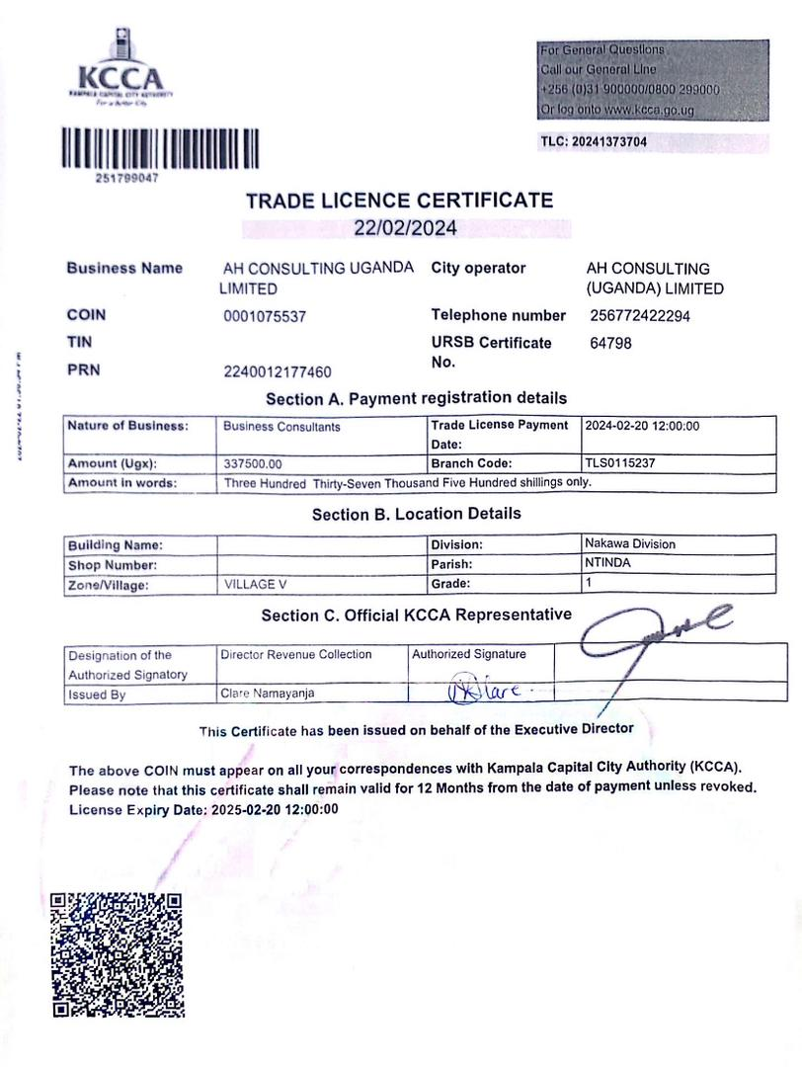

# Copies of completion certificates and contracts

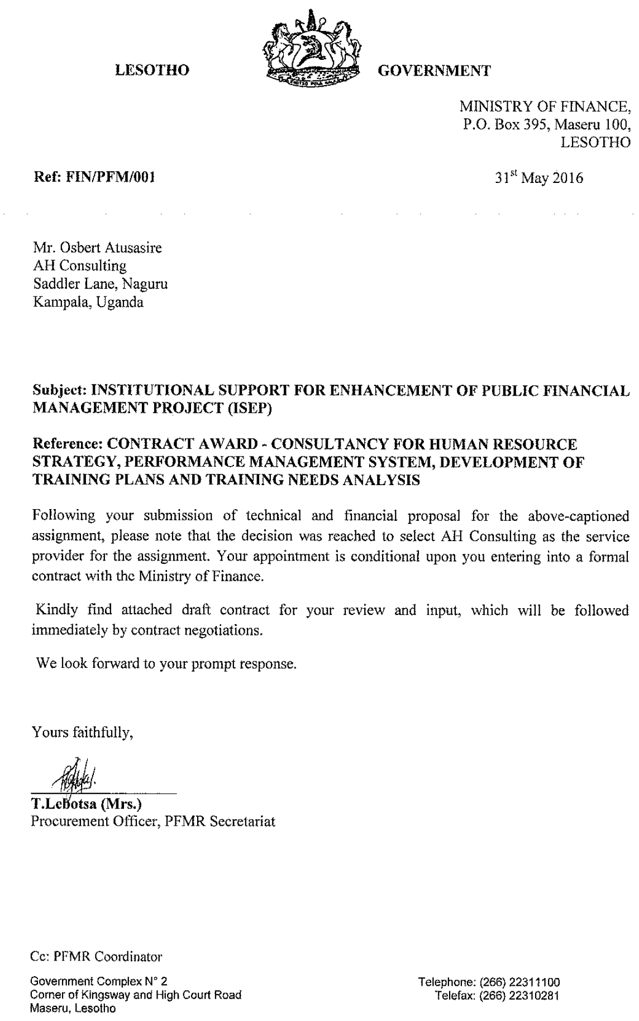

**Assignment: Selection of Consulting Services for: TECHNICAL ASSISTANCE ON ESTABLISHMENT MANAGEMENT CONTROL AND HR MANAGEMENT, RFP No.: P152398/SER/COM2/2 Client: Public Financial Management Reform Secretariat. Kingdom of Lesotho. Project: Public Sector Modernization Project (PSMP). Contract Price: USD 347,800 + USD 30,400 taxes.**

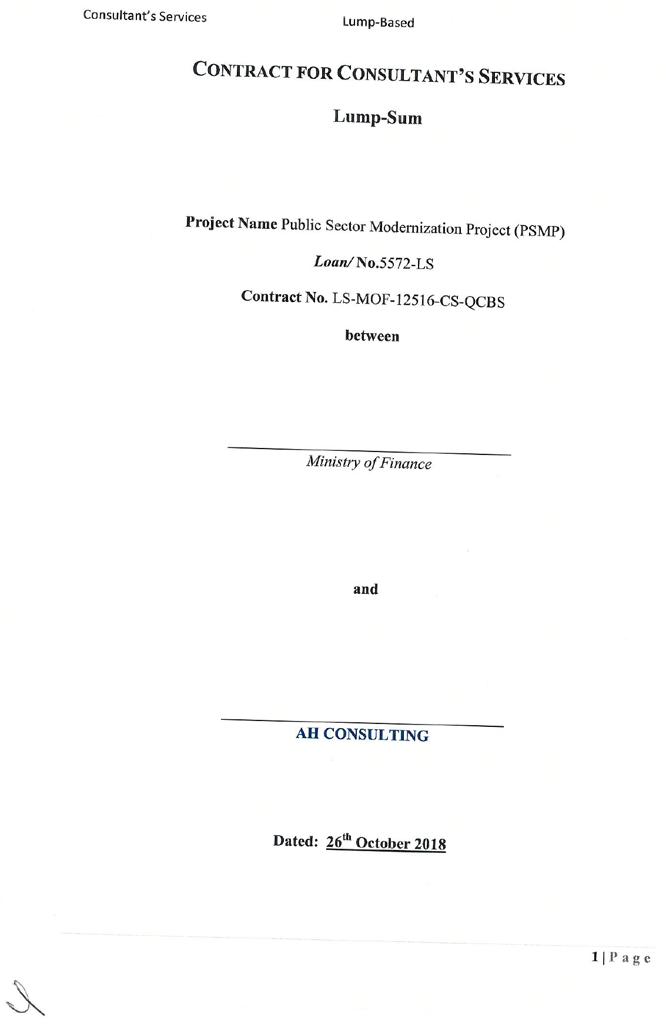

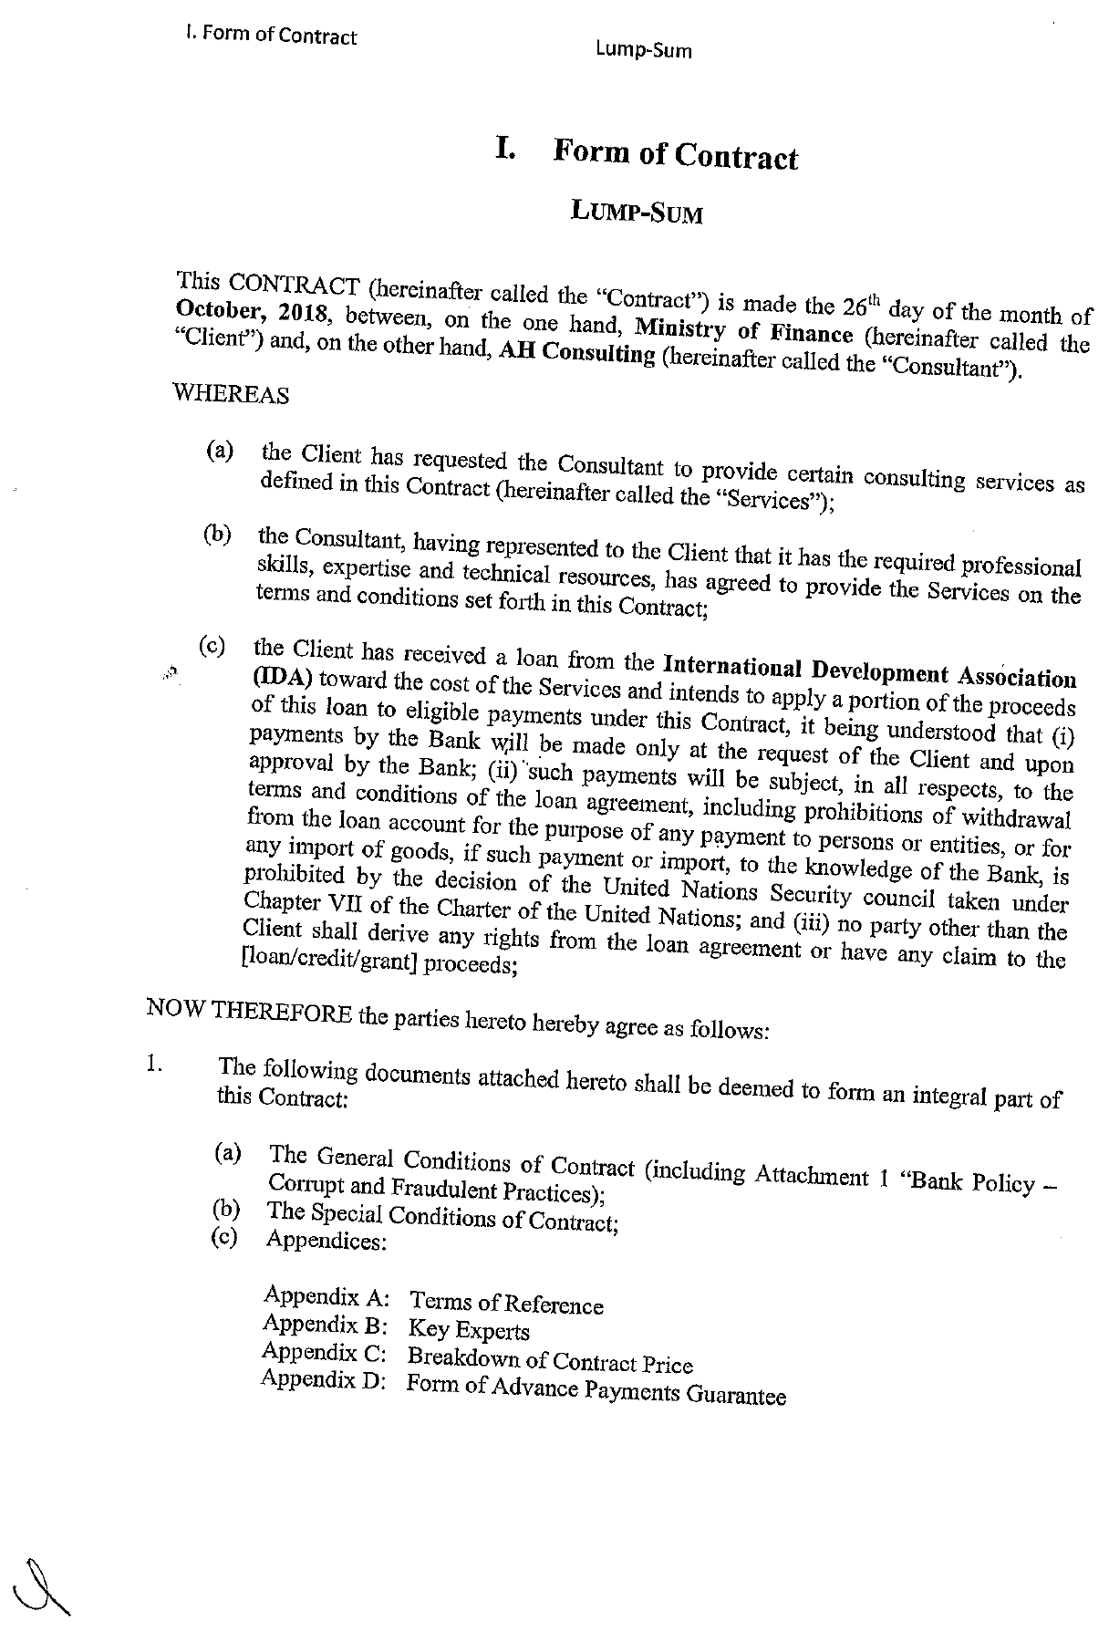

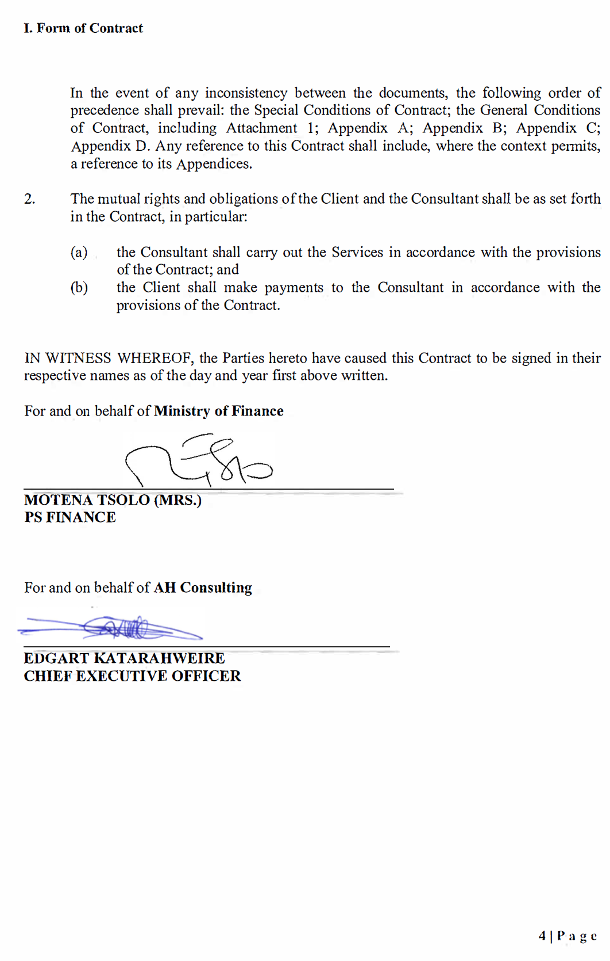

**Assignment:** Consulting Services for technical assistance on auditing of HRMIS system – Public Sector Modernisation Project (PSMP), Ministry of Finance. Financed by the World Bank.

**Date Signed: September 2019 Contract Price:** USD 175,200

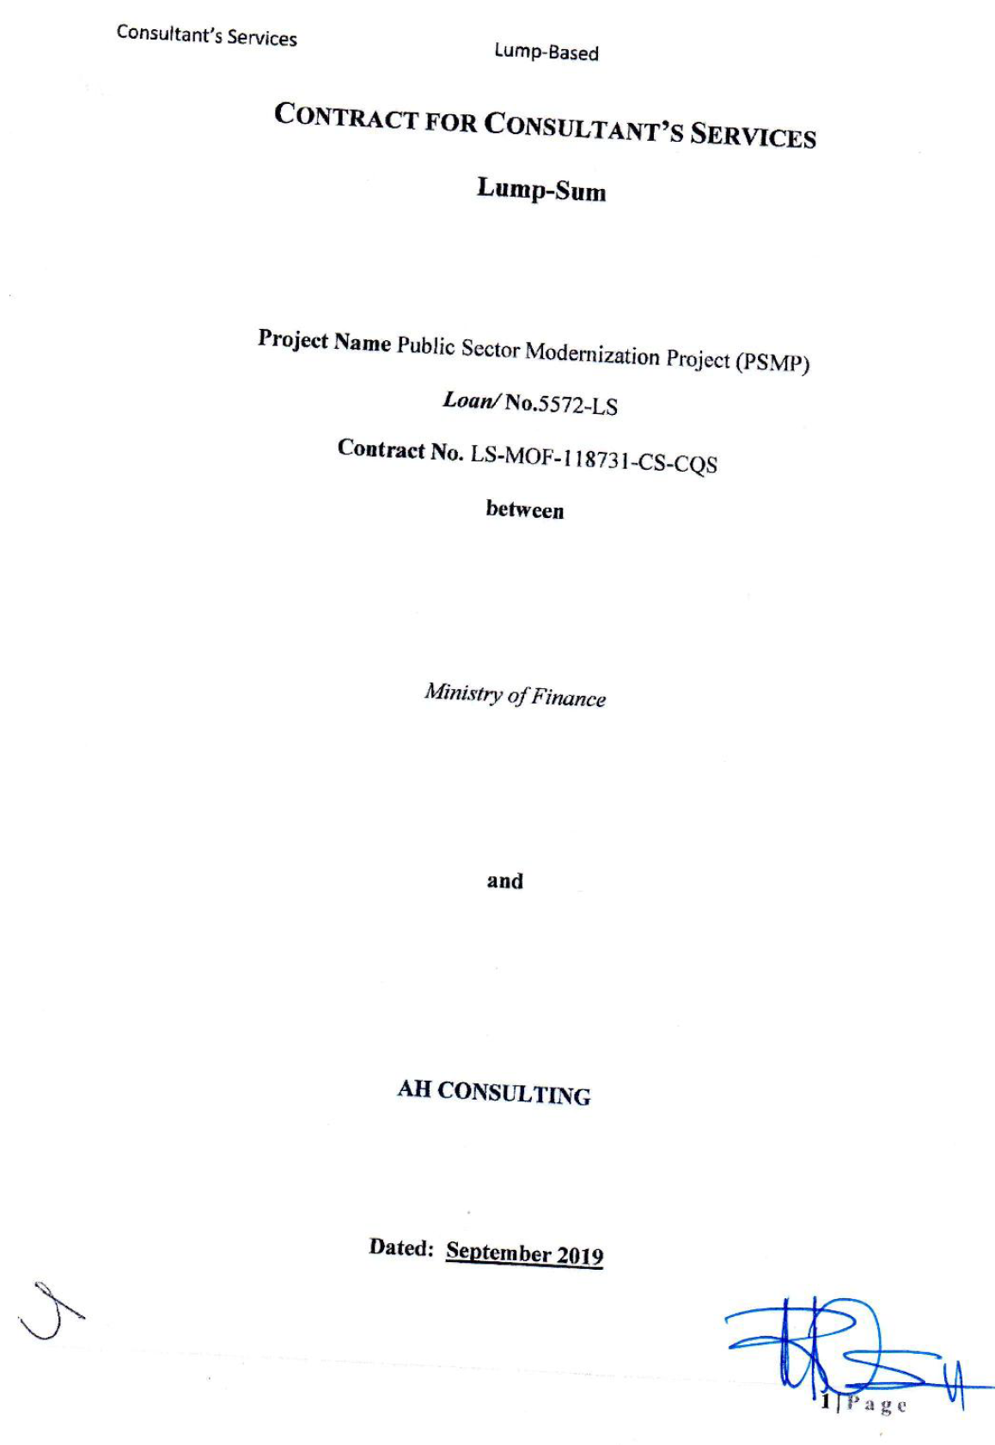



**Assignment Name: Consultancy services to undertake Development of HRMIS Strategy, HRMIS Procurement Requirements, Data Cleaning, Project Management, Supervision and Quality Assurance. Date Signed:** March 2020 **Contract Price:** US$ 332,777.80

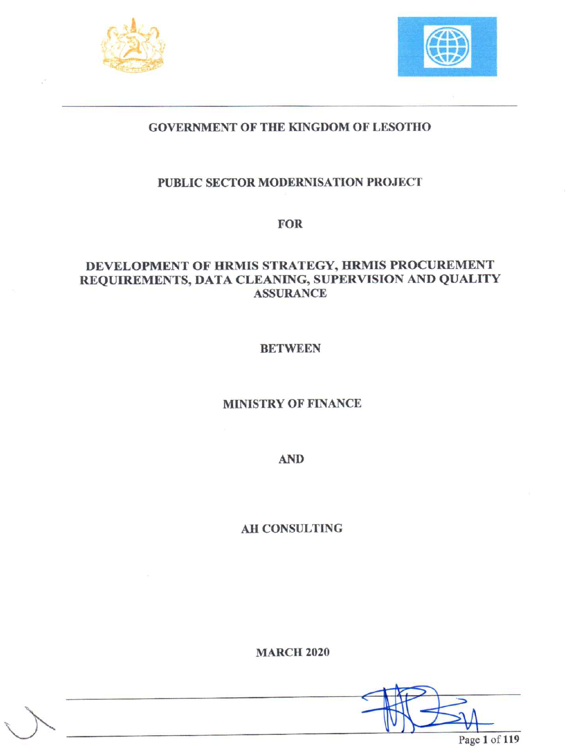

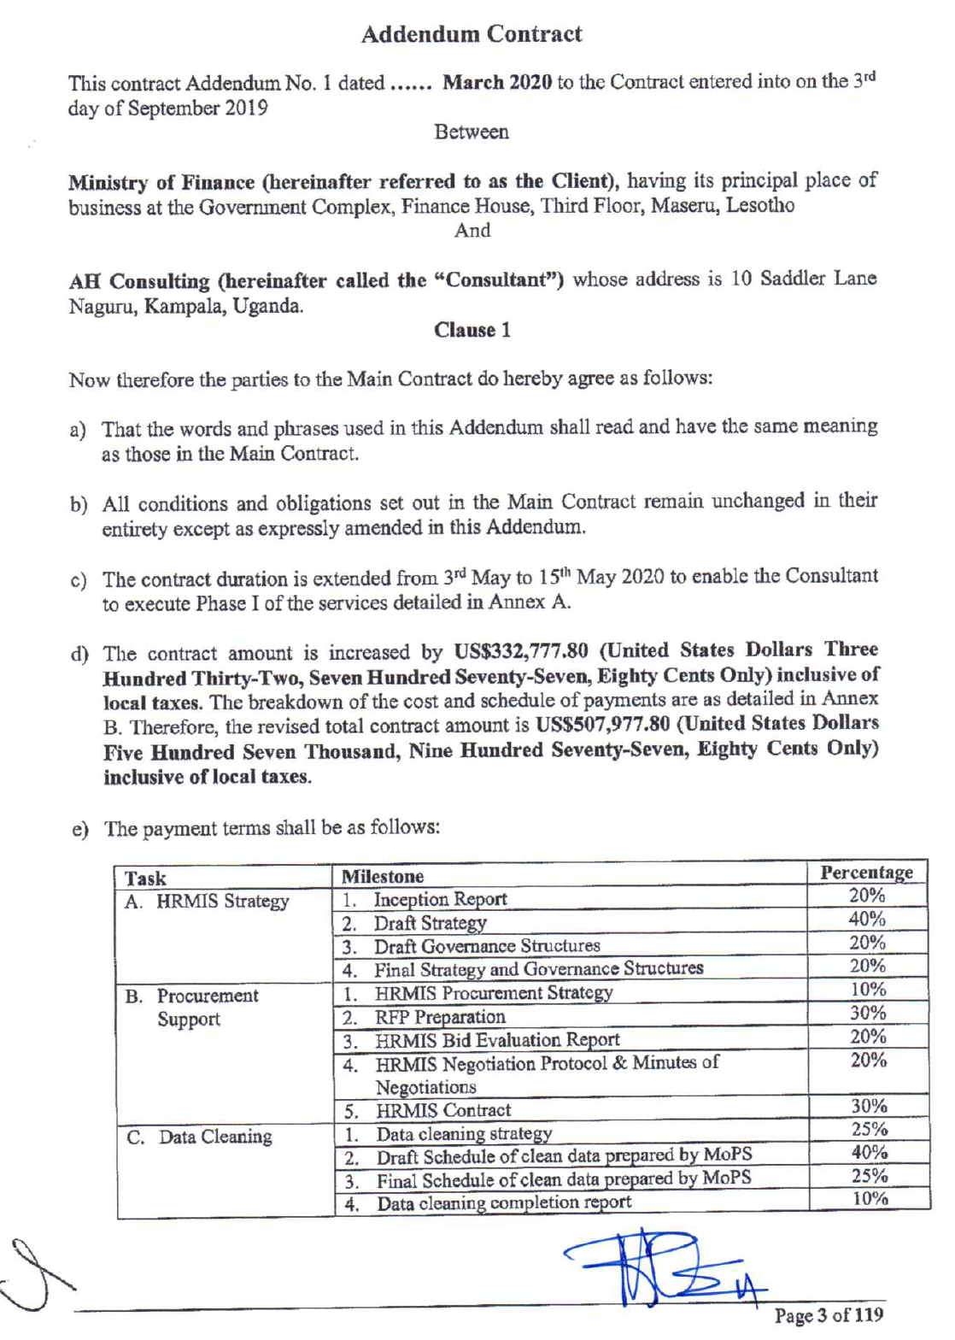

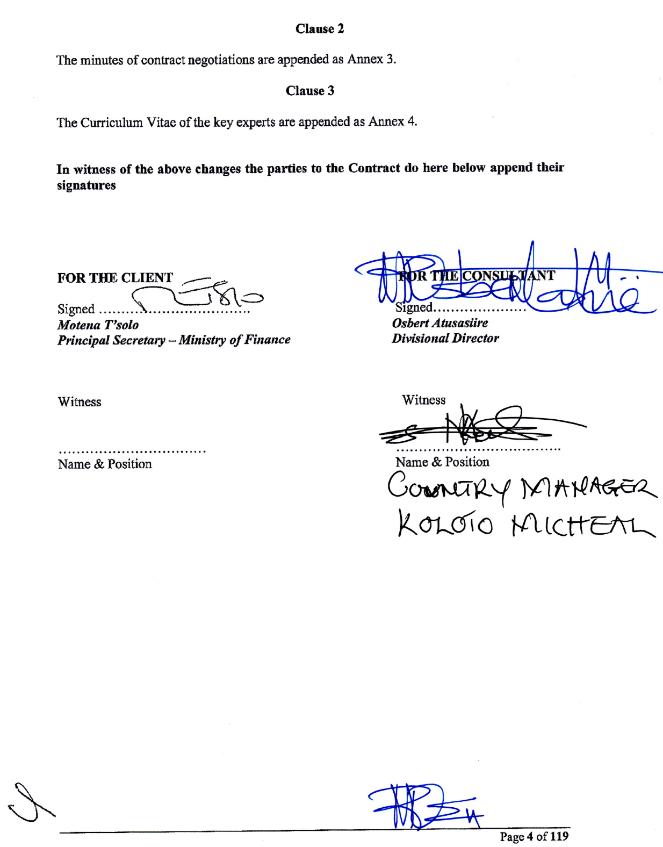

**Assignment:** Consultancy services Project Management, Supervision and Quality Assurance. Public Sector Modernisation Project. Financed by the World Bank. Public Finance Management Reform Secretariat, Ministry of Finance. **Date Signed: October 2020 Contract Price:** USD 349,800

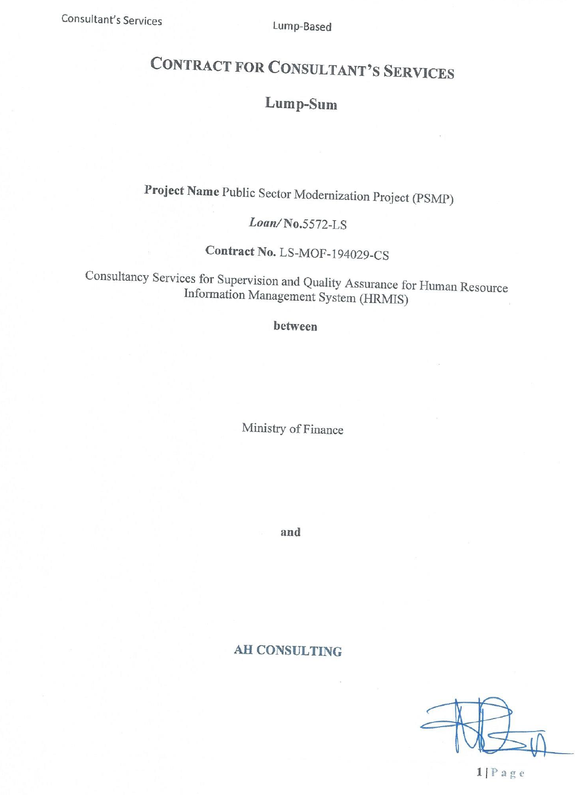

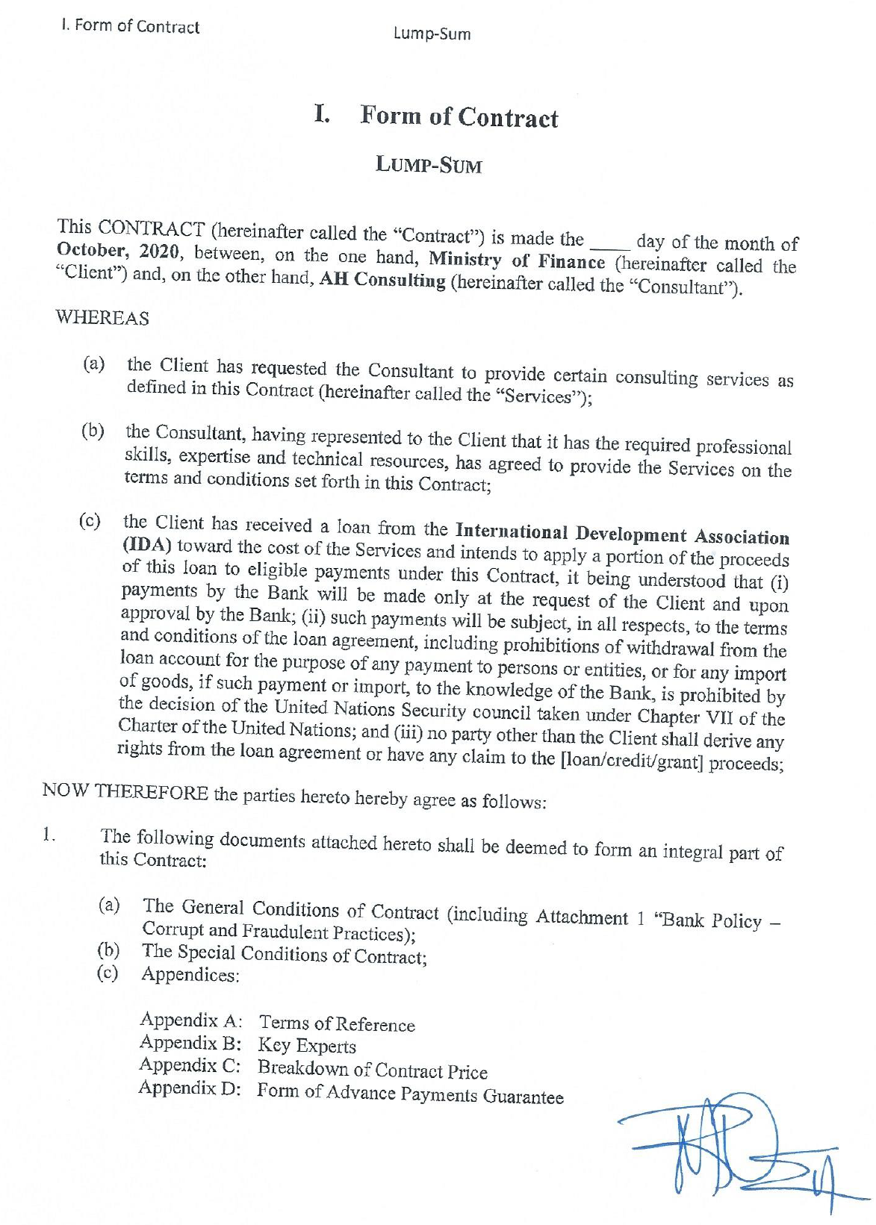

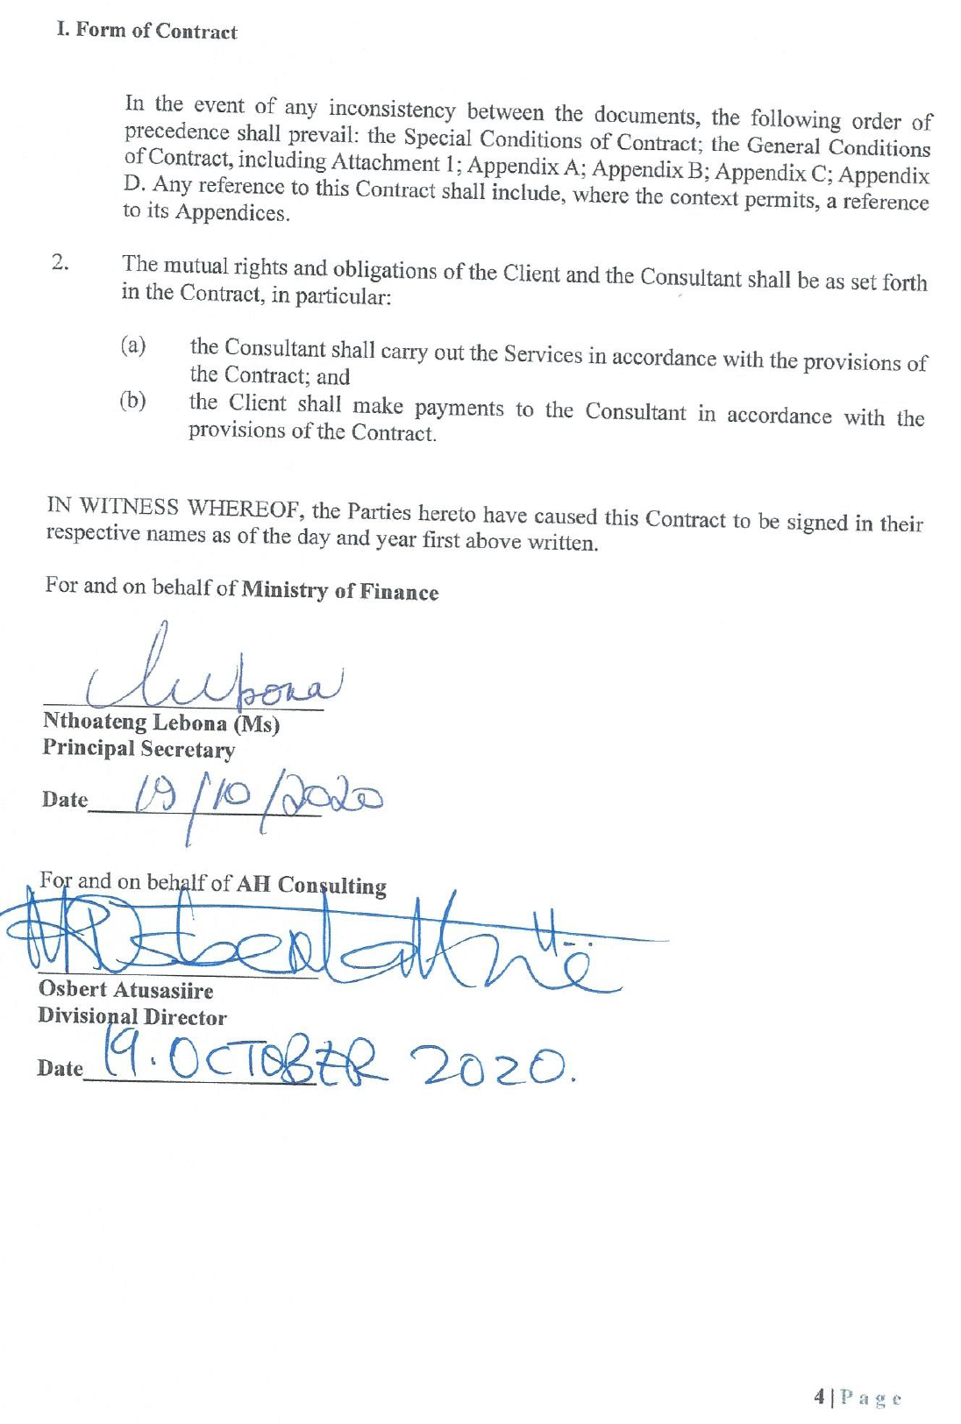

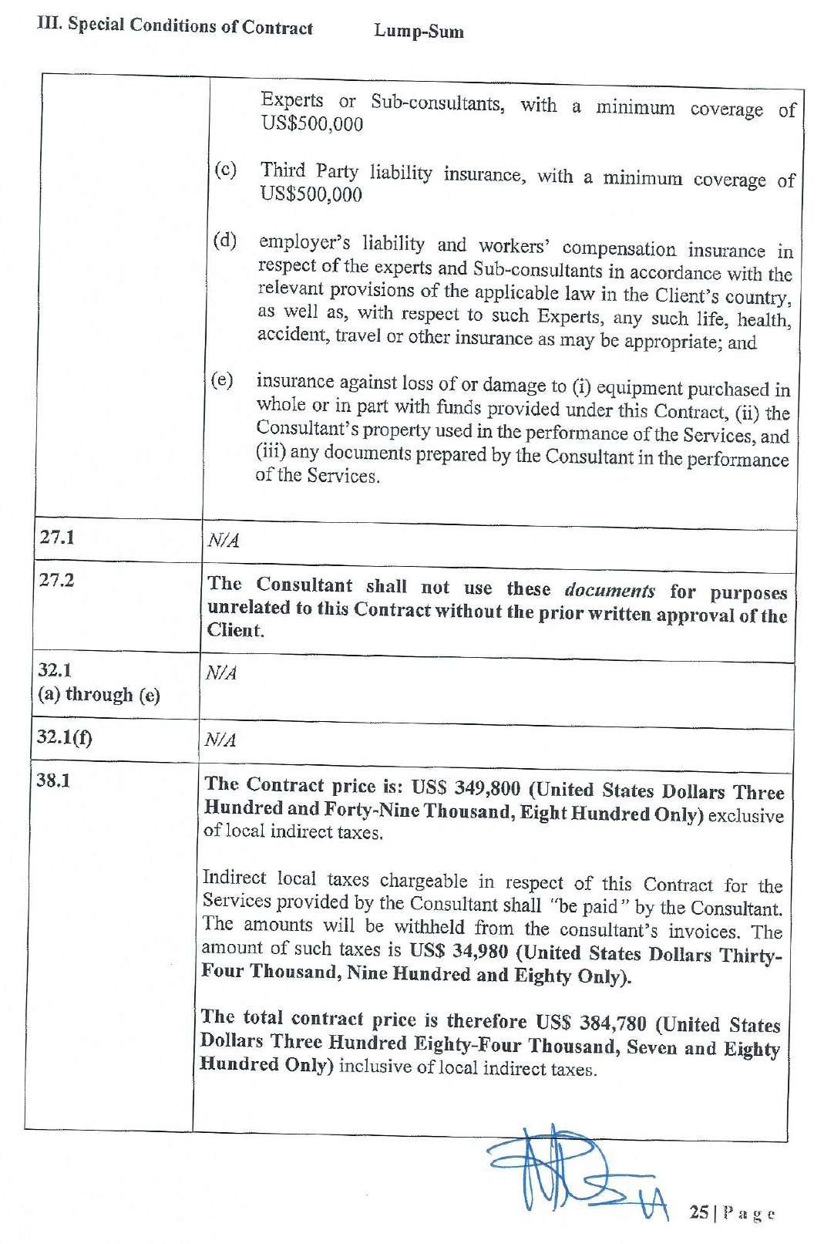

1. **Assignment: Developing HR Requirement analysis and tender documents to procure the services of an implementation partner for Oracle-based Human Resources Management Information System, RFP No.:** 3-2015. **Contract Price:** USD 115,088 and USD 7,962 (Taxes). Client: CONTROLLER AND ACCOUNTANT GENERAL’S DEPARTMENT OF THE MINISTRY OF FINANCE AND ECONOMIC PLANNING. Financing by World Bank. 1ST November 2012 to 1st March 2013. US$199,600.00

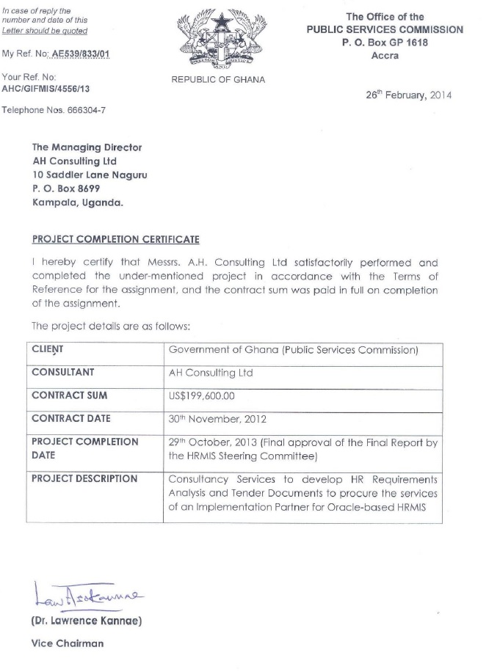

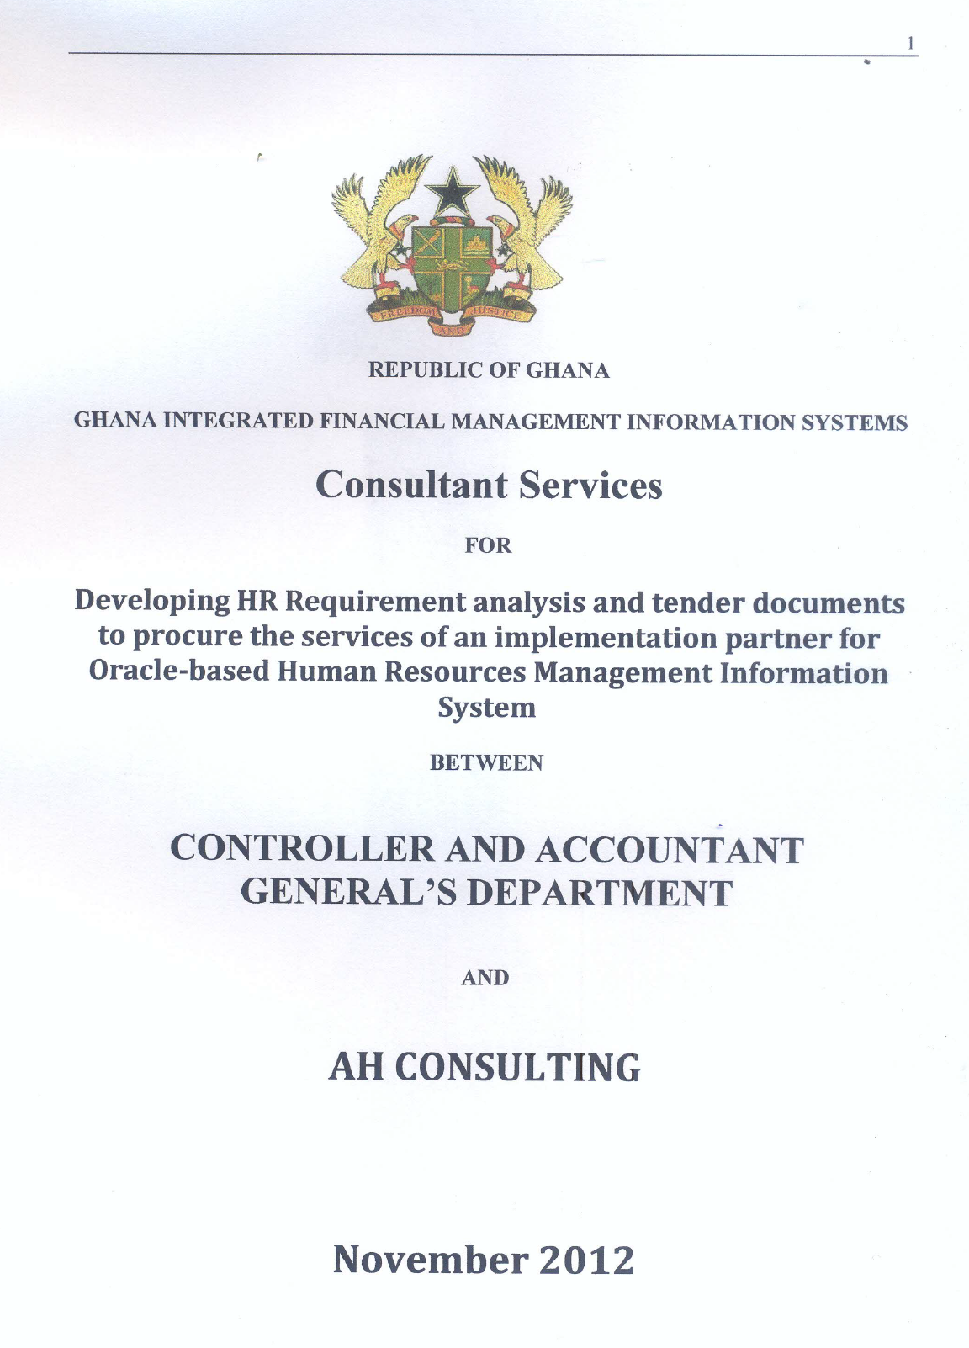

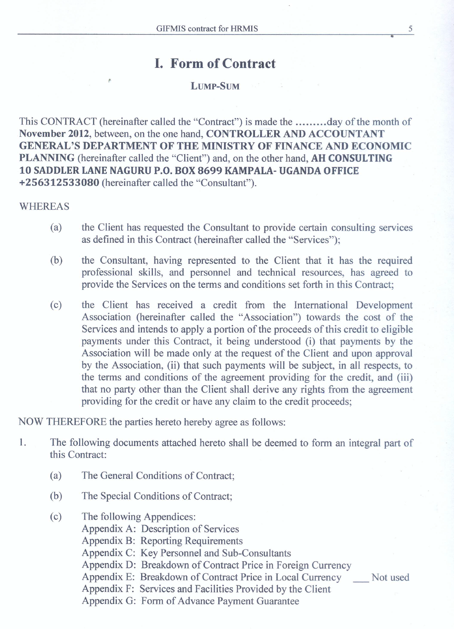



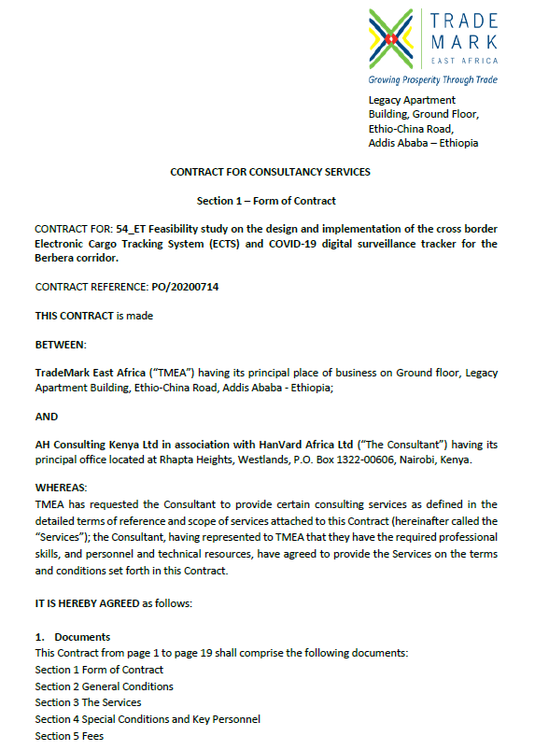

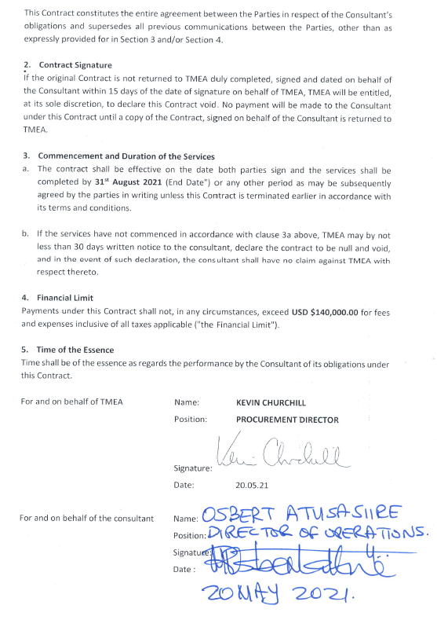

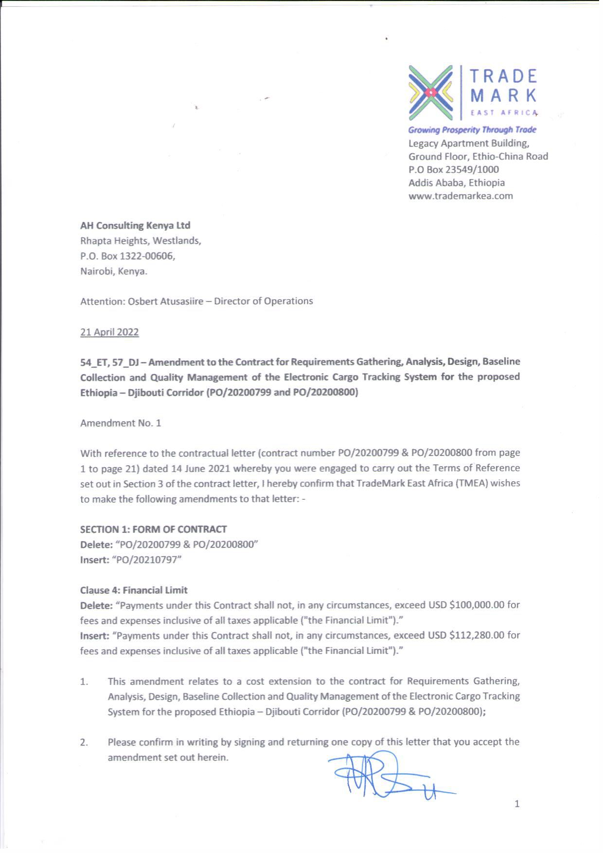

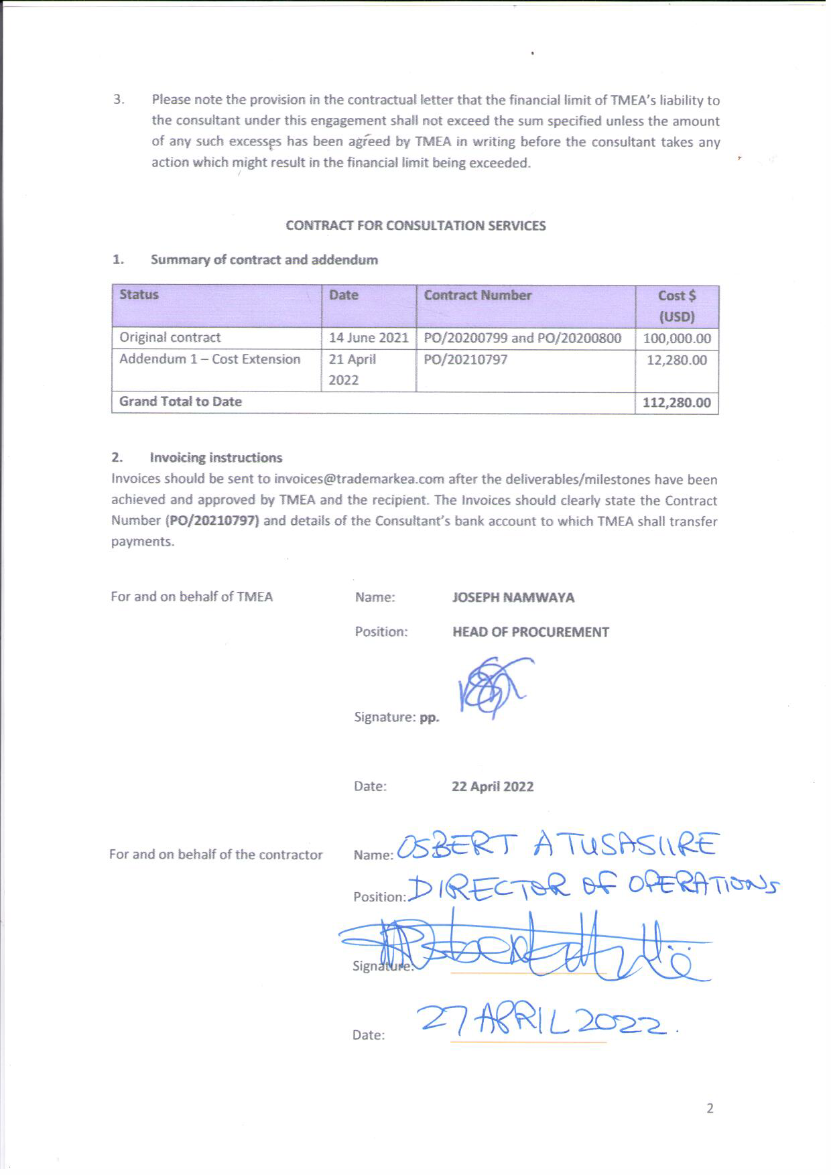

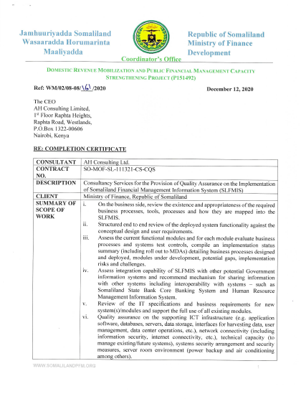

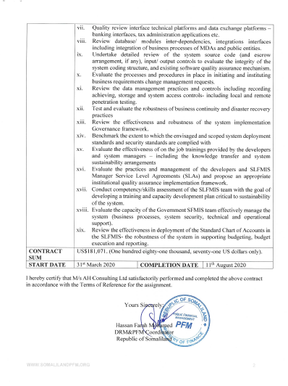

**Assignment:** Developing Technical Specifications of an Integrated Management Information System for Electricity generation Company (Malawi) Limited

**Company:** Electricity Generation Company (Malawi) Limited

**Industry:** Electricity Generation Company/ Electricity Utility Company

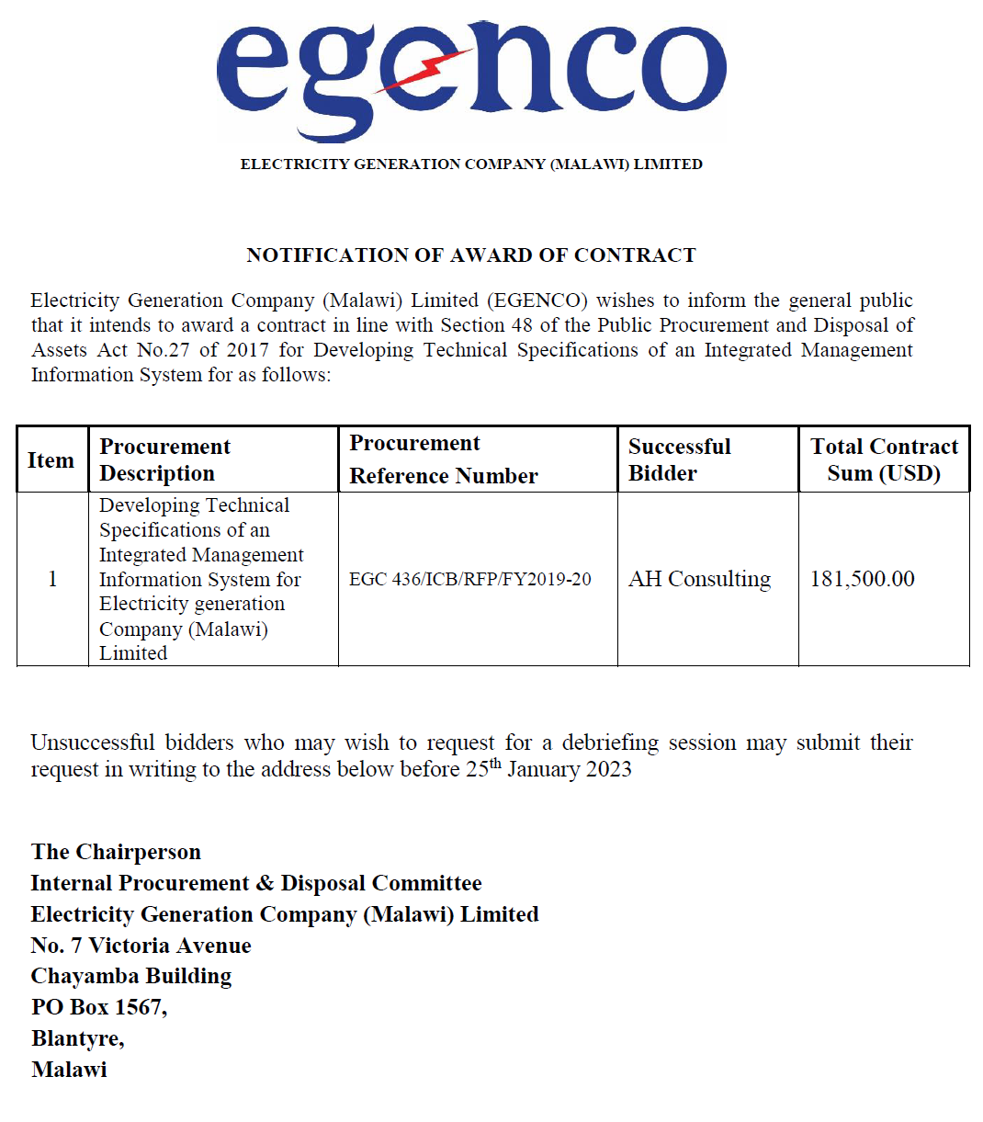

**Assignment:** Consultancy Services for the Development of Specifications for The Electricity Supply Corporation of Malawi (ESCOM) Management Information System (MIS) for Electricity Supply Corporation of Malawi Ltd, Malawi. financed by Millennium Challenge Account, MCA Malawi

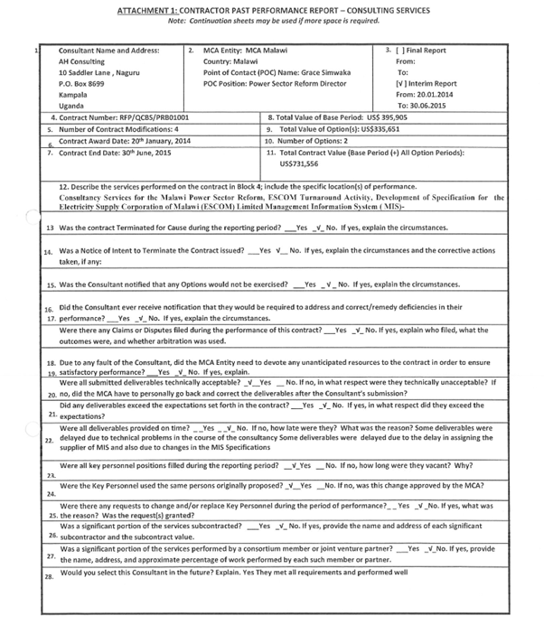

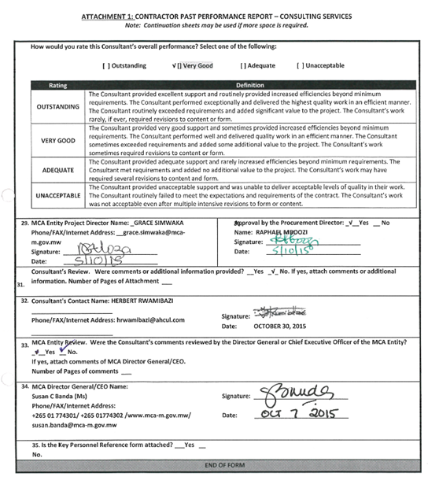

**Assignment:** Project Management, Supervision and Quality Assurance of the Implementation of Management Information Systems (SCADA, GIS, ERP, HR, Billing, Network development and maintenance,) for the Electricity Supply Corporation of Malawi (ESCOM), Malawi

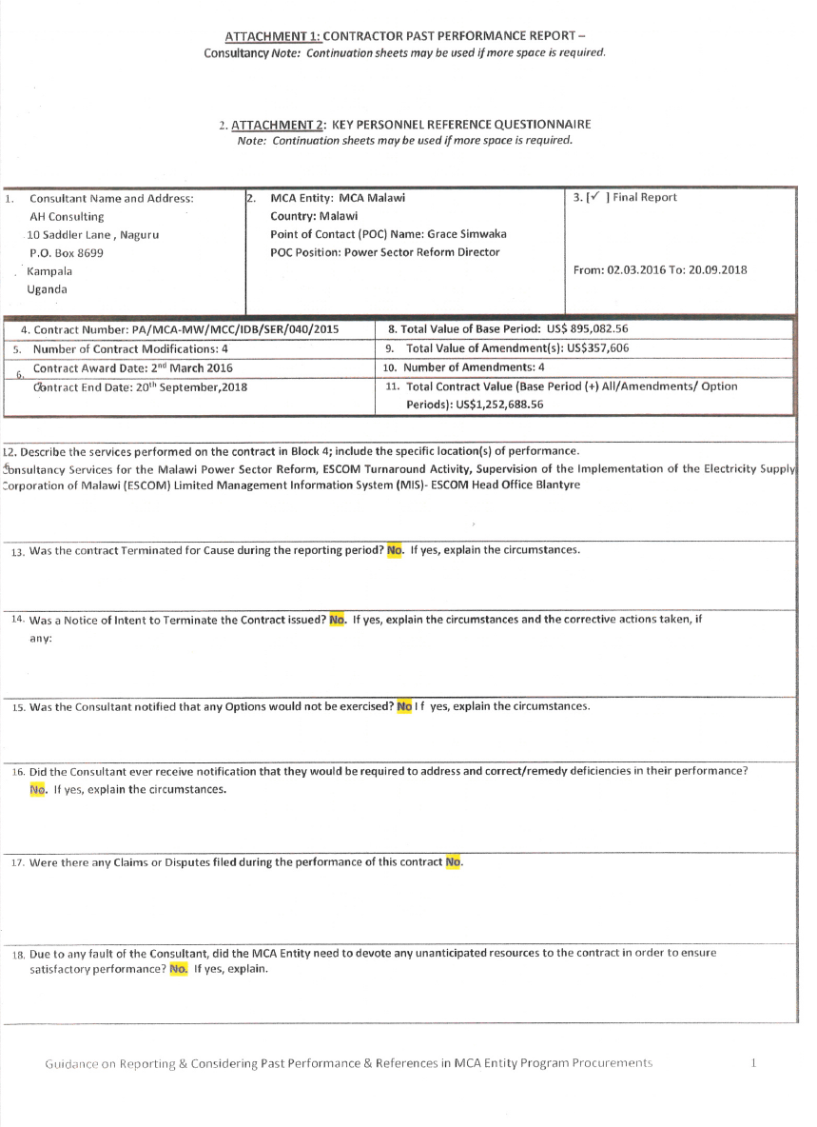



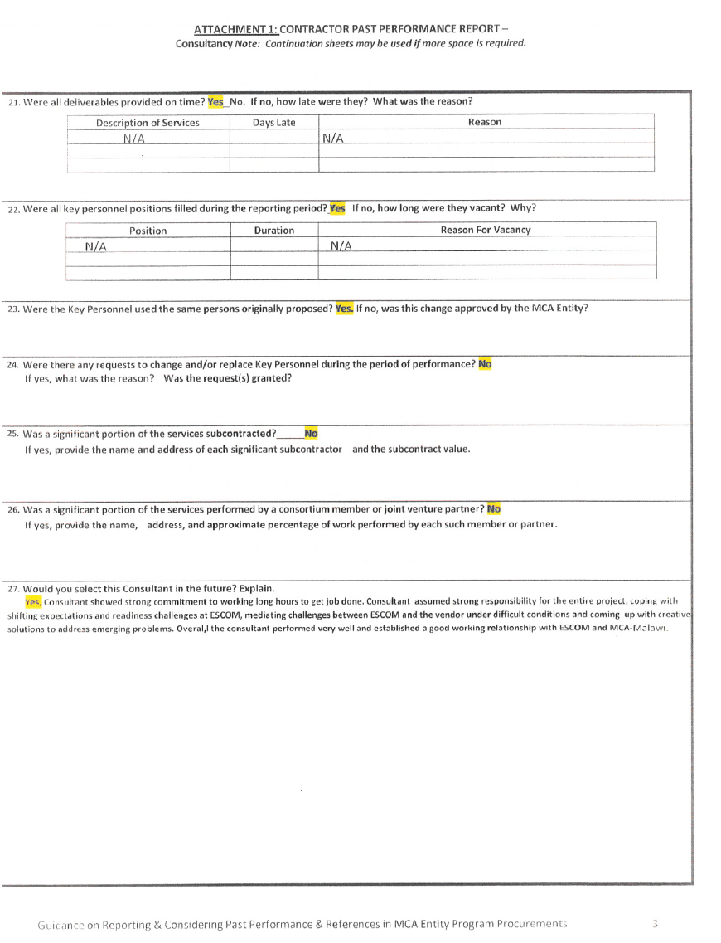

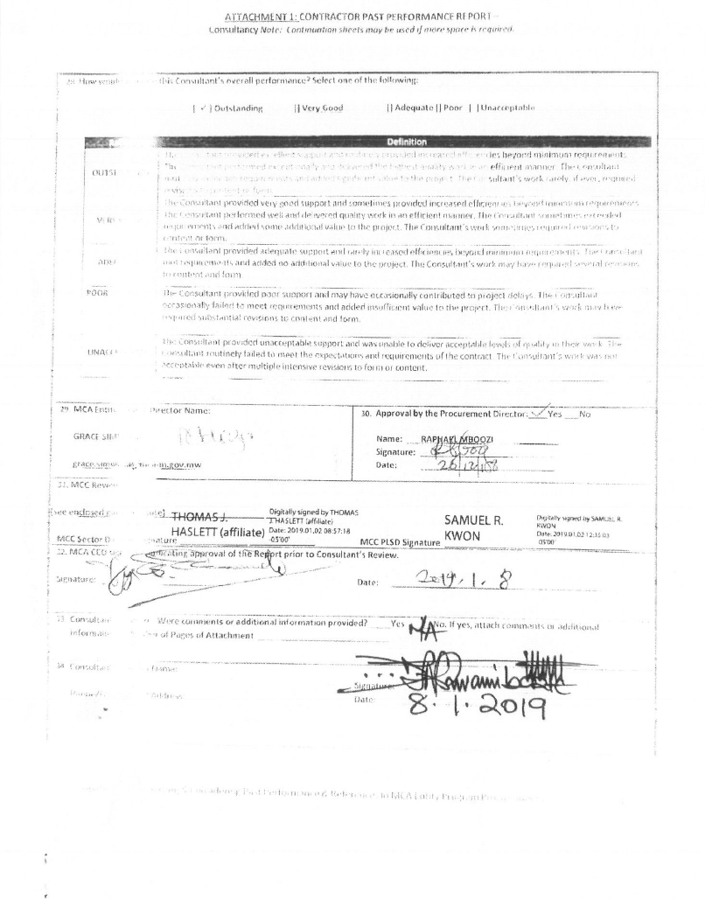

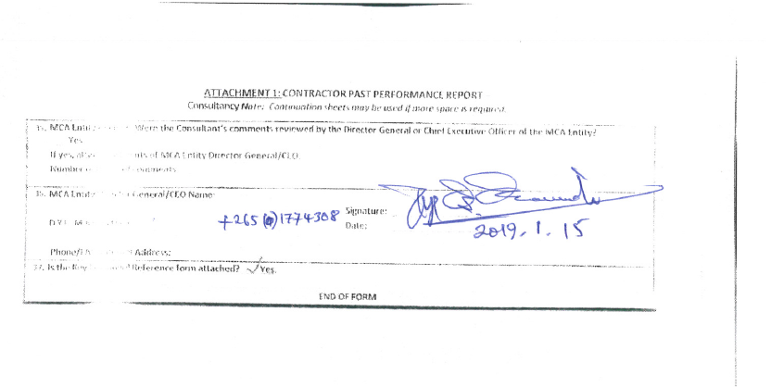

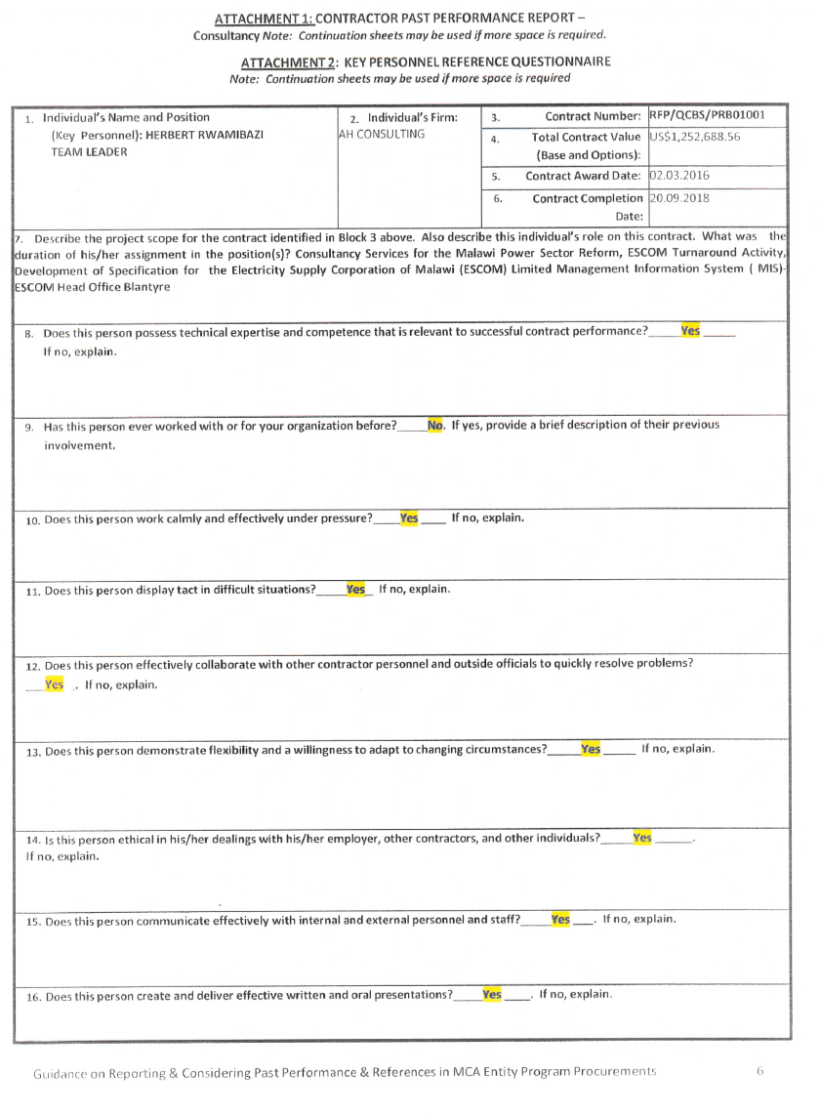

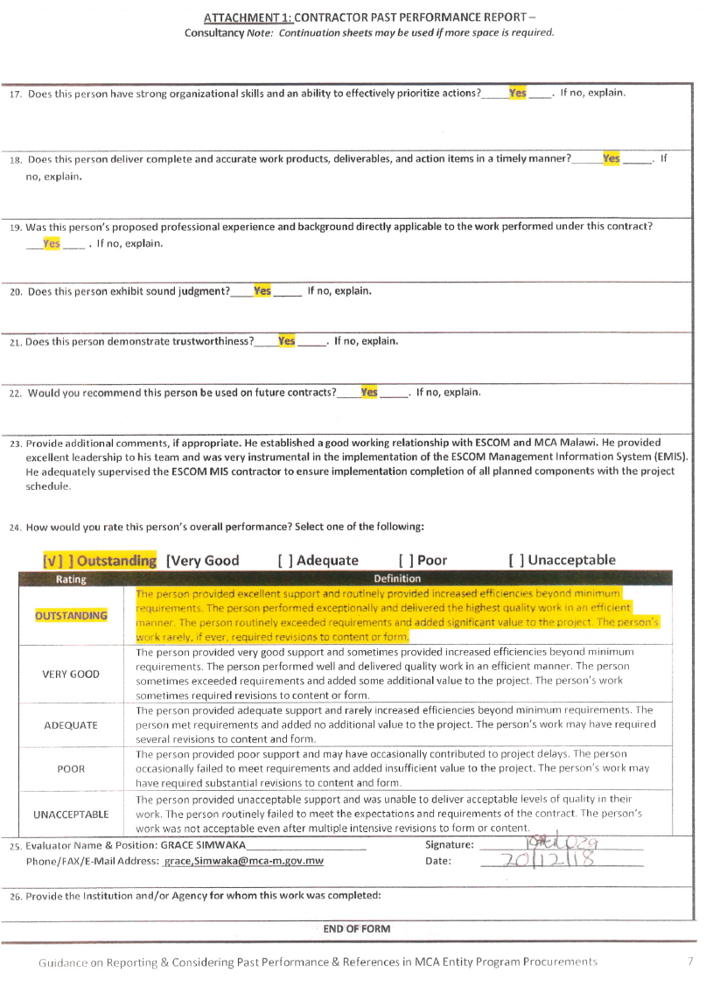

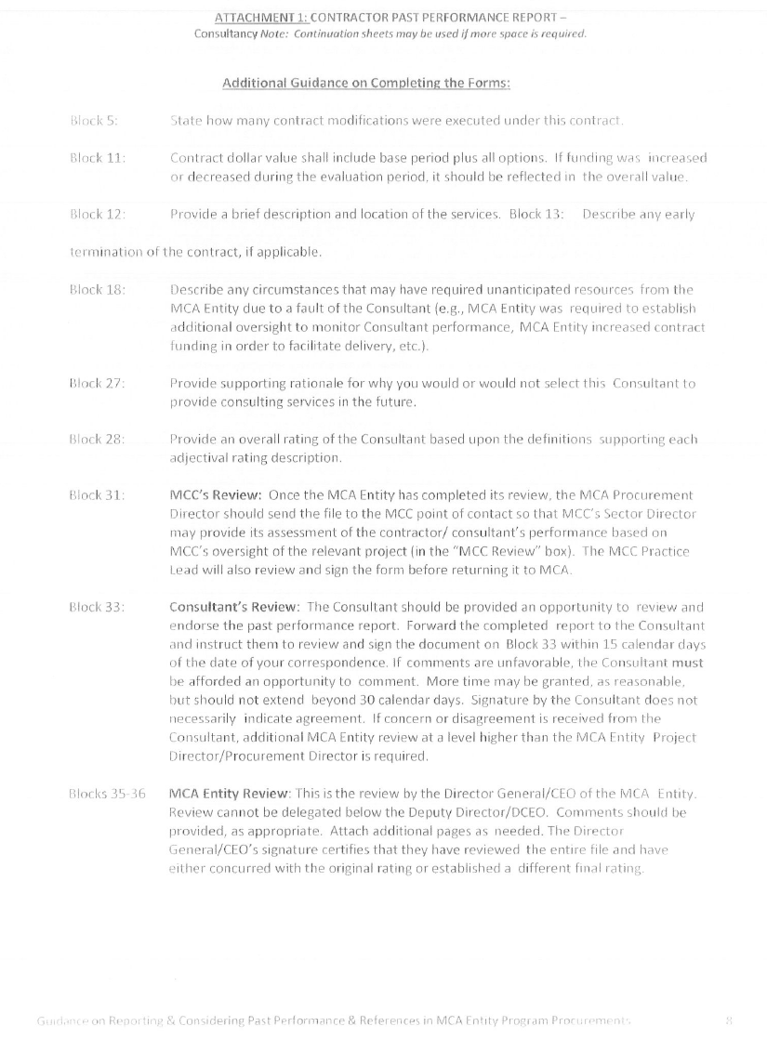

**Assignment:** Design & Development of an Environmental Information System for the Petroleum Sector (Including Business Process Re-Engineering) for National Environmental Management Authority, Kenya

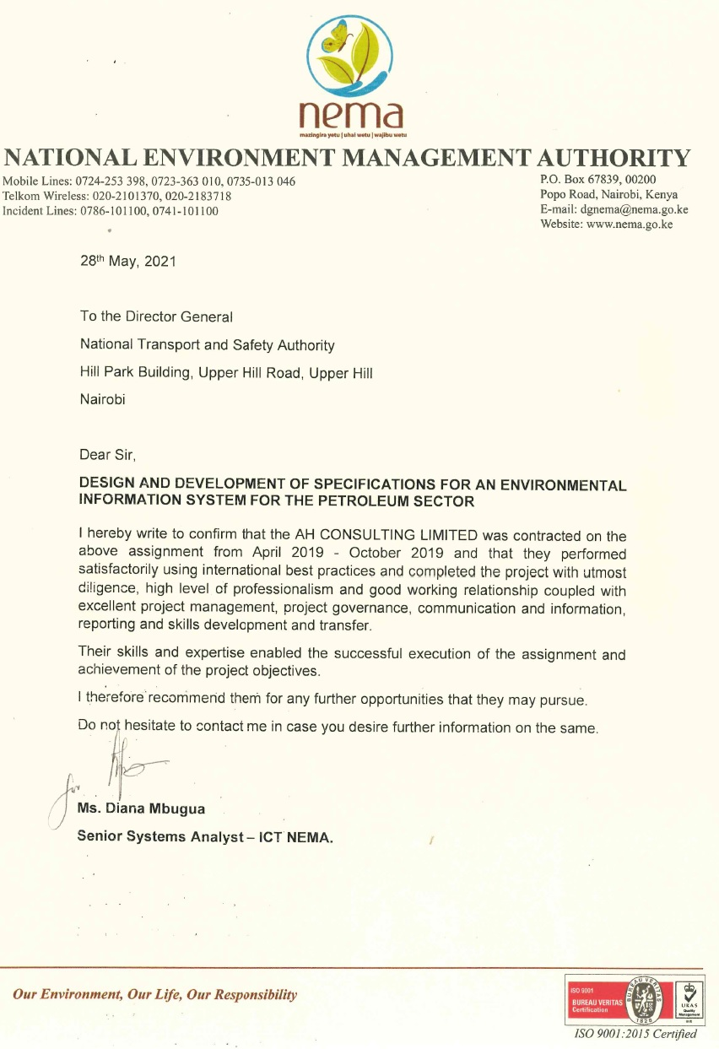

**Assignment:** Consulting Services to Design a Transaction Processing Hub for the Microfinance and Financial Cooperatives Industry in Malawi for Reserve Bank of Malawi

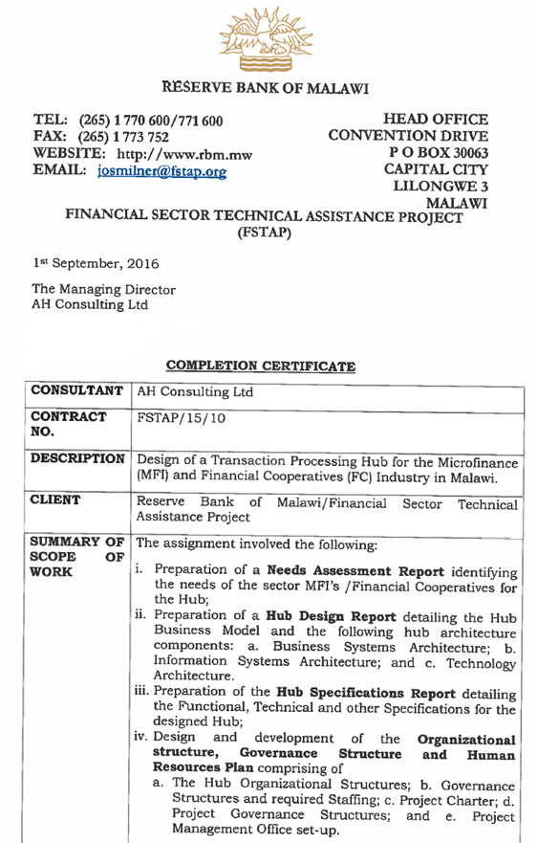

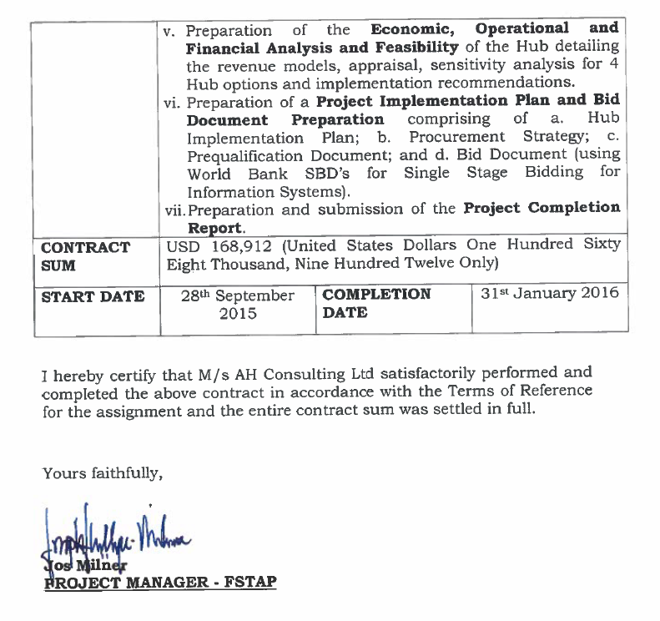

**Assignment:** Supervision of Ethiopian Roads Authority (ERA) and Ministry of Transport (MoT) Data Center infrastructure and Unified Communication and Collaboration Solutions Project

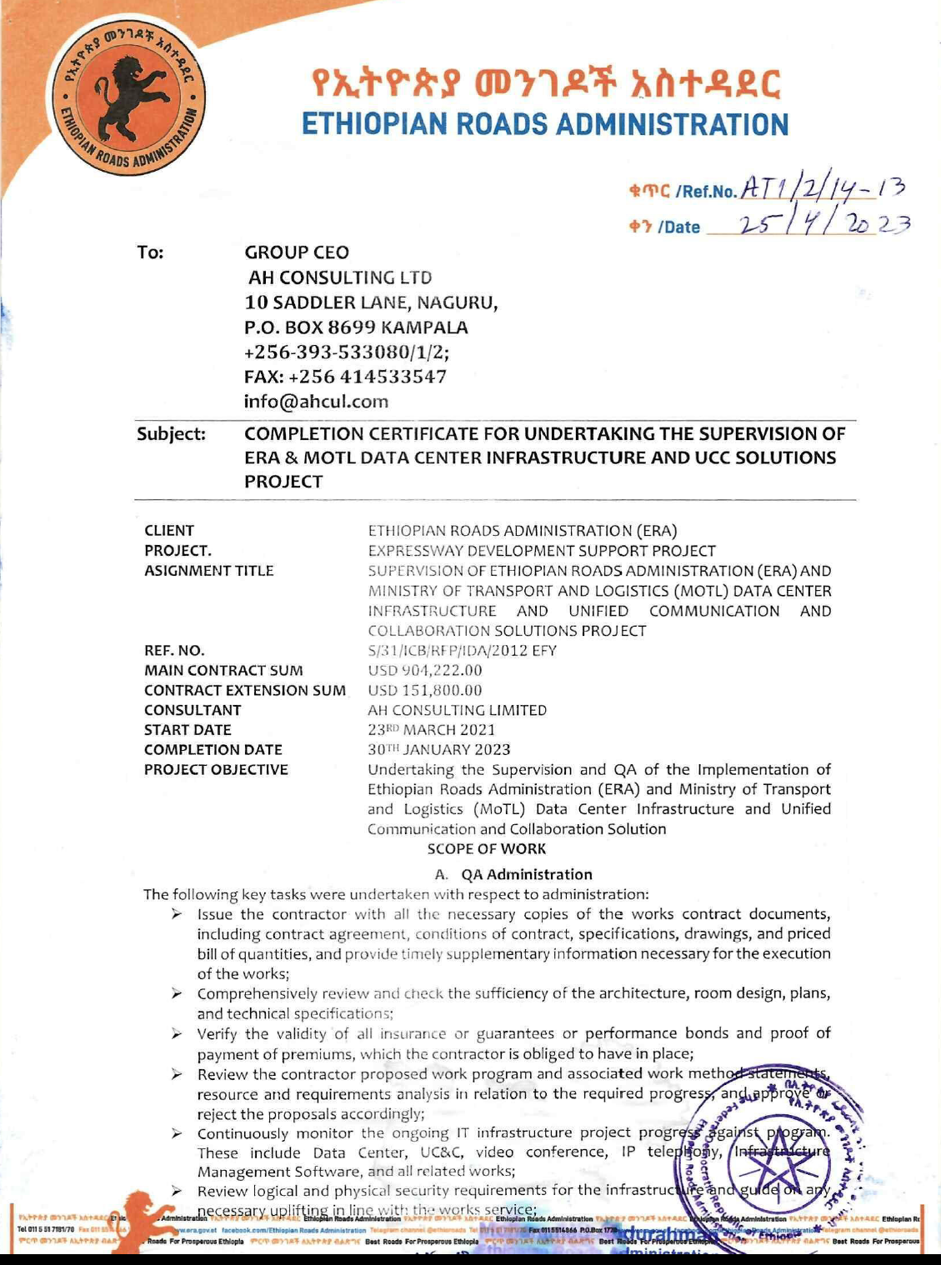

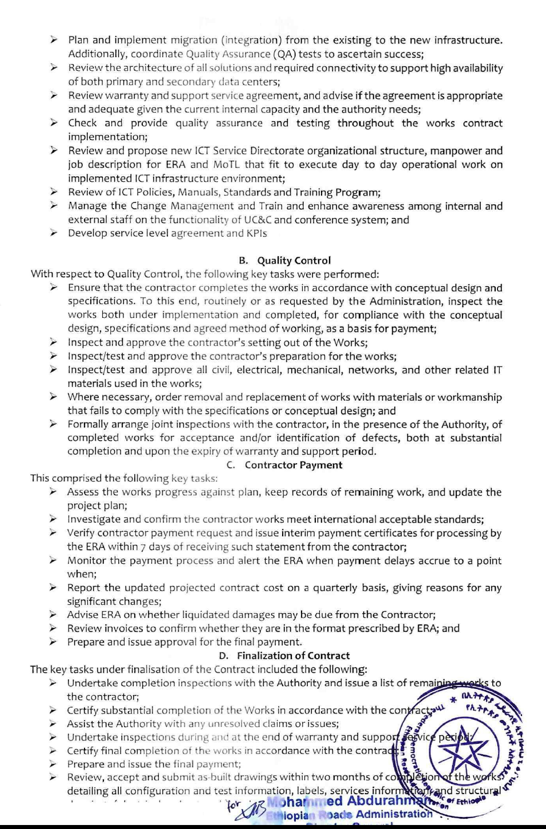

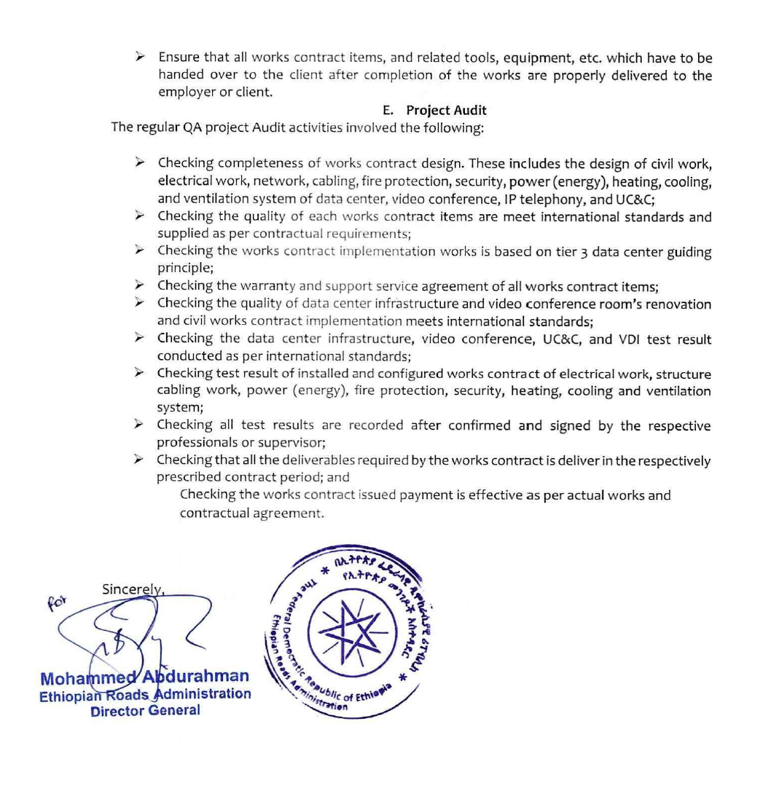

**Assignment: Consultancy for Procurement Support, Contract Supervision and Quality Assurance of the Integrated Human Resources and Payroll Information Management System (HRMIS) For Ministry Of Finance Lesotho.** Contract Sum: US$507,977

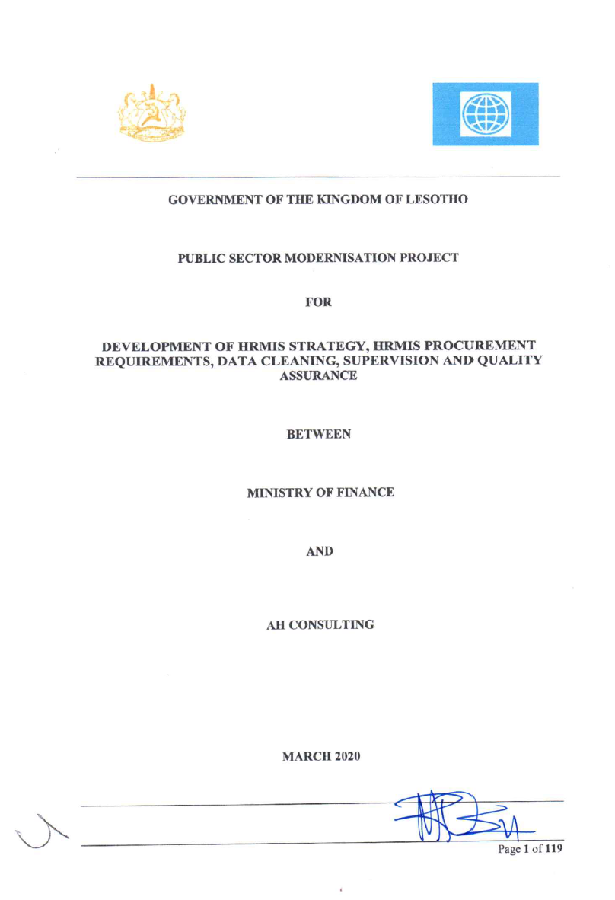

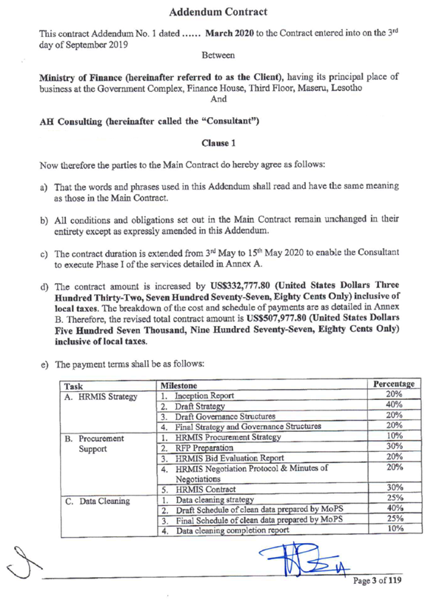

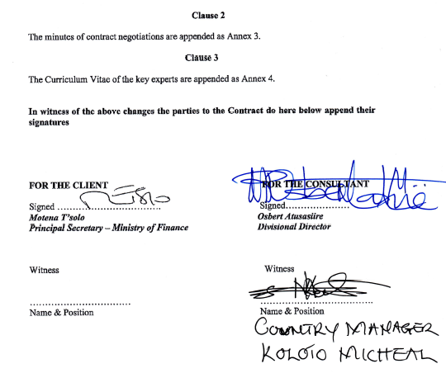

**Assignment: Design of the Integrated Management Information System (IMIS): This covered the financial, human resource, IT and administration management information systems of the African Union.**

**And**

**Project Management of the Procurement of the IMIS for the African Union**

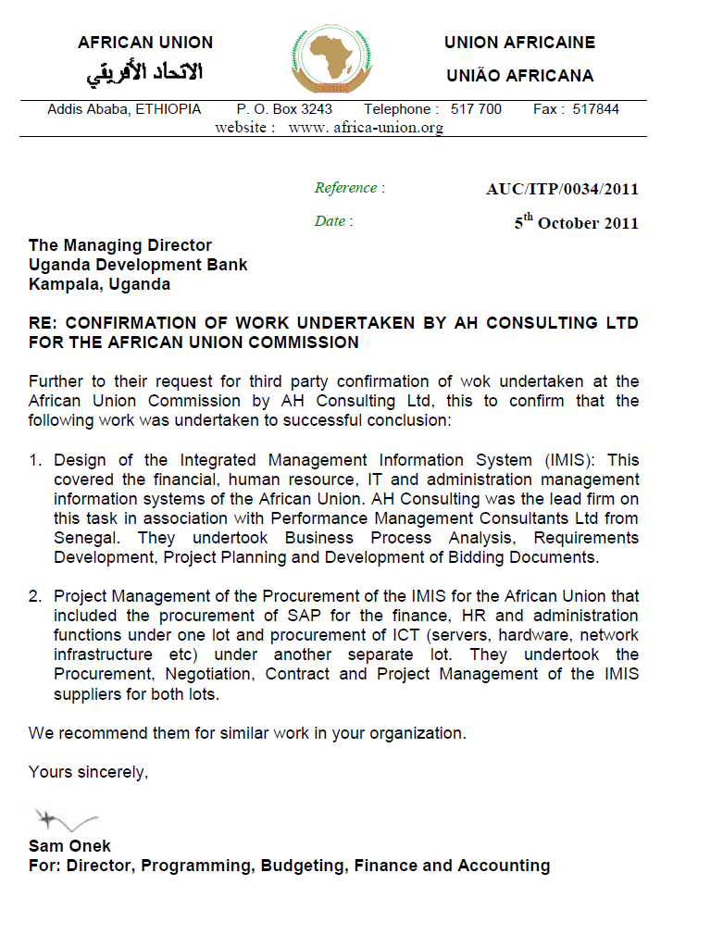

**Assignment:** Consultancy Services in Provision of Quality Assurance for the Implementation of the Government of Kenya (GoK) Integrated Financial Management Information System (IFMIS), for The National Treasury, Kenya.

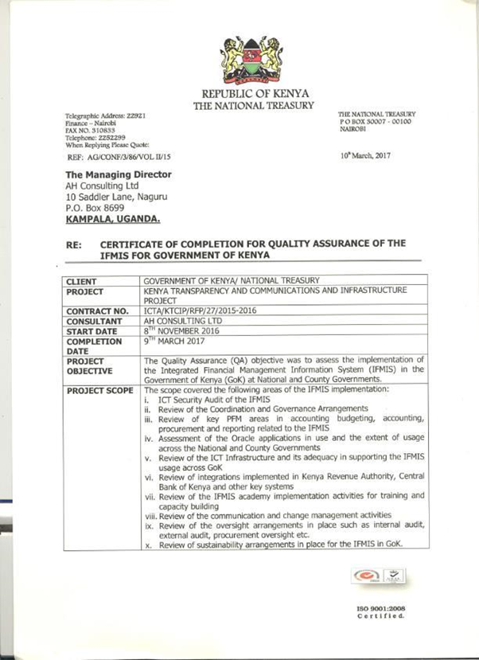

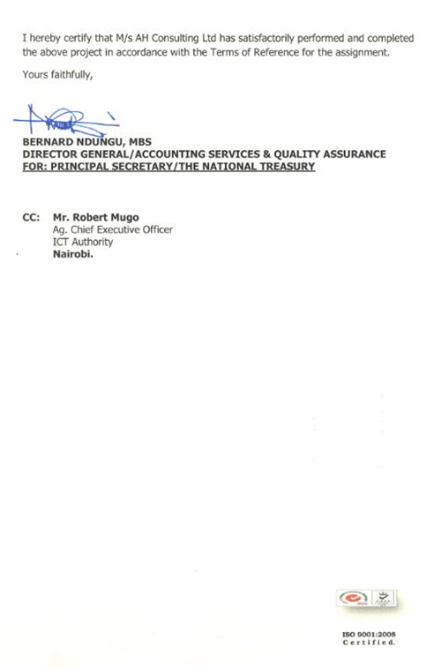

**Assignment: Quality Assurance Consultancy Services For The Integrated Financial Management Information System (IFMIS) Rollout Implementation Of Federal Democratic Republic Of Ethiopia.**

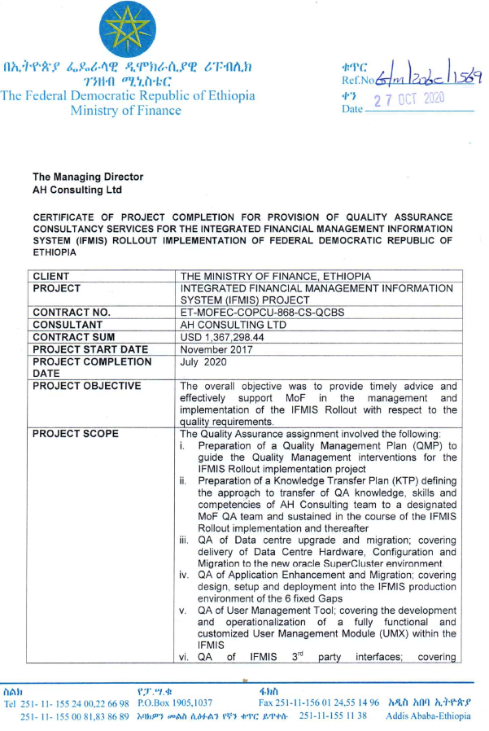

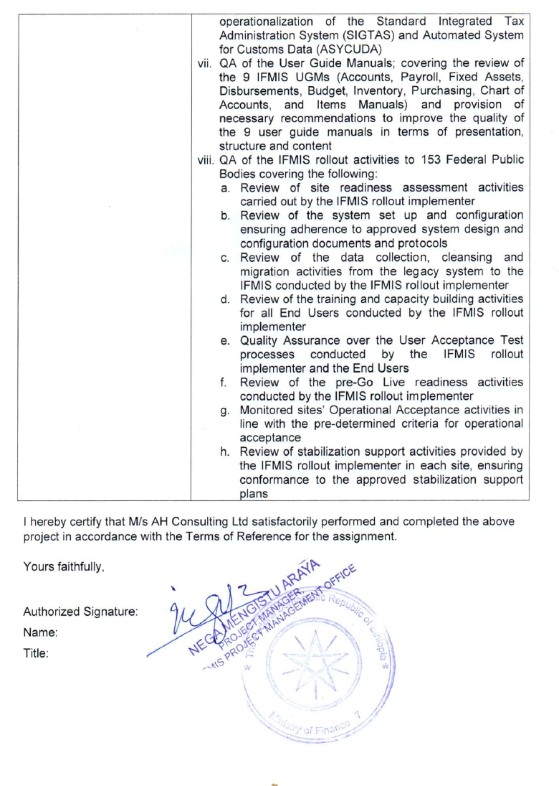

**Technical Assistance (Consultancy Service) For Design of The ULGDP II and UIIDP Management Information System that supports the Program’s Operations at the Federal, Regional and ULG Levels (44 Cities).**

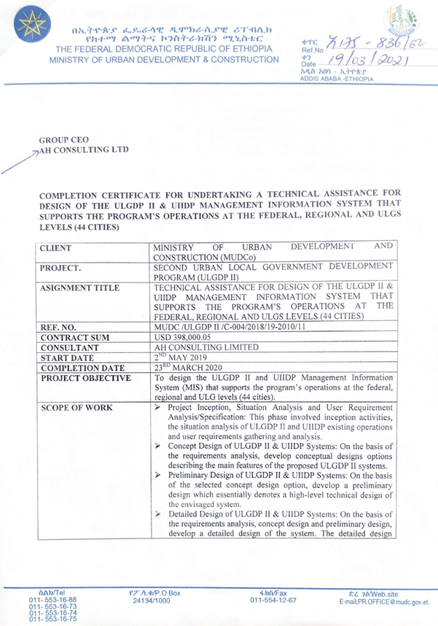

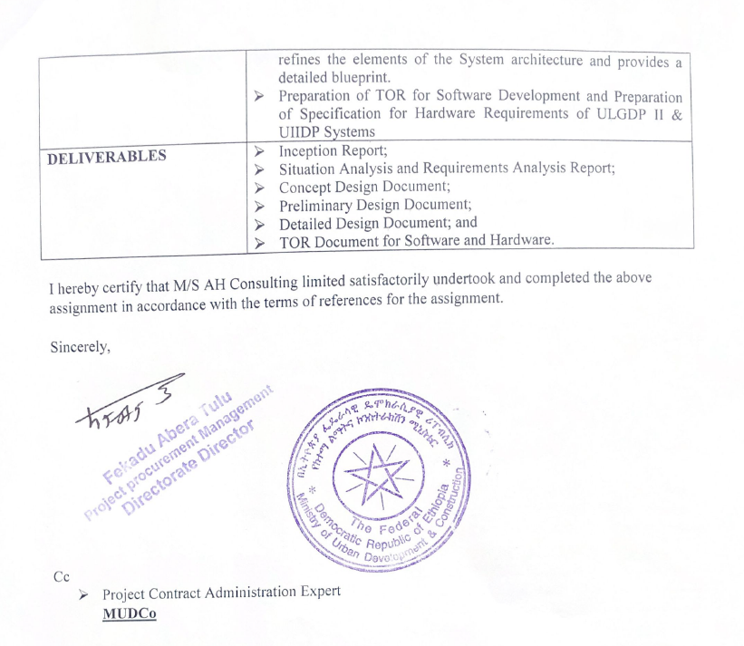

**Assignment:** Quality Assurance Consultancy Service for Integrated Financial Management Information System (IFMIS) Rollout Implementation for Ministry of Finance and Economic Cooperation, Ethiopia

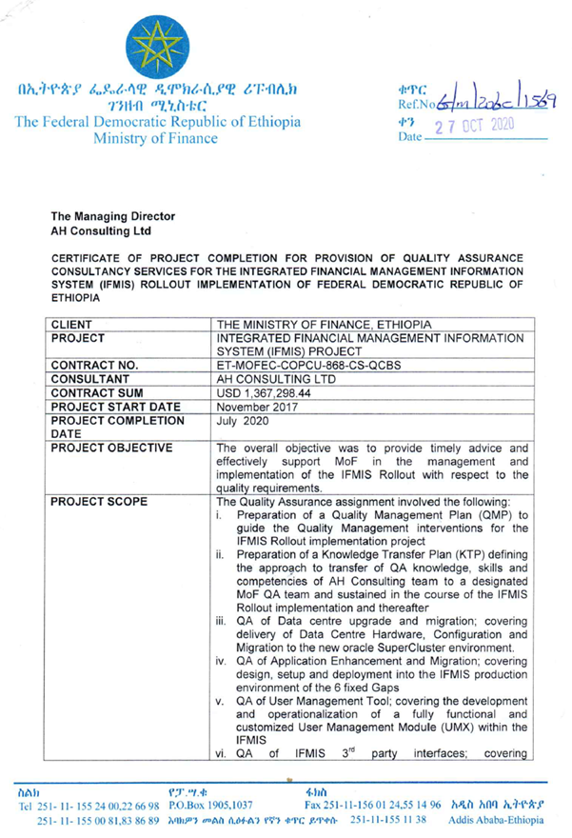

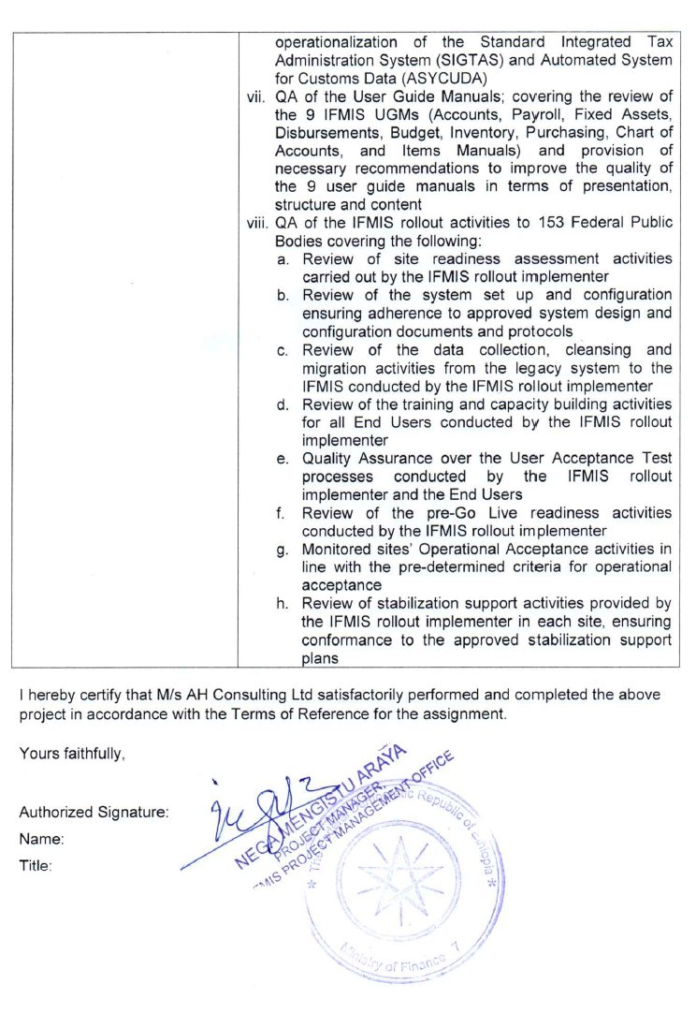

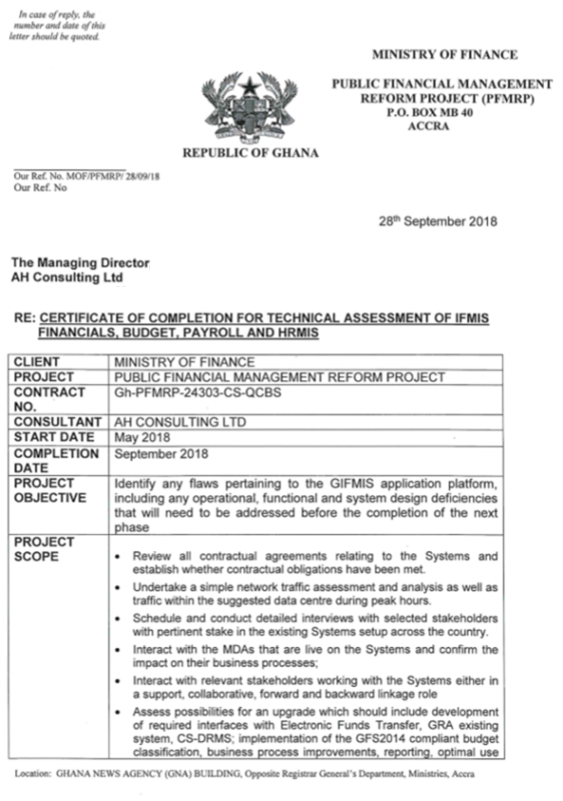

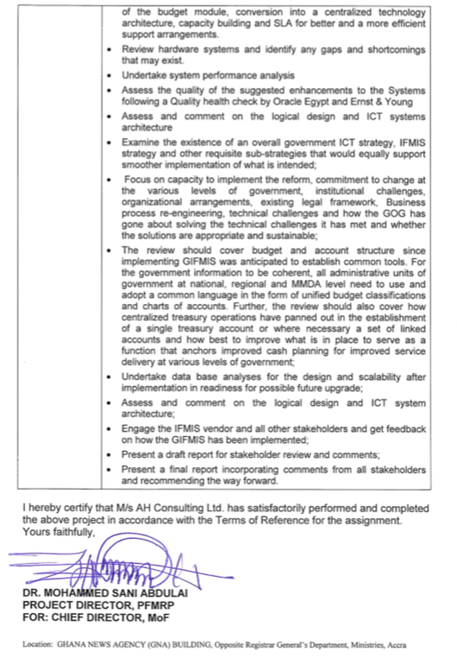

Preparation of a 5-year Government Integrated Financial Management Information System (GIFMIS) Strategy. For Ministry of Finance Ghana.

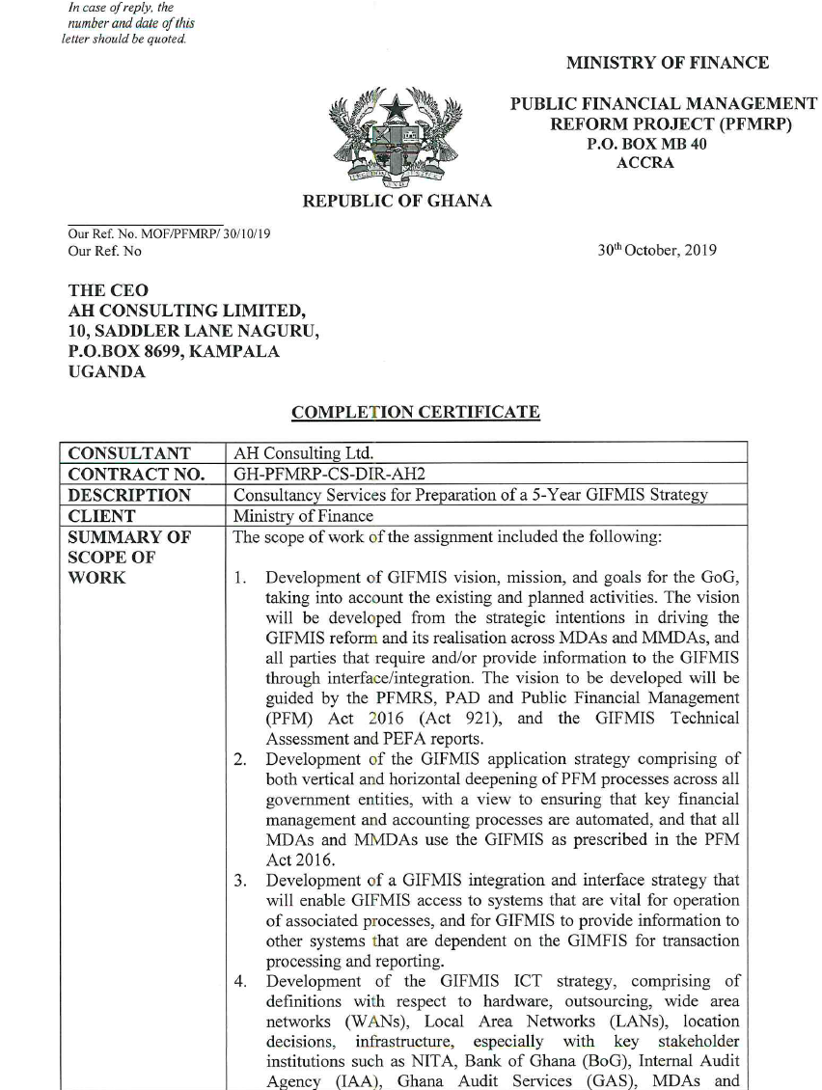

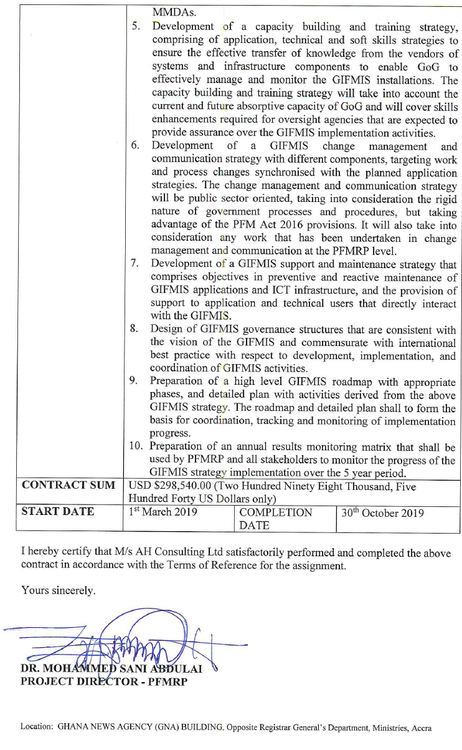

1. **Assignment:** Development of TORs/Specifications for Implementation of the GIFMIS Technical Assessment Recommendations, for Ministry of Finance, Ghana.

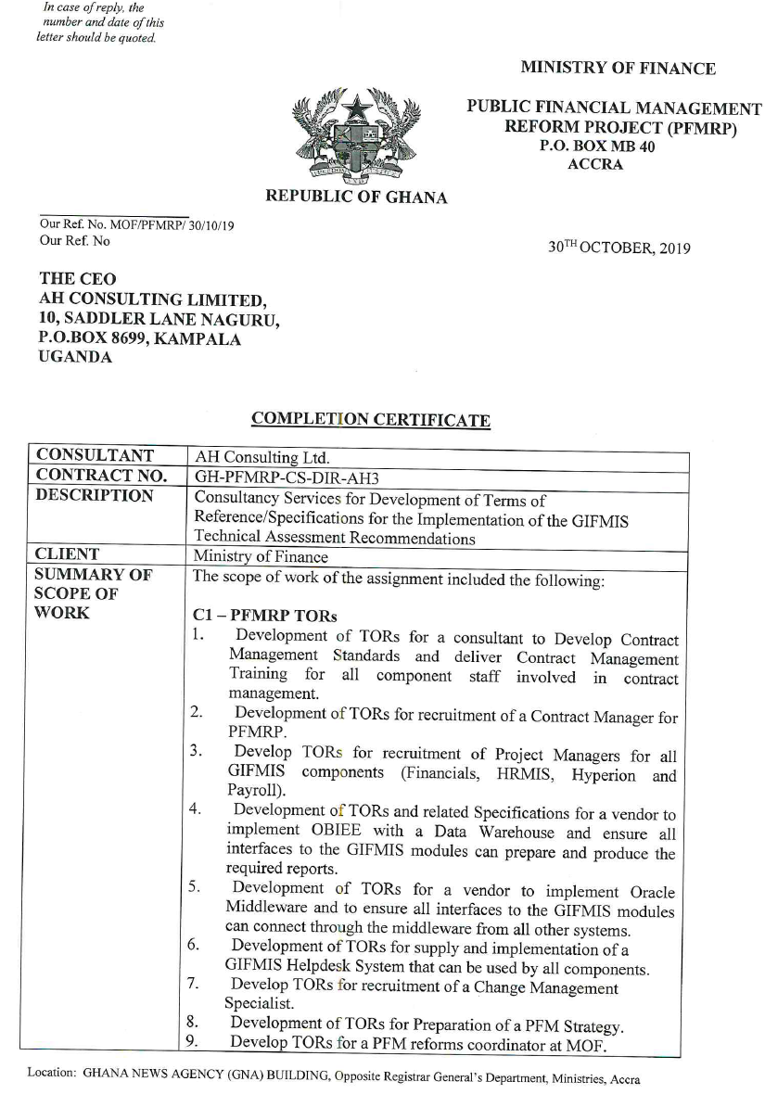

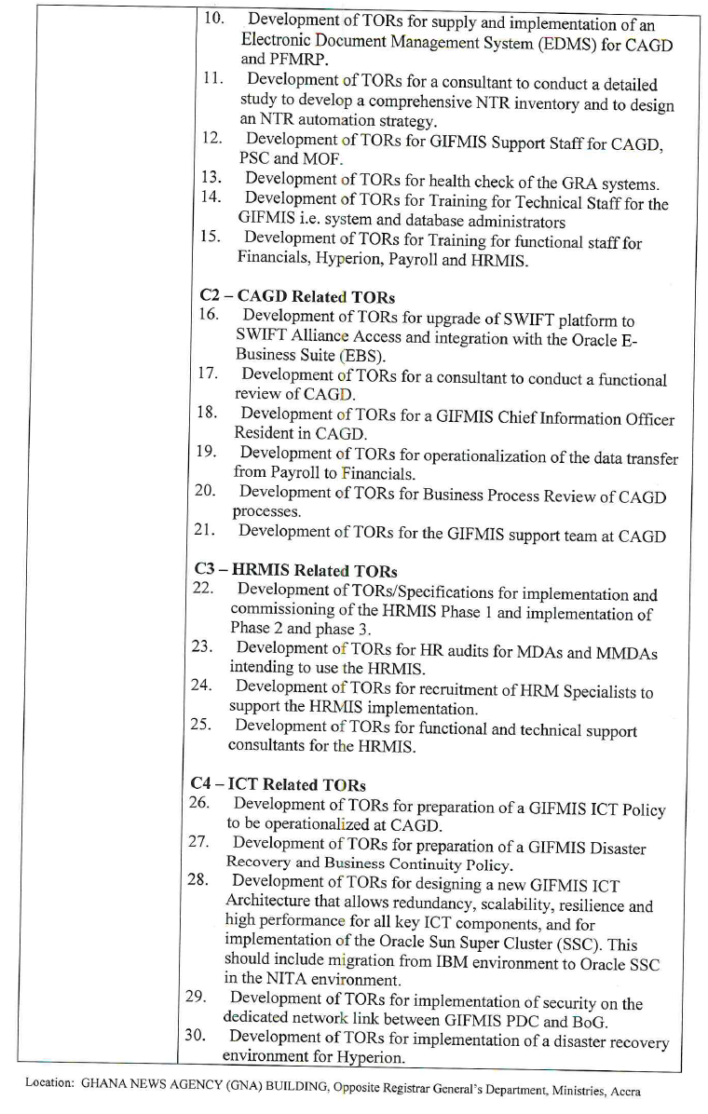

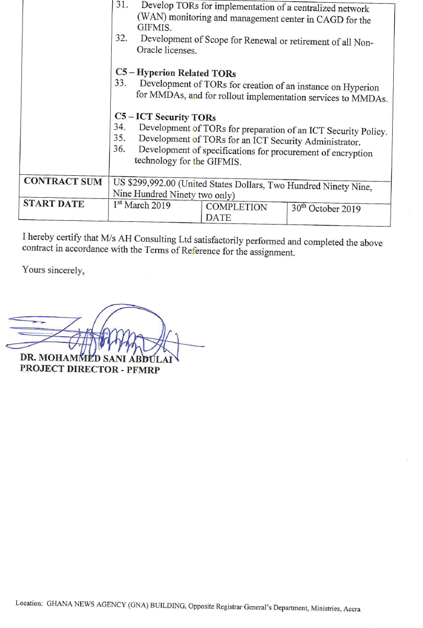

1. **Assignment:** Development of an Environmental Information System for the Petroleum Sector. For Ministry of Petroleum and Mining/NEMA Kenya.

